#### printFormsData (Only Print Form Field Content)

This element specifies that printing the contents of this document shall only print the contents of WordprocessingML form fields defined using the [FORMTEXT](FORMTEXT.docx), [FORMCHECKBOX](FORMCHECKBOX.docx), and [FORMDROPDOWN](FORMDROPDOWN.docx) field codes in their current locations on the page - all other document contents shall be suppressed.

[Rationale: This setting is typically used to allow duplication of paper forms in electronic WordprocessingML document form, allowing the resulting online document to be printed into the correct locations on the existing paper form. end rationale]

If this element is omitted, then the contents of the entire document (not just form fields) should be printed according to the normal print settings.

[Example: Consider a WordprocessingML document which has form fields in the top right and bottom left corners of the first page, as follows (with the text box form fields shaded in grey):

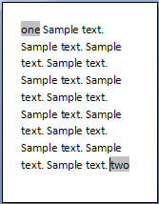

If the only content which shall be printed on the page are the form fields' contents, this requirement is specified using the following WordprocessingML in the document settings:

<w:printFormsData w:val="true" />

The printFormsData element's val attribute as a value of true, specifying that only form field data shall be printed, resulting in output as follows when printed:

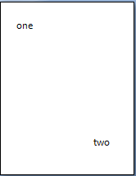

end example]

|  |
| --- |
| Parent Elements |
| settings (§) |

|  |  |
| --- | --- |
| Attributes | Description |
| val (On/Off Value) | Specifies a binary value for the property defined by the parent [XML](XML.docx) element.  A value of on, 1, or true specifies that the property shall be explicitly applied. This is the default value for this attribute, and is implied when the parent element is present, but this attribute is omitted.  A value of off, 0, or false specifies that the property shall be explicitly turned off.  [Example: For example, consider the following on/off property:  <w:… w:val="off"/>  The val attribute explicitly declares that the property is turned off. end example]  The possible values for this attribute are defined by the [ST_OnOff](ST_OnOff.docx) simple [type](type.docx) (§). |

The following [XML](XML.docx) Schema fragment defines the contents of this element:

<complexType [name](name.docx)="CT_OnOff">

<attribute [name](name.docx)="val" [type](type.docx)="[ST_OnOff](ST_OnOff.docx)"/>

</complexType>