#### printTwoOnOne (Print Two Pages Per Sheet)

This element specifies whether two pages should be printed on one sheet of paper when this document is printed. Specifically, this element specifies that each page displayed for the contents in a given WordprocessingML document should be the page size specified in the section settings divided in half with two top margins originating from the bisector of the page, and bottom margins instantiated at the top and bottom of each page.

If this element is omitted, then pages should be displayed and printed as one per sheet.

[Example: Consider a one section document with a 2,160 twentieths of a point (one and a half inch) top margin, and 1,440 twentieths of a point (one inch) bottom, right, and left margins surrounding the document editing canvas (represented by the gray shaded area in diagrams below). This page setup is represented in WordprocessingML using the following fragment:

<w:[pgMar](pgMar.docx) w:top="2160" w:right="1440" w:bottom="1440" w:left="1440" />

The resulting printed pages would appear as follows:

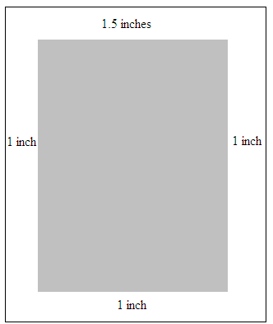

If a document should be displayed and printed as though two pages were printed on a single sheeting, this requirement would be specified using the following WordprocessingML:

<w:printTwoOnOne w:val="true" />

The printTwoOnOne element's val attribute is equal to true specifying that pages should be printed two to a sheet, resulting in the following printout given these page margins:

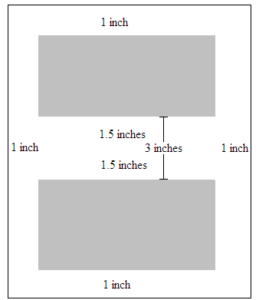

end example]

|  |
| --- |
| Parent Elements |
| settings (§) |

|  |  |
| --- | --- |
| Attributes | Description |
| val (On/Off Value) | Specifies a binary value for the property defined by the parent [XML](XML.docx) element.  A value of on, 1, or true specifies that the property shall be explicitly applied. This is the default value for this attribute, and is implied when the parent element is present, but this attribute is omitted.  A value of off, 0, or false specifies that the property shall be explicitly turned off.  [Example: For example, consider the following on/off property:  <w:… w:val="off"/>  The val attribute explicitly declares that the property is turned off. end example]  The possible values for this attribute are defined by the [ST_OnOff](ST_OnOff.docx) simple [type](type.docx) (§). |

The following [XML](XML.docx) Schema fragment defines the contents of this element:

<complexType [name](name.docx)="CT_OnOff">

<attribute [name](name.docx)="val" [type](type.docx)="[ST_OnOff](ST_OnOff.docx)"/>

</complexType>