#### scrollbar (Scrollbar Display Option)

This element specifies when a scrollbar shall be visible for the contents of the current frame. When this element is set, the val attribute determines exactly when the scrollbar shall be visible. This property is analogous to the scrolling attribute on the [frame](frame.docx) element in HTML.

If this element is omitted, the scrollbar shall only be displayed when the contents of the [frame](frame.docx) exceed the visible space for the [frame](frame.docx) (i.e. when the scrollbar is needed to display all of the content).

[Example: Consider a WordprocessingML document which serves as the [frameset](frameset.docx) container for a [frameset](frameset.docx) consisting of the following three frames:

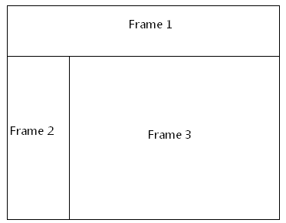

The [frameset](frameset.docx) properties for this document are specified by the following WordprocessingML within the web page settings:

<w:[frameset](frameset.docx)>

…

<w:[frameset](frameset.docx)>

…  
 <w:[frame](frame.docx)>  
 <w:name w:val="Frame 2" />  
 <w:scrollbar w:val="auto" />  
 </w:[frame](frame.docx)>  
 …

</w:[frameset](frameset.docx)>

</w:[frameset](frameset.docx)>

The scrollbar element has a val attribute of auto, which specifies that the [frame](frame.docx) shall only display a scrollbar when it is needed to display all of its content. end example]

|  |
| --- |
| Parent Elements |
| [frame](frame.docx) (§) |

|  |  |
| --- | --- |
| Attributes | Description |
| val (Scrollbar Display Option Value) | Specifies the criteria under which a scrollbar shall be displayed along with the contents of this [frameset](frameset.docx), as defined by the simple [type](type.docx) referenced below.  [Example: Consider a [frameset](frameset.docx) definition within a WordprocessingML document which defines the following scrollbar visibility setting:  <w:[frame](frame.docx)>  <w:scrollbar w:val="on" />  … </w:[frame](frame.docx)>  The val attribute value of on specifies that the scrollbar shall always be displayed, even when it is not needed (i.e. when it would be displayed disabled). end example]  The possible values for this attribute are defined by the [ST_FrameScrollbar](ST_FrameScrollbar.docx) simple [type](type.docx) (§). |

The following [XML](XML.docx) Schema fragment defines the contents of this element:

<complexType [name](name.docx)="CT_FrameScrollbar">

<attribute [name](name.docx)="val" [type](type.docx)="[ST_FrameScrollbar](ST_FrameScrollbar.docx)" use="required"/>

</complexType>