#### showBreaksInFrames (Display Page/Column Breaks Present in Frames)

This element specifies whether applications should honor the presence of page and/or column breaks which are present within the contents of paragraphs which have been defined as frames using the [framePr](framePr.docx) element (§).

Typically, breaks within frames shall be ignored and shall have no [effect](effect.docx) on the display of the paragraph in which they are contained. This element, when present with a val attribute value of true (or equivalent), specifies that rather than completely ignoring these breaks, applications should display the break and move the remaining [frame](frame.docx) content, and all subsequent text, to the [next](next.docx) page and/or column, as needed.

[Example: Consider a WordprocessingML document with a paragraph contained within a text frame:

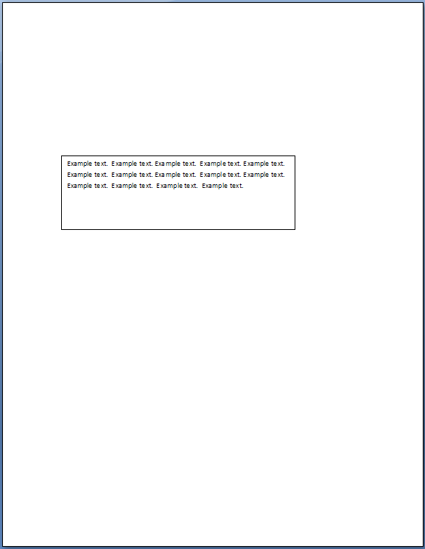

The default presentation would display the page break inline in the [frame](frame.docx) (breaking the [frame](frame.docx) into two) but would not actually break the page:

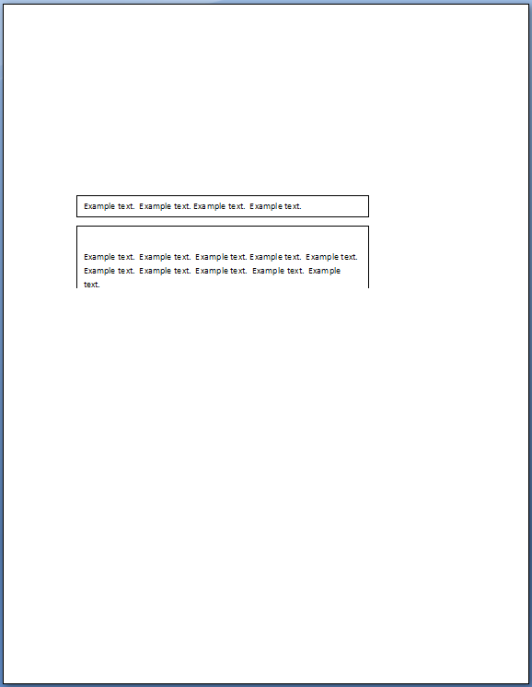

However, if this compatibility setting is turned on:

<w:[compat](compat.docx)>  
 <w:showBreaksInFrames />  
</w:[compat](compat.docx)>

Then the page breaks will be used even though they are present in the [frame](frame.docx), breaking the page and resulting in the following output:

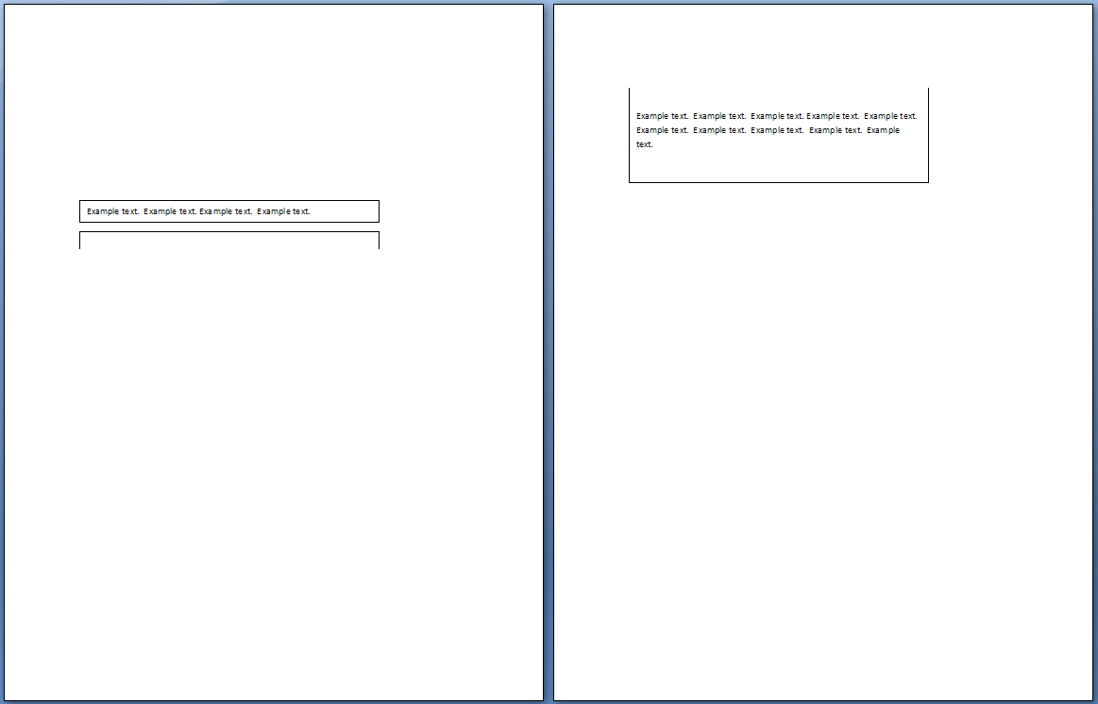

end example]

|  |
| --- |
| Parent Elements |
| [compat](compat.docx) (§) |

|  |  |
| --- | --- |
| Attributes | Description |
| val (On/Off Value) | Specifies a binary value for the property defined by the parent [XML](XML.docx) element.  A value of on, 1, or true specifies that the property shall be explicitly applied. This is the default value for this attribute, and is implied when the parent element is present, but this attribute is omitted.  A value of off, 0, or false specifies that the property shall be explicitly turned off.  [Example: For example, consider the following on/off property:  <w:… w:val="off"/>  The val attribute explicitly declares that the property is turned off. end example]  The possible values for this attribute are defined by the [ST_OnOff](ST_OnOff.docx) simple [type](type.docx) (§). |

The following [XML](XML.docx) Schema fragment defines the contents of this element:

<complexType [name](name.docx)="CT_OnOff">

<attribute [name](name.docx)="val" [type](type.docx)="[ST_OnOff](ST_OnOff.docx)"/>

</complexType>