#### sourceFileName (Source File for Frame)

This element specifies the ID for the relationship which specifies the source file for a single [frame](frame.docx) within a [frameset](frameset.docx) document.

The relationship referenced by this element's [id](id.docx) attribute shall exist in the relationship part item for the Web [Settings](Settings.docx) part,or this document shall be considered non-conformant. Also, the [type](type.docx) of the relationship referenced by this element's [id](id.docx) attribute shall be http://schemas.openxmlformats.org/officeDocument/2006/relationships/[frame](frame.docx), or this document shall be considered non-conformant.

If this element is omitted, then no source file is present for the current [frame](frame.docx), and one may be created dynamically as needed to display content within the frame.

[Example: Consider a WordprocessingML document which serves as the [frameset](frameset.docx) container for a [frameset](frameset.docx) consisting of the following three frames:

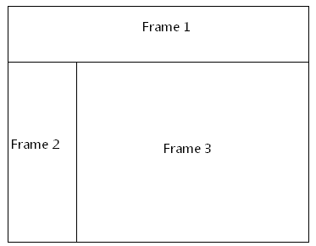

The [frameset](frameset.docx) properties for this document are specified by the following WordprocessingML within the web page settings:

<w:[frameset](frameset.docx)>

…

<w:[frameset](frameset.docx)>

…  
 <w:[frame](frame.docx)>  
 <w:name w:val="Frame 2" />  
 <w:sourceFileName r:id="rId5" />  
 </w:[frame](frame.docx)>  
 …

</w:[frameset](frameset.docx)>

</w:[frameset](frameset.docx)>

The sourceFileName element specifies that the contents of this [frame](frame.docx) shall be the contents of the file targeted by the relationship with ID rId5 in the web settings part's relationship part item. end example]

|  |
| --- |
| Parent Elements |
| [frame](frame.docx) (§) |

|  |  |
| --- | --- |
| Attributes | Description |
| [id](id.docx) (Relationship to Part)  Namespace: .../officeDocument/2006/relationships | Specifies the relationship ID to a specified part.  The specified relationship shall match the [type](type.docx) required by the parent element:   * http://schemas.openxmlformats.org/officeDocument/2006/relationships/footer for the [footerReference](footerReference.docx) element * http://schemas.openxmlformats.org/officeDocument/2006/relationships/header for the [headerReference](headerReference.docx) element * http://schemas.openxmlformats.org/officeDocument/2006/relationships/font for the [embedBold](embedBold.docx), [embedBoldItalic](embedBoldItalic.docx), [embedItalic](embedItalic.docx), or [embedRegular](embedRegular.docx) elements * http://schemas.openxmlformats.org/officeDocument/2006/relationships/[printerSettings](printerSettings.docx) for the [printerSettings](printerSettings.docx) element   [Example: Consider an [XML](XML.docx) element which has the following [id](id.docx) attribute:  <… r:id="rId10" />  The markup specifies the associated relationship part with relationship ID rId1 contains the corresponding relationship information for the parent [XML](XML.docx) element. end example]  The possible values for this attribute are defined by the ST_RelationshipId simple [type](type.docx) (§). |

The following [XML](XML.docx) Schema fragment defines the contents of this element:

<complexType [name](name.docx)="CT_Rel">

<attribute ref="r:id" use="required"/>

</complexType>