#### splitPgBreakAndParaMark (Always Move Paragraph Mark to Page after a Page Break)

This element specifies whether a page break shall automatically complete the line on which it appears, moving the end of the paragraph to a new line on the [next](next.docx) page, or if it shall behave as true run-level content within its current paragraph.

Typically, a page break defined using the [br](br.docx) element (§) is treated as run-level content, which means that although it delimits the end of the page, if there is no content after it within the current paragraph, that the paragraph shall also end on that page. This element, when present with a val attribute value of true (or equivalent), specifies that a page break shall always immediately end the current page, moving the paragraph mark which delimits the end of its parent paragraph to a new line on the [next](next.docx) page.

Note that this setting only affects the case where there is no run-level content after the page break within the paragraph - if any further run content appears in the paragraph it shall appear on subsequent lines on the [next](next.docx) page.

[Example: Consider a WordprocessingML document with two paragraphs of content - the first ending with a page break:

<w:[p](p.docx)>  
 <w:[r](r.docx)>  
 <w:[t](t.docx)>This is text before a page break.</w:[t](t.docx)>  
 <w:[br](br.docx) w:[type](type.docx)="page" />  
 </w:[r](r.docx)>  
</w:[p](p.docx)>  
<w:[p](p.docx)>  
 <w:[r](r.docx)>  
 <w:[t](t.docx)>This is text on the [next](next.docx) page.</w:[t](t.docx)>  
 </w:[r](r.docx)>  
</w:[p](p.docx)>

The default presentation would have the text content This is text on the [next](next.docx) page. as the first line of the second page, as there is no run content after the page break in paragraph one, and therefore no need for a new line on page two (in this image, a graphical illustration of the pilcrow and the page break have been added for clarity):

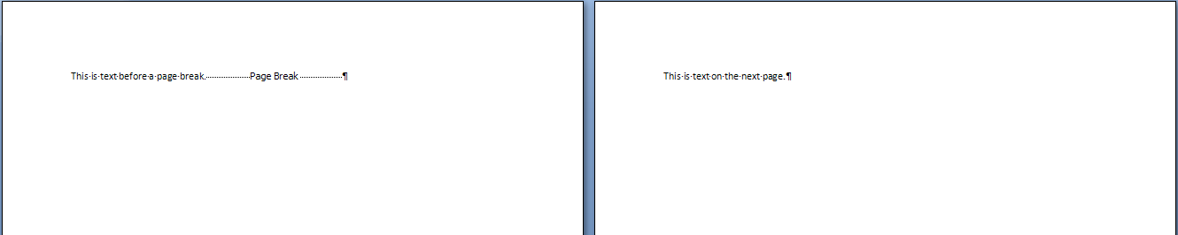

However, if this compatibility setting is turned on:

<w:[compat](compat.docx)>  
 <w:splitPgBreakAndParaMark />  
</w:[compat](compat.docx)>

Then even though it is followed by no additional content, the page break shall immediately end the first page, pushing the end of the first paragraph onto the first line of the second page, resulting in the following output:

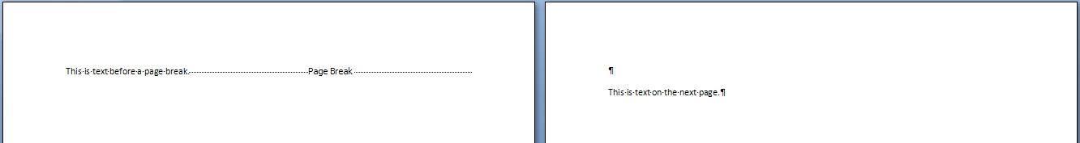

end example]

|  |
| --- |
| Parent Elements |
| [compat](compat.docx) (§) |

|  |  |
| --- | --- |
| Attributes | Description |
| val (On/Off Value) | Specifies a binary value for the property defined by the parent [XML](XML.docx) element.  A value of on, 1, or true specifies that the property shall be explicitly applied. This is the default value for this attribute, and is implied when the parent element is present, but this attribute is omitted.  A value of off, 0, or false specifies that the property shall be explicitly turned off.  [Example: For example, consider the following on/off property:  <w:… w:val="off"/>  The val attribute explicitly declares that the property is turned off. end example]  The possible values for this attribute are defined by the [ST_OnOff](ST_OnOff.docx) simple [type](type.docx) (§). |

The following [XML](XML.docx) Schema fragment defines the contents of this element:

<complexType [name](name.docx)="CT_OnOff">

<attribute [name](name.docx)="val" [type](type.docx)="[ST_OnOff](ST_OnOff.docx)"/>

</complexType>