#### suppressTopSpacing (Ignore Minimum and Exact Line Height for First Line on Page)

This element specifies whether the minimum line height specified using the [spacing](spacing.docx) element (§) with a lineRule attribute value of atLeast or exact shall be ignored for the first line on each page.

Typically, if a minimum or exact line height has been specified using the [spacing](spacing.docx) element, then all lines within that paragraph have the necessary line [spacing](spacing.docx) added to them in order to meet this constraint. This element, when present with a val attribute value of true (or equivalent), specifies that no additional [spacing](spacing.docx) shall be added above the first line on each page as a [result](result.docx) of these line [spacing](spacing.docx) requirements - the top of the text characters on the first line shall be at the top edge of the page.

[Example: Consider a WordprocessingML document whose first paragraph has a line [spacing](spacing.docx) setting requiring exactly 25 points of space per line:

<w:[p](p.docx)>  
 <w:[pPr](pPr.docx)>  
 <w:[spacing](spacing.docx) w:line="500" w:lineRule="exact" />  
 </w:[pPr](pPr.docx)>  
 …  
</w:[p](p.docx)>

The default presentation would have the necessary amount of space added [between](between.docx) each line such that all lines in the paragraph are centered within 25 points of [spacing](spacing.docx) (highlighting has been added to the image below in order to illustrate the additional [spacing](spacing.docx) above the first line):

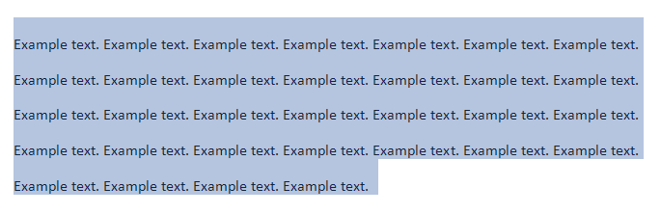

However, if this compatibility setting is turned on:

<w:[compat](compat.docx)>  
 <w:suppressTopSpacing />  
</w:[compat](compat.docx)>

Then no additional line [spacing](spacing.docx) shall be added above the first line on the page (although all other lines are unaffected), resulting in the following output:

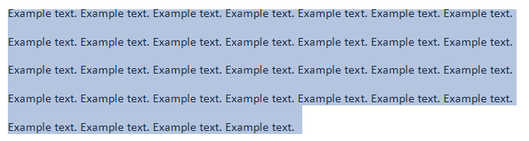

end example]

|  |
| --- |
| Parent Elements |
| [compat](compat.docx) (§) |

|  |  |
| --- | --- |
| Attributes | Description |
| val (On/Off Value) | Specifies a binary value for the property defined by the parent [XML](XML.docx) element.  A value of on, 1, or true specifies that the property shall be explicitly applied. This is the default value for this attribute, and is implied when the parent element is present, but this attribute is omitted.  A value of off, 0, or false specifies that the property shall be explicitly turned off.  [Example: For example, consider the following on/off property:  <w:… w:val="off"/>  The val attribute explicitly declares that the property is turned off. end example]  The possible values for this attribute are defined by the [ST_OnOff](ST_OnOff.docx) simple [type](type.docx) (§). |

The following [XML](XML.docx) Schema fragment defines the contents of this element:

<complexType [name](name.docx)="CT_OnOff">

<attribute [name](name.docx)="val" [type](type.docx)="[ST_OnOff](ST_OnOff.docx)"/>

</complexType>