#### [sz](sz.docx) (Frame Size)

This element specifies the size for a single [frame](frame.docx) within a frameset.

This size shall be interpreted based on the contents of the [frameLayout](frameLayout.docx) element (§) for the parent [frameset](frameset.docx), as follows:

* If the val attribute on that element is [cols](cols.docx), then this element specifies the width of the [frame](frame.docx)
* If the val attribute on that element is rows, then this element specifies the height of the [frame](frame.docx)

Once the axis of this measurement has been established using the criteria above, the actual value of the measurement shall be determined by the following:

* If the val attribute ends in a asterisk (*), then this measurement is a relative measurement (relative to all other frames in this frameset).
* If the val attribute ends in a percentage symbol (%), then this measurement is a percentage of the height and/or width of the parent window, respectively.
* Otherwise, the value of the val attribute specifies the size of the [frame](frame.docx) in pixels. This measurement shall be interpreted in the context of the [pixelsPerInch](pixelsPerInch.docx) element (§) to determine the width of the resulting measurement in inches.

If this element is omitted, then no information shall be implied about the size of the current frame.

[Example: Consider a [frameset](frameset.docx) consisting of the following three frames:

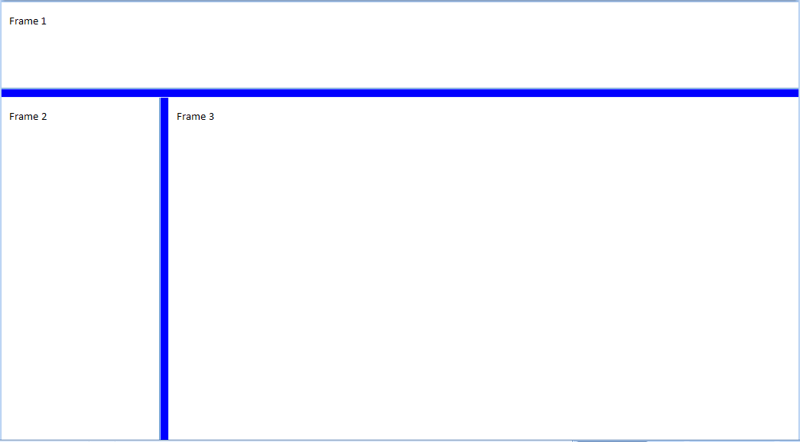

The following properties define the presentation of the top [frame](frame.docx) within this frameset:

<w:[frameset](frameset.docx)>  
 …  
 <w:[frame](frame.docx)>  
 <w:[sz](sz.docx) w:val="300" />  
 <w:name w:val="Frame 1" />  
 </w:[frame](frame.docx)>  
 …  
 <w:[pixelsPerInch](pixelsPerInch.docx) w:val="150" />  
</w:[frameset](frameset.docx)>

The [sz](sz.docx) element's val attribute specifies that the size of this [frame](frame.docx) is 300 - which translates to a height of exactly 300 pixels tall. In addition, this document specifies that the intended number of pixels per inch for this measurement is 150, resulting in a 2" tall [frame](frame.docx) height. end example]

|  |
| --- |
| Parent Elements |
| [frame](frame.docx) (§) |

|  |  |
| --- | --- |
| Attributes | Description |
| val (String Value) | Specifies that its contents will contain a string.  The contents of this string are interpreted based on the context of the parent [XML](XML.docx) element.  [Example: Consider the following WordprocessingML fragment:  <w:[pPr](pPr.docx)>  <w:[pStyle](pStyle.docx) w:val="heading1" />  </w:[pPr](pPr.docx)>  The value of the val attribute is the ID of the associated paragraph style's styleId.  However, consider the following fragment:  <w:[sdtPr](sdtPr.docx)>  <w:[alias](alias.docx) w:val="SDT Title Example" />  ...  </w:[sdtPr](sdtPr.docx)>  In this case, the decimal number in the val attribute is the [caption](caption.docx) of the parent structured document tag. In each case, the value is interpreted in the context of the parent element. end example]  The possible values for this attribute are defined by the [ST_String](ST_String.docx) simple [type](type.docx) (§). |

The following [XML](XML.docx) Schema fragment defines the contents of this element:

<complexType [name](name.docx)="CT_String">

<attribute [name](name.docx)="val" [type](type.docx)="[ST_String](ST_String.docx)" use="required"/>

</complexType>