### tblOverlap (Floating Table Allows Other [Tables](Tables.docx) to Overlap)

This element specifies whether the current [table](table.docx) shall allow other floating tables to overlap its extents when the tables are displayed in a document. If specified, then no adjustment shall be made to prevent tables whose properties would normally cause them to overlap from overlapping when displayed. If turned off, then the tables shall be adjusted as needed to prevent them from overlapping when displayed by adjusting the floating [table](table.docx) properties as needed.

If this element is omitted on a given [table](table.docx), then this [table](table.docx) shall allow other tables to overlap when displayed. If the parent [table](table.docx) is not floating via the [tblpPr](tblpPr.docx) element (§), then this element shall be ignored.

[Example: Consider two floating tables in a WordprocessingML document which overlap when displayed, as follows:

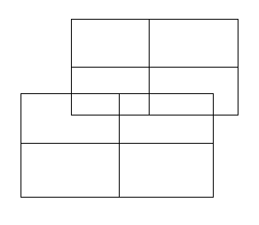

If either of these tables specifies that it shall not allow overlapping, using the following WordprocessingML:

<w:[tblPr](tblPr.docx)>  
 <w:tblOverlap w:val="never"/>  
</w:[tblPr](tblPr.docx)>

The resulting tables shall not overlap, and must be adjusted at display time to prevent any overlapping, for example:

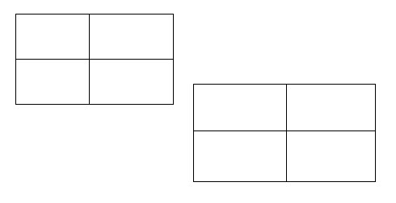

The tblOverlap element with a value of never specifies that the specified [table](table.docx) cannot overlap with other floating tables in the document. end example]

|  |
| --- |
| Parent Elements |
| [tblPr](tblPr.docx) (§); [tblPr](tblPr.docx) (§); [tblPr](tblPr.docx) (§); [tblPr](tblPr.docx) (§) |

|  |  |
| --- | --- |
| Attributes | Description |
| val (Floating Table Overlap Setting) | Specifies whether a floating [table](table.docx) shall allow other floating tables in the document to overlap its extents when displayed.  [Example: The following WordprocessingML specifies that the [table](table.docx) is not allowed to overlap:  <w:tblOverlap w:val="never" />  end example]  The possible values for this attribute are defined by the [ST_TblOverlap](ST_TblOverlap.docx) simple [type](type.docx) (§). |

The following [XML](XML.docx) Schema fragment defines the contents of this element:

<complexType [name](name.docx)="CT_TblOverlap">

<attribute [name](name.docx)="val" [type](type.docx)="[ST_TblOverlap](ST_TblOverlap.docx)" use="required"/>

</complexType>