#### tblStylePr (Style Conditional Table Formatting Properties)

This element specifies a set of formatting properties which shall be conditionally applied to the parts of a [table](table.docx) which match the requirement specified on the [type](type.docx) attribute. These [table](table.docx) conditional formats are applied to different regions of the [table](table.docx) as follows:

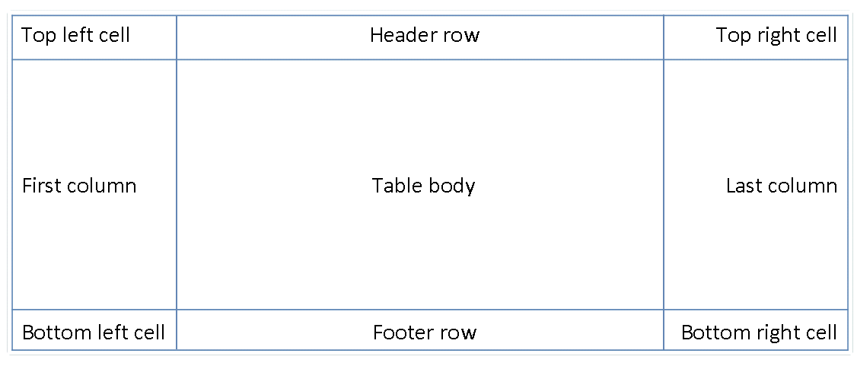

All rows in the [table](table.docx) can also have conditional formatting on an alternating row/column basis as well as follows:

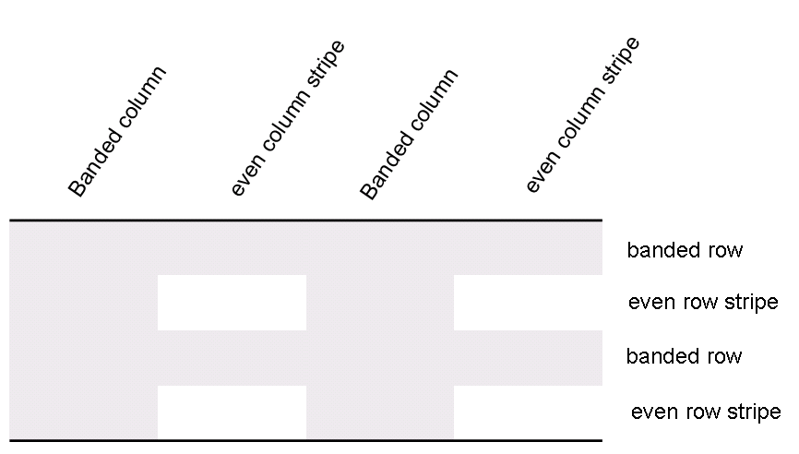

When specified, these conditional formats shall be applied in the following order (therefore subsequent formats override properties on previous formats):

* Whole [table](table.docx)
* Banded columns, even column banding
* Banded rows, even row banding
* First row, last row
* First [column](column.docx), last [column](column.docx)
* Top left, top right, bottom left, bottom right

[Example: Consider a [table](table.docx) style which contains conditional formatting, defined as follows:

<w:style w:[type](type.docx)="[table](table.docx)" w:styleId="exampleTableStyle">  
 …  
 <w:tblStylePr w:[type](type.docx)="firstRow">  
 <w:[tblPr](tblPr.docx)>  
 <w:[tblCellSpacing](tblCellSpacing.docx) w:[w](w.docx)="29" w:[type](type.docx)="dxa"/>  
 </w:[tblPr](tblPr.docx)>  
 …  
 </w:tblStylePr>  
</w:style>

The tblStylePr element specifies a set of [table](table.docx) properties which shall be conditionally applied to all parts of the [table](table.docx) which meet the criteria specified by the [type](type.docx) attribute (in this case, all heading rows for the current table). end example]

|  |
| --- |
| Parent Elements |
| style (§) |

|  |  |
| --- | --- |
| Child Elements | Subclause |
| [pPr](pPr.docx) (Table Style Conditional Formatting Paragraph Properties) | § |
| [rPr](rPr.docx) (Table Style Conditional Formatting [Run](Run.docx) Properties) | § |
| [tblPr](tblPr.docx) (Table Style Conditional Formatting Table Properties) | § |
| [tcPr](tcPr.docx) (Table Style Conditional Formatting Table Cell Properties) | § |
| [trPr](trPr.docx) (Table Style Conditional Formatting Table Row Properties) | § |

|  |  |
| --- | --- |
| Attributes | Description |
| [type](type.docx) (Table Style Conditional Formatting Type) | Specifies the section of the [table](table.docx) to which the current conditional formatting properties shall be applied.  [Example: Consider a [table](table.docx) style which contains conditional formatting, defined as follows:  <w:style w:[type](type.docx)="[table](table.docx)" …>  …  <w:tblStylePr w:[type](type.docx)="lastRow">  …  </w:tblStylePr> </w:style>  The [type](type.docx) attribute value of lastRow specifies that this set of conditional formatting properties shall be applied to the last row of the [table](table.docx) only. end example]  The possible values for this attribute are defined by the [ST_TblStyleOverrideType](ST_TblStyleOverrideType.docx) simple [type](type.docx) (§). |

The following [XML](XML.docx) Schema fragment defines the contents of this element:

<complexType [name](name.docx)="CT_TblStylePr">

<sequence>

<element [name](name.docx)="[pPr](pPr.docx)" [type](type.docx)="CT_PPr" minOccurs="0"/>

<element [name](name.docx)="[rPr](rPr.docx)" [type](type.docx)="CT_RPr" minOccurs="0"/>

<element [name](name.docx)="[tblPr](tblPr.docx)" [type](type.docx)="CT_TblPrBase" minOccurs="0"/>

<element name="[trPr](trPr.docx)" [type](type.docx)="CT_TrPr" minOccurs="0" maxOccurs="1"/>

<element name="[tcPr](tcPr.docx)" [type](type.docx)="CT_TcPr" minOccurs="0" maxOccurs="1"/>

</sequence>

<attribute [name](name.docx)="[type](type.docx)" [type](type.docx)="[ST_TblStyleOverrideType](ST_TblStyleOverrideType.docx)" use="required"/>

</complexType>