#### txbxContent (Rich Text Box Content Container)

This element specifies that its contents shall be any rich WordprocessingML content, and that this content is the rich contents of a [drawing](drawing.docx) [object](object.docx) defined using the Vector Markup Language (VML) syntax (§).

If this element contains within any of its contents any of the following content, then the document shall be considered non-conformant:

* References to other WordprocessingML document stories (comments, [footnotes](footnotes.docx), endnotes)
* Additional txbxContent elements (as part of nested VML objects)

[Example: Consider a WordprocessingML document consisting of a single VML shape element (§) (in this case, a star) that contains within it some WordprocessingML content:

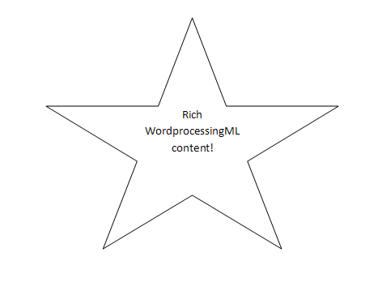

That [drawing](drawing.docx) [object](object.docx) now contains a text box, and so uses the syntax for that text box:

<v:shape [id](id.docx)="_x0000_s1026" [type](type.docx)="#_x0000_t12" style="…">  
 <v:textbox>  
 <w:txbxContent>  
 <w:[p](p.docx)>  
 <w:[pPr](pPr.docx)>  
 <w:[jc](jc.docx) w:val="center"/>  
 </w:[pPr](pPr.docx)>  
 <w:[r](r.docx)>  
 <w:[t](t.docx)>Rich WordprocessingML content!</w:[t](t.docx)>  
 </w:[r](r.docx)>  
 </w:[p](p.docx)>  
 </w:txbxContent>  
 </v:textbox>  
</v:shape>

The txbxContent element is the container for the WordprocessingML contained within the text box inside that shape - once inside this element any content (subject to the restrictions defined above) may be used. end example]

|  |
| --- |
| Parent Elements |
| textbox (§) |

|  |  |
| --- | --- |
| Child Elements | Subclause |
| [altChunk](altChunk.docx) (Anchor for Imported External Content) | § |
| [bookmarkEnd](bookmarkEnd.docx) (Bookmark End) | § |
| [bookmarkStart](bookmarkStart.docx) (Bookmark Start) | § |
| [commentRangeEnd](commentRangeEnd.docx) (Comment Anchor Range End) | § |
| [commentRangeStart](commentRangeStart.docx) (Comment Anchor Range Start) | § |
| [customXml](customXml.docx) (Block-Level Custom [XML](XML.docx) Element) | § |
| [customXmlDelRangeEnd](customXmlDelRangeEnd.docx) (Custom [XML](XML.docx) Markup Deletion End) | § |
| [customXmlDelRangeStart](customXmlDelRangeStart.docx) (Custom [XML](XML.docx) Markup Deletion Start) | § |
| [customXmlInsRangeEnd](customXmlInsRangeEnd.docx) (Custom [XML](XML.docx) Markup Insertion End) | § |
| [customXmlInsRangeStart](customXmlInsRangeStart.docx) (Custom [XML](XML.docx) Markup Insertion Start) | § |
| [customXmlMoveFromRangeEnd](customXmlMoveFromRangeEnd.docx) (Custom [XML](XML.docx) Markup Move Source End) | § |
| [customXmlMoveFromRangeStart](customXmlMoveFromRangeStart.docx) (Custom [XML](XML.docx) Markup Move Source Start) | § |
| [customXmlMoveToRangeEnd](customXmlMoveToRangeEnd.docx) (Custom [XML](XML.docx) Markup Move Destination Location End) | § |
| [customXmlMoveToRangeStart](customXmlMoveToRangeStart.docx) (Custom [XML](XML.docx) Markup Move Destination Location Start) | § |
| [del](del.docx) (Deleted [Run](Run.docx) Content) | § |
| [ins](ins.docx) (Inserted [Run](Run.docx) Content) | § |
| [moveFrom](moveFrom.docx) (Move Source [Run](Run.docx) Content) | § |
| [moveFromRangeEnd](moveFromRangeEnd.docx) (Move Source Location Container - End) | § |
| [moveFromRangeStart](moveFromRangeStart.docx) (Move Source Location Container - Start) | § |
| [moveTo](moveTo.docx) (Move Destination [Run](Run.docx) Content) | § |
| [moveToRangeEnd](moveToRangeEnd.docx) (Move Destination Location Container - End) | § |
| [moveToRangeStart](moveToRangeStart.docx) (Move Destination Location Container - Start) | § |
| [oMath](oMath.docx) (Office Math) | § |
| oMathPara (Math Paragraph) | § |
| [p](p.docx) (Paragraph) | § |
| [permEnd](permEnd.docx) (Range Permission End) | § |
| [permStart](permStart.docx) (Range Permission Start) | § |
| [proofErr](proofErr.docx) (Proofing Error Anchor) | § |
| [sdt](sdt.docx) (Block-Level Structured Document Tag) | § |
| [tbl](tbl.docx) (Table) | § |

The following [XML](XML.docx) Schema fragment defines the contents of this element:

<complexType [name](name.docx)="CT_TxbxContent">

<[group](group.docx) ref="EG_BlockLevelElts" minOccurs="1" maxOccurs="unbounded"/>

</complexType>