#### [w](w.docx) (Frameset Splitter Width)

This element specifies the width of the splitters within the [frameset](frameset.docx) in this WordprocessingML document. This element shall only be honored on the root [frameset](frameset.docx) for this document, and may be ignored for all nested framesets in this document.

If this element is omitted, then the default width of the splitters in this document shall be 4.5 points (90 twentieths of a point) wide. If the [noBorder](noBorder.docx) element (§) is also specified, then this element shall be ignored and no splitters shall be displayed.

[Example: Consider a [frameset](frameset.docx) consisting of the following three frames:

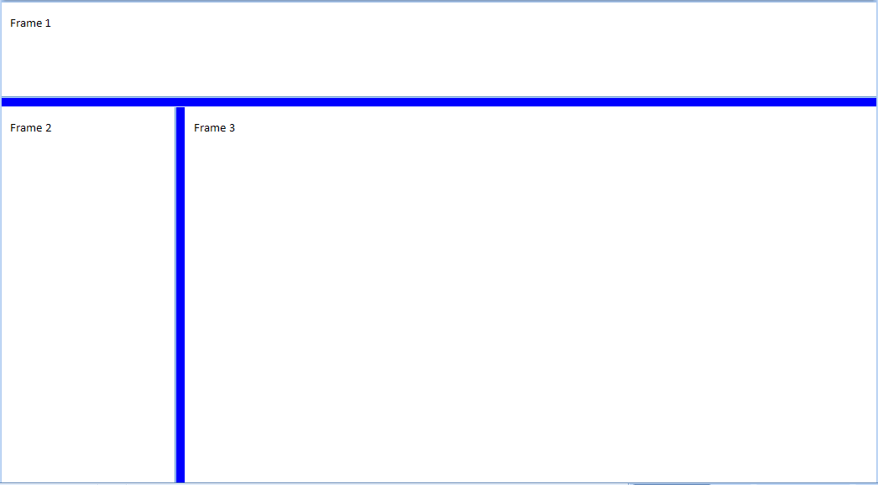

The following properties define the presentation of the splitter bars within this frameset:

<w:[frameset](frameset.docx)>  
 <w:[framesetSplitbar](framesetSplitbar.docx)>  
 <w:[w](w.docx) w:val="200" />  
 <w:[color](color.docx) w:val="0000FF" />  
 </w:[framesetSplitbar](framesetSplitbar.docx)>  
 …   
</w:[frameset](frameset.docx)>

The [w](w.docx) element's val attribute specifies that the splitter shall be 10 points (200 twentieths of a point) wide when the contents of this document are displayed. end example]

|  |
| --- |
| Parent Elements |
| [framesetSplitbar](framesetSplitbar.docx) (§) |

|  |  |
| --- | --- |
| Attributes | Description |
| val (Measurement in Twentieths of a Point) | Specifies a positive measurement value, specified in twentieths of a point. This value is interpreted based on the context of the parent [XML](XML.docx) element.  [Example: Consider the following WordprocessingML element with a val attribute containing a positive measurement in twentieths of a point:  <w:… w:val="720" />  The val attribute has a value of 720, specifying that this measurement value is 720 twentieths of a point (0.5"). This value is interpreted by the parent element as needed. end example]  The possible values for this attribute are defined by the [ST_TwipsMeasure](ST_TwipsMeasure.docx) simple [type](type.docx) (§). |

The following [XML](XML.docx) Schema fragment defines the contents of this element:

<complexType [name](name.docx)="CT_TwipsMeasure">

<attribute [name](name.docx)="val" [type](type.docx)="[ST_TwipsMeasure](ST_TwipsMeasure.docx)" use="required"/>

</complexType>