#### widowControl (Allow First/Last Line to Display on a Separate Page)

This element specifies whether a consumer shall prevent a single line of this paragraph from being displayed on a separate page from the remaining content at display time by moving the line onto the following page.

When displaying a paragraph in a page, it is sometimes the case that the first line of that paragraph would display as the last line on one page, and all subsequent lines would display on the following page. This property ensures that a consumer shall move the single line to the following page as well to prevent having one line on its own page. As well, if a single line appears at the top of a page, a consumer shall move the preceding line onto the following page as well, to prevent a single line from being displayed on a separate page.

If this element is omitted on a given paragraph, its value is determined by the setting previously set at any level of the style hierarchy (i.e. that previous setting remains unchanged). If this setting is never specified in the style hierarchy, then this paragraph shall prevent a single line from being shown on a separate page whenever it would normally occur.

[Example: Consider a document with a paragraph which shall be shown on four lines at display time. If this paragraph would normally be laid out with its first line at the bottom of one page, and its following lines on the [next](next.docx) page, as follows:

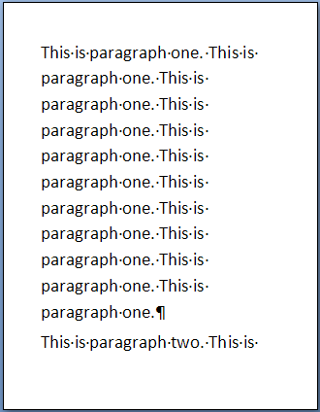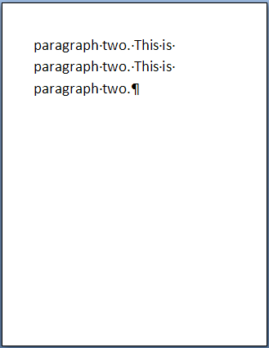

This property would ensure that the default [behavior](behavior.docx) for each paragraph prevented this, by moving this line onto the following paragraph as follows:

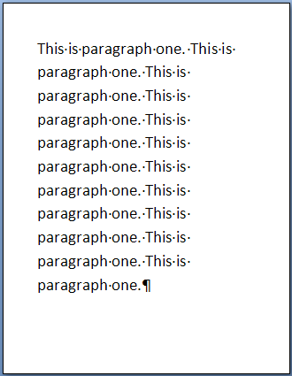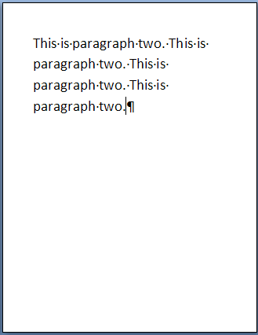

However, if this default is overridden by specifying the following WordprocessingML:

<w:[pPr](pPr.docx)>

<w:widowControl w:val="off" />

</w:[pPr](pPr.docx)>

The specifying of the widowControl element with value off means that the consumer displaying this document shall not move the first line onto a separate page if it would be separated from all other lines (the first [picture](picture.docx) above). end example]

|  |
| --- |
| Parent Elements |
| [pPr](pPr.docx) (§); [pPr](pPr.docx) (§); [pPr](pPr.docx) (§); [pPr](pPr.docx) (§); [pPr](pPr.docx) (§); [pPr](pPr.docx) (§) |

|  |  |
| --- | --- |
| Attributes | Description |
| val (On/Off Value) | Specifies a binary value for the property defined by the parent [XML](XML.docx) element.  A value of on, 1, or true specifies that the property shall be explicitly applied. This is the default value for this attribute, and is implied when the parent element is present, but this attribute is omitted.  A value of off, 0, or false specifies that the property shall be explicitly turned off.  [Example: For example, consider the following on/off property:  <w:… w:val="off"/>  The val attribute explicitly declares that the property is turned off. end example]  The possible values for this attribute are defined by the [ST_OnOff](ST_OnOff.docx) simple [type](type.docx) (§). |

The following [XML](XML.docx) Schema fragment defines the contents of this element:

<complexType [name](name.docx)="CT_OnOff">

<attribute [name](name.docx)="val" [type](type.docx)="[ST_OnOff](ST_OnOff.docx)"/>

</complexType>