#### wrapTrailSpaces (Line Wrap Trailing Spaces)

This element specifies whether applications shall perform line wrapping on trailing spaces in the contents of a line when displaying in it a paragraph. Trailing spaces are all space characters which are not followed by non-space characters on the same line.

Typically, applications do not line wrap trailing spaces, instead allowing an unbounded number of trailing spaces on a line, with the [next](next.docx) non-space character starting at the first character [position](position.docx) on the [next](next.docx) line. This element, when present with a val attribute value of true (or equivalent), specifies that all characters, including trailing spaces, shall be line wrapped normally.

[Example: Consider a WordprocessingML document with the following paragraph of text, including a long interstitial of spaces which become trailing spaces when the paragraph is displayed:

<w:[r](r.docx)>  
 <w:[t](t.docx)> This is some text followed by a long number of trailing spaces.  
   
   
 And some more text.</w:[t](t.docx)>  
</w:[r](r.docx)>

The default presentation would not wrap those trailing spaces, so the text at the end of the run would begin at the first character [position](position.docx) on the second line:

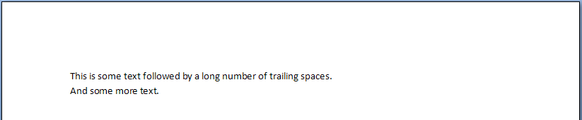

However, if this compatibility setting is turned on:

<w:[compat](compat.docx)>  
 <w:wrapTrailSpaces />  
</w:[compat](compat.docx)>

Then all trailing spaces would be handled as regular characters when line wrapping, resulting in the following output:

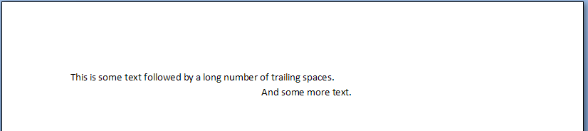

end example]

|  |
| --- |
| Parent Elements |
| [compat](compat.docx) (§) |

|  |  |
| --- | --- |
| Attributes | Description |
| val (On/Off Value) | Specifies a binary value for the property defined by the parent [XML](XML.docx) element.  A value of on, 1, or true specifies that the property shall be explicitly applied. This is the default value for this attribute, and is implied when the parent element is present, but this attribute is omitted.  A value of off, 0, or false specifies that the property shall be explicitly turned off.  [Example: For example, consider the following on/off property:  <w:… w:val="off"/>  The val attribute explicitly declares that the property is turned off. end example]  The possible values for this attribute are defined by the [ST_OnOff](ST_OnOff.docx) simple [type](type.docx) (§). |

The following [XML](XML.docx) Schema fragment defines the contents of this element:

<complexType [name](name.docx)="CT_OnOff">

<attribute [name](name.docx)="val" [type](type.docx)="[ST_OnOff](ST_OnOff.docx)"/>

</complexType>