**2040 Watershed Plan for Elm Creek River**

**Abstract**

Ballinger, TX is located within the County of Runnels and comprises about 35% of the population within. The city of Ballinger has a population density of 1,121 people per square mile and a total of 3,767 in 2010 (1) along with Winters, Texas at 2,562 in 2010 (2). Runnels county averages 9.99 people per square mile and a total population of approximately 10,501 (3). These two cities comprise the largest clusters of population within the Elm Creek watershed. Runnels County is a mixture of 65% white, 32% Hispanic or Latino, and less than two percent Black Non-Hispanic residents, with the county becoming increasingly “red” since 1996, when about half of the population voted Republican, in comparison to about two-thirds in the 2012 election (4). Using nearby San Angelo estimates of 131 Gallons per day (GPD)/per capita use in 2008 (5), estimates of the Total Annual Water Demand can be determined. As shown (Table 1), the projected Elm Creek watershed population of 21,002 can be multiplied by the per capita usage of 131 GPD to determine the daily water demand. Converting the daily water demand to acre feet per year yields 3,083 acre-feet/year. The USGS gage Elm Creek @ Ballinger (USGS 12090101) has a maximum monthly discharge (Q) of 21,400 cubic feet per second (cfs), a mean of 41.80 cfs, and a minimum monthly output of zero for multiple months, on a relatively consistent, yearly basis for the time period of 1934-2013 (Table 3).

The Elm Creek watershed area is managed by the Upper Colorado River Authority as Elm Creek drains directly into the Colorado, just southeast of Ballinger. The Lipan Aquifer is the single aquifer in the region, and is located to the southwest of the Elm Creek watershed, in the southwestern portion of Runnels County. The largest single land use in the county is agricultural with a total of 656,204 acres of which 264,780 acres is crop or farm land and the balance of 391,424 acres is range land (11). The Elm Creek watershed falls within Region F of the SB1 Groundwater Planning Areas for Texas, Groundwater Region 7, and the Lipan-Kickapoo Water Conservation District (Table 2). Elm Creek also falls within the West Texas Regional Groundwater Alliance. The primary public water source for the City of Ballinger is the O.H. Ivie Reservoir located southeast of Ballinger, on the Colorado River. Water is pumped to Ballinger from O.H. Ivie (outside the Elm Creek watershed) as opposed to using Lake Ballinger to the west, due to water quality issues. Water in Lake Ballinger must be heavily treated, and the disinfection process leaves high levels of Trihalomethanes. This substance can cause liver, kidney, or central nervous problems and has been associated with an increased risk of cancer. Ballinger has violated the legal limits for this substance 24 times (among some 28 EPA violations) over the span of six years (2005, 2006, 2007, 2008, 2009, 2010, 2011) with measurements of the contaminant Trihalomethane reaching as high as 191.2% above the legal limit (16). SWTR (Public water system with failure to filter) accounts for the four other EPA violations.

Runnels County ranks 169 out of 173 counties for water quality in the State of Texas (7). Ballinger (major city in Runnels) ranks 494 out of 500 water systems within Texas, and 7,953 out of 8,440 nationally for water quality (9). The public fresh water supply of Runnels is 1.49 million gallons per day/543.85 million gallons per year (8), with five percent from ground water and 95% from surface water. All recorded dangerous levels of contaminants (2010) have been within the Ballinger water system, totaling 24 times over the course of six years, from 2005-2011 (9). The largest use of land and water in Runnels County goes to agriculture needs followed by livestock grazing. “Historical annual pumping from the Lipan Aquifer has been based largely on the water levels in the aquifer at the beginning of the irrigation season. Each year, pumping depletes the aquifer to the point that it is no longer economical to continue… The amount of water available for pumping, therefore, varies depending on the amount of winter recharge (11).

The region has a naturally high level of nitrate, likely attributed to the degradation of vegetation (Jones, 1973). A high water table contributes to elevated nitrate levels in surface water during storm events, as the ground quickly becomes saturated and the aquifers in the area have low porosity. Appropriate dilution does not occur. The air quality within Runnels county is some of the poorest in the country (Figure 3) falling within the 70-80 percentile in comparison to other Texas counties for off-site transfers of chemical releases or waste generation. Runnels also ranks in the 60-70 percentile for Total production-related waste (Figure 3), with a sizeable mining and light manufacturing industries. No rivers or tributaries in the Elm Creek watershed (in Runnels) are listed under The Clean Water Act 303d or through exploration of the EPA data. There are also no fish consumption advisories within the Elm Creek watershed. Regulations for the Lipan-Kickapoo Water Conservation District serves as a government agency and adheres to The Clean Water Act as well as Texas Water Code. The district was created “to provide for the conservation, preservation, protection, recharge, and prevention of waste and pollution of the district’s groundwater and surface water,” (11)

**2040 Management Plan**

The Elm Creek watershed faces a unique array of issues. The largest single land use in the county is agriculture with a total of 656,204 acres of which 264,780 acres is crop or farm land and the balance of 391,424 acres is range land (11). The primary use of the Lipan Aquifer is for irrigation (agricultural) while rural domestic and livestock needs are secondary uses. “The typical irrigation practice in the area is to pump water held in storage in the aquifer during the growing season with the expectation of recharge of the aquifer during winter months.” (11).This practice is questionable as the region is arid with a high evaporation rate. Historically drought is a recurring issue for the Elm Creek watershed (Figure 1) and west Texas in general.

The flat geology of the Great Plains contributes to runoff and wind erosion. High discharge rates are experienced despite comparably small amounts of precipitation (Figure 2). The coefficient of determination (r-squared value) is weakly correlated. Precipitation acts as the independent variable while discharge (Q) acts as the dependent variable (Figure 4). A wide range of potential water temperatures is experienced due to climactic variables, streams and reservoirs at partial capacity, lack of vegetation, and potential for periods of no precipitation (Figure 6) that can last 3-5 months annually. The water table for the area is higher than normal partially causing the heavy salinity (chlorite/nitrate) issues in the area. Invasive saltcedar has significantly amplified this problem as a mature salt cedar can consume up to 200 gallons per day at full maturity, and also transpires chlorites (salts). Decades of poor agricultural practices and oil/gas exploration also affect salinity, but not heavily. . The trophic spectrum within the region suffers from this salinity as well, and complicates solutions as many endangered species must be accounted for (Table 4). Low annual precipitation leads to intermittent streams and tributaries throughout the watershed. Ballinger and most of the surrounding counties purchase public water from the Colorado River Municipal District. Evaporation and extended drought have left the O.H. Ivie Reservoir at fractional capacity (Figure 5). As of 2014, Ballinger was approved for $7.4 million in loans and $3.1 million in loan forgiveness by the Texas Water Development board, via the Drinking Water State Revolving Fund (10). Large stores of brackish water are available within west Texas and improving technology within desalinization and reverse osmosis systems allows more reliable access to these resources with better conversions ratios between energy input and output. Runnels County has undergone large transitions to drip irrigation over the last decade converting from water intensive and wasteful methods of irrigation, particularly furrow irrigation (11).

**Goals and Objectives**

The Elm Creek watershed and the surrounding areas need to utilize as many conservation, treatment, and runoff mitigation projects as possible to meet the supply needs of an increasing population. Surface water quality and drought should be monitored regularly in order to adapt plans and allocations appropriately. A primary factor to be monitored is the height of the water table. Excessive rain leads to high nitrate levels and can affect surface water many weeks after. Unfortunately methods such as rainwater harvesting are not financially feasible due to low mean annual precipitation. Conservation through precise metering and adequate usage must be carefully monitored to maximize available water resources. Although the area has a relatively stable population over the last decade, growth must be accounted for considering that agricultural and grazing production will be in higher demand and more strained, as climate change continues to effect the already arid, drought-ridden watersheds of west Texas, and the population of Texas continues to increase. Land-use changes may be necessary to adapt to extended periods of drought. The conversion of agricultural land to grazing land has potential to significantly reduce water consumption rates. With water usage from the Lipan aquifer dependent upon recharge during the winter months, water availability can vary each year. Projects to slow surface water during storm events and increase groundwater recharge using barriers of vegetation, or man-made structures to increase roughness and slow recharge to the Lipan aquifer and rivers should be considered in the mitigation process.

**Conclusions**

The Elm Creek watershed is fully allocated and may be an appropriate situation for a water market. The O.H. Ivie Reservoir (on the Colorado River) provides water to Ballinger and several surrounding watersheds, while also suffering from recurring drought itself. A water market could help to ensure proper and more even distribution of available resources, within the Elm Creek watershed and also with neighboring watersheds and counties. With a never-ending battle over water scarcity, it is concerning to read the Mayor of Ballinger (Sam Mallory) comment that “No. 1 is pray, pray, pray for rain,” (10) while historical data shows common reoccurrence of issues and future climactic data reveals trends towards less precipitation, extended drought, and increased extreme weather events. Water scarcity is an ongoing issue for the Elm Creek watershed and must be approached from many angles, including conservation, mitigation, water quantity and quality, as well as consideration for the many stakeholders involved. Innovations in desalinization may hold the key for the region, as brackish water is readily available but still costly. This filtered water must then still be mixed with freshwater, ensuring that the surface water issues of the region must be closely watched, regardless of innovation among desalinization technology.

**Table 1**

|  |  |  |  |  |
| --- | --- | --- | --- | --- |
| **2010 Population estimate for Elm Creek watershed** | **Projected 2040 Elm Creek watershed Population** | **Per Capita Usage 2010 (Gallons per day)** | **Total Water Demand (Gallons per day)** | **Annual Water Demand (Acre-feet per year)** |
| 10,501 | 21,002 | 131 | 2,751,262 | 3083.86 |

**Table 2**

|  |  |
| --- | --- |
| Major Aquifers | None |
| Minor Aquifers | Lipan Aquifer (outcrop) |
| Groundwater Management Area(s) | 7 |
| Groundwater Conservation District(s) | Lipan-Kickapoo WCD (11/3/87) |
| SB1 Regional Water Planning Area | Region F |
| River Authority | Upper Colorado River Authority |

**Table 3**

|  |  |  |  |  |  |
| --- | --- | --- | --- | --- | --- |
| **Mean Discharge (Q)** | **Standard Deviation** | **Median Discharge**  **(Q)** | **Minimum Discharge (Q)** | **Maximum Discharge (Q)** | **TX Surface Water Quality Standard** |
| 41.80 cfs | 385.51 | 1 cfs | 0 cfs | 21400 cfs |  |

**Table 4** (6)

**Runnels County, TX Endangered Species List**

|  |  |  |  |
| --- | --- | --- | --- |
| **Name** | **Trophic type** | **Federal Status** | **State Status** |
| American Peregrine Falcon | Bird | DL | T |
| Arctic Peregrine Falcon | Bird | DL | None |
| Baird’s Sparrow | Bird | None | None |
| Bald Eagle | Bird | DL | T |
| Black-capped Vireo | Bird | LE | E |
| Ferruginous Hawk | Bird | None | None |
| Interior Least Tern | Bird | LE | E |
| Mountain Plover | Bird | None | None |
| Peregrine Falcon | Bird | DL | T |
| Sprague’s Pipit | Bird | C | None |
| Western Burrowing Owl | Bird | None | None |
| Western Snow Plover | Bird | None | None |
| Whooping Crane | Bird | LE | E |
| Guadalupe bass | Fish | None | None |
| Black-tailed prairie dog | Mammals | None | None |
| Cave myotis bat | Mammals | None | None |
| Gray wolf | Mammals | LE | E |
| Red wolf | Mammals | LE | E |
| Creeper (squawfoot) | Mollusks | None | None |
| Smooth pimpleback | Mollusks | C | T |
| Texas fatmucket | Mollusks | C | T |
| Texas fawnsfoot | Mollusks | C | T |
| Texas pimpleback | Mollusks | C | T |
| Concho water snake | Reptiles | DL | None |
| Spot-tailed earless lizard | Reptiles | None | None |
| Texas horned lizard | Reptiles | None | T |
| Irion County wild-buckwheat | Plants | None | None |
| Texas poppy-mallow | Plants | LE | E |

**Table 4**

|  |  |  |  |
| --- | --- | --- | --- |
| Water body | Chemical of Concern | Species | Consumption Advice |
| O.H. Ivie Reservoir | None | None | None |

**Table 5**

|  |  |  |  |
| --- | --- | --- | --- |
| **Groundwater Conservation District** | **Available Groundwater Model (acre-feet per year)** | | |
|  | **Minimum** | **Maximum** | **Average** |
| Lipan-Kickapoo | 21,587 | 52,003 | 41,265 |

**Figure 1**

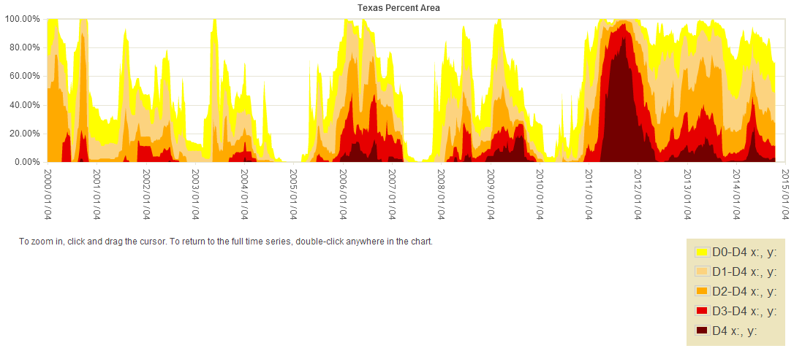

**Figure 2**

**Figure 3**

(<http://scorecard.goodguide.com/env-releases/ranking.tcl?fips_county_code=48399&comparison=st>)

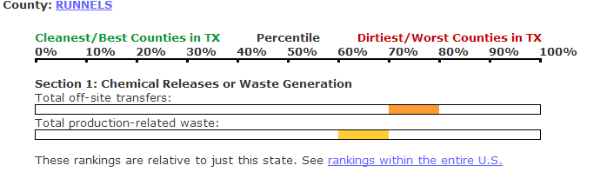

**Figure 4**

**Figure 5** (14)

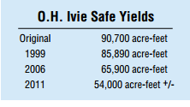

**Figure 6**

# Works Cited

**1.** factfinder2. [Online] Census, U.S. Government.[Cited: November 20, 2014.] http://factfinder2.census.gov/faces/nav/jsf/pages/community_facts.xhtml.

**2.** factfinder. [Online] U.S. Census.[Cited: 11 20, 2014.] http://factfinder2.census.gov/faces/nav/jsf/pages/community_facts.xhtml.

**3.** John Hall: roadsidethoughts. [Online] Last modified 10/28/2014.[Cited: November 20, 2014.] http://roadsidethoughts.com/tx/county/runnels-census.htm.

**4.** City-data. [Online] Onboard Informatics.[Cited: November 20, 2014.] http://www.city-data.com/county/Runnels_County-TX.html.

**5.** Population and Water Demand Projections. [Online] Water for Texas 2012 State Water Plan.[Cited: November 21, 2014.]

**6.** Texas Parks and wildlife Department. [Online] Texas Parks and Wildlife Department, 4200 Smith School Road, Austin, TX 78744.[Cited: November 23, 2014.] http://www.tpwd.state.tx.us/gis/ris/es/ES_Reports.aspx?county=Runnels.

**7.** Water Delivery. [Online] [Cited: 11 28, 2014.] http://www.water-delivery.org/WaterQuality/Runnels_County/Texas/.

**8.** city-data. [Online] Onboard Informatics.[Cited: 11 28, 2014.] http://www.city-data.com/county/Runnels_County-TX.html.

**9.** Water Delivery. [Online] [Cited: 11 28, 2014.] http://www.water-delivery.org/WaterQuality/Ballinger/Runnels_County/Texas/City_Of_Ballinger.

**10.** Monique Ching. *gosanangelo.com.* [Online] [Cited: November 28, 2014.] http://www.gosanangelo.com/business/ballinger-gets-105-million-for-water.

**11.** 2010, Hutchison et AL., *Lipan-Kickapoo Water Conservation District Management Plan 2013-2018.* s.l. : [Online] W.R., GAM Run 10-002: Texas Water Development Board, GAM Run 10-002 Report, 8 p. [Cited: 11 28, 2014.].

**13.** lipan-kickapoo.org. [Online] 2010, Hutchison.[Cited: 11 28, 2014.] http://lipan-kickapoo.org/FILES/Management_Plan/Adopted_-_Approved_Management_Plan_2013.pdf.