Virtual Water: TPP Implications for Texas Resource Management and the Beef Cattle Industry

By: Chad Lengefeld

Water Policy, Mr. Russell Johnson

**Objective**

* Analyze U.S. Trans-Pacific Partnership (TPP) in the context of trade agreements with Texas, particularly beef exports
* Look at potential effects/controversies of the TPP in the context of Chapter 36 of the Texas Water Code.
* Defining virtual water, how water footprint is calculated.
* Defining Concentrated Animal Feeding Operations, cattle production methods and their results in the context of water consumption and regulation.
* Discuss Texas Ground Water Conservation Districts

The U.S. Trans-Pacific Partnership (TPP) is the largest economic treaty in history, involving nations that represent more than 40 percent of the world’s GDP. The U.S. and 11 other countries: Australia, Brunei, Canada, Chile, Japan, Malaysia, Mexico, New Zealand, Peru, Singapore, and Vietnam, are negotiating agreements that will “support economic growth and jobs by removing trade barriers for goods and services, improving intellectual property protection, and creating new 21st century trade rules.” (1)However, the TPP has been extremely controversial, and widely described as secretive trade deals that give power to corporate entities beyond the laws and regulations of countries, to work within a framework of regulation that protects businesses and allows for governments to be sued by corporations. The TPP was initially conducted in secrecy, until November of 2013 when Wikileaks.org released a draft of the Intellectual property rights chapter of the November 2013 summit in Salt Lake City, Utah. “Access to drafts of the TPP chapters have been shielded from the general population, while members of the U.S. Congress are only able to view selected portions of treaty-related documents in highly restrictive conditions and under strict supervision. It has been previously revealed that only three individuals in each TPP nation have access to the full text of the agreement, while 600 ‘trade advisers’ – lobbyists guarding the interests of large U.S. corporations such as Chevron, Halliburton, Monsanto, and Walmart – are granted privileged access to crucial sections of the treaty.” (3). The chapter that was published was considered very controversial, in that it mapped out the implications that the trade agreements would have on medicines, internet services, publishers, civil liberties, and biological patents.

The TPP involves the United States and 11 other countries that are negotiating to “strengthen trade and investment relationships across the Asia-Pacific region.” (1*).* The pending partners of the TPP as well as the current free trade agreement partners have resource implications for Texas that are substantial. In this context, the TPP is proposed to expand trade between Texas and six current U.S. free trade agreement (FTA) partners, open new markets to five other countries that are not currently FTA partners, and increase investment ties between Texas and the TPP countries.

In 2011, trade – exports and imports of goods and services -- with TPP countries supported an estimated 1,160,100 jobs in the state of Texas. (*4)* An estimated 1,121 Texas businesses are subsidiaries of companies based in TPP countries – serving as an important source of business investment and job creation in the state. (*5)* In 2012, Texas exported approximately $7.1 billion worth of goods to the new TPP countries, (Japan, Vietnam, Malaysia, Brunei, New Zealand). Exported products include basic chemicals, semiconductors and components, communications equipment, petroleum and coal products, resins and synthetic fibers, as well as “other” exports, such as agricultural, which comprise $3.4 Billion, or 48% of total exports (Figure 2). These countries currently charge high tariff rates and other barriers with certain exports. For example, beef products are charged a 38.5 % tariff rate as exports from Texas to Japan.

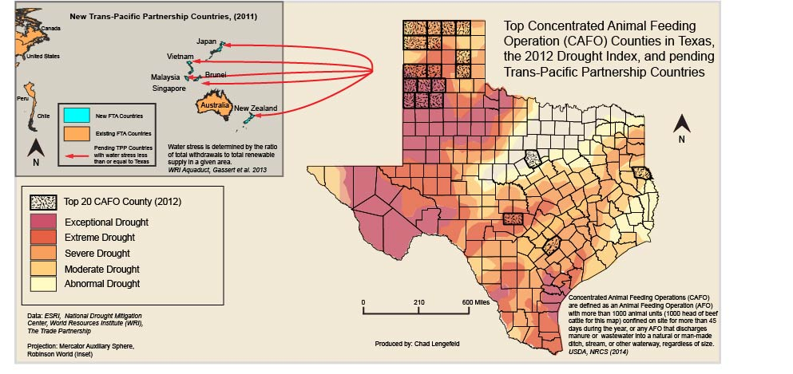

Figure 1.

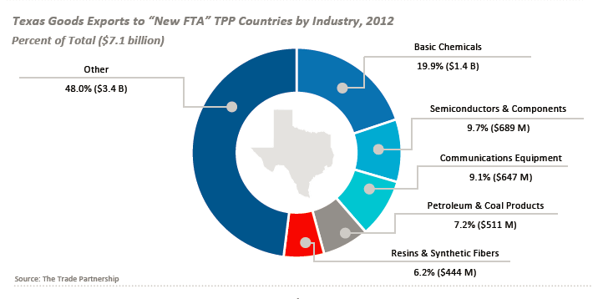Figure 2

**TPP in the context of Chapter 36 of the Texas Water Code**

The TPP trade agreements may potentially have negative effects on the water resources of Texas. According to 36.117 of the Texas Water Code, there are exemptions of rules to obtain a drilling permit for drilling or operating wells used solely for domestic or livestock or poultry, located on tract larger than 10 acres.” The implications of this in the context of increased exports point to more water loss in the Texas ecosystem to new TPP countries, several of which are at a low level of water stress in comparison to Texas, according to the 2015 Global Water Scarcity Index. These new TPP countries include Japan, Vietnam, Malaysia, Brunei, Singapore, and New Zealand. (Figure 1). From the resource management and conservation perspective, the transportation of water (via products) requires a significant amount of energy as the products make their way to these Pacific countries. In addition to the movement of water from areas of higher water scarcity, as well as higher potential for water conflict in Texas than these other countries, these trade agreements may have some significant negative impacts on Texas resources, as well as the possibility to increase drought intensity on a long-term scale. Unfortunately, resource management, conservation, and virtual water movement do not seem to be part of the documentation available concerning the TPP.

“Virtual water is the water needed to produce agricultural commodities. The concept could be expanded to include the water needed to produce non-agricultural commodities.” (Allan 2003) Total water self-sufficiency requires that a national economy has sufficient local water to provide drinking water, domestic water, water for industry and services, and water for food and other essential agricultural production. Since the late 1970s, and especially since the early 1990s, self-sufficiency has also included – at least in the best managed economies – an explicit allocation to support the environmental services underpinned by water in the environment. (Allan, 2003)

The water footprint of beef has been a contentious subject for some time. Several factors make a difference in calculating the amount of water that it takes to produce a pound of beef, including direct consumption, irrigation of pastures and crops, carcass processing, and transportation (if export costs are being considered). According to the Texas Farm Bureau, “It takes 2.6 pounds of grain and 435 gallons of water to produce a pound of beef in the U.S.” (Texas Farm Bureau 2015) Other estimates have ranged significantly higher. More recent studies imply that the main factor in the water footprint of beef concerns the diet of the animal, as feeding of crops may imply a significantly higher water use than grazing. Considering that cattle and calves were the top U.S. commodity for Agricultural Cash Receipts ($49.1 billion) and top Texas commodity for Agricultural Cash Receipts ($7.4 billion), understanding the resource implications is an important step. According to the 2012 Drought Severity Index for Texas, the area that contains the highest concentrations of CAFO’s lie within the most exceptionally drought ridden areas in the panhandle region of the state such as Deaf Smith County, with the highest concentration of Beef CAFO’s. (Figure 1)

**Virtual Water**

The term of “virtual water” was first coined at a University of London, School of Oriental and African Studies meeting (SOAS) around 1993 by J.A (Tony) Allan of the SOAS/King’s College London, Water Research Group. The term was preceded by the use of “embedded water” (Allan 1993; 1994), which was not well accepted by the water management community. “Virtual water is the water needed to produce agricultural commodities. The concept could be expanded to include the water needed to produce non-agricultural commodities.” (Allan 2003) Total water self-sufficiency requires that a national economy has sufficient local water to provide drinking water, domestic water, water for industry and services, and water for food and other essential agricultural production. Since the late 1970s, and especially since the early 1990s, self-sufficiency has also included – at least in the best managed economies – an explicit allocation to support the environmental services underpinned by water in the environment. (Allan, 2003). As we learn more about the distribution of water through the human need/geographic location complex, considerations for an alternate approach may need to be made, especially for locations such as Texas, where intermittent drought issues, paired with the implications of continued global climate change, and several of the fastest growing cities in the nation, are all increasing stress on water resources.

Virtual water falls within the realm of what Allan calls the water, food, and trade nexus, as defined in his paper “Virtual Water – the Water, Food, and Trade Nexus; Useful Concept or Misleading Metaphor?” The major indicator of the scale of the water deficit of an economy is the level of its food imports. The reason food imports are such a strong indicator of water deficit is that the water required to raise food is what an economist would refer to as the dominant consumptive use of water. The use is dominant whether viewed from the point of view of the individual citizen or the national economy. Water used in the agricultural sector exceeds by ten times the water used by the industrial and municipal sectors combined… An individual needs each year only one cubic meter of drinking water, between 50 and 100 cubic meters for other domestic uses, though a much lower actual use is the norm in many rural communities in countries in other regions, for example in the economies south of the Sahara. By contrast an individual needs each year at least 1000 cubic meters of water, either naturally occurring in soil profiles, or transported to the profiles by irrigation systems, to raise the food needs for that individual. “At the national level over 90 per cent of all national water budgets are devoted to the agricultural sector.” (Allan, 1997, Virtual Water Issues Study Group, Occasional Papers). Texas follows this trend, devoting the largest portions of water to agricultural and ranching, however, deviates from the standard framework in some ways.

|  |
| --- |
| **Individual water use—cubic meters/year** |
|  |
| **Figure 1** |

**Allan, 1997, Virtual Water Issues Study Group, Occasional Papers**

“The Texas economy is the second largest in the U.S. totaling $1.65 trillion, and is ranked first for current economic climate, due to the second fastest job and economic growth over the past five years. In addition, there are 121 out of the 1,000 largest publicly and private companies in the U.S. based in Texas, including giants like AT&T, ExxonMobil, and Dell.” (Forbes, October 2015). Texas leads the U.S. in cattle, hay, sheep, goats, and mohair production, with 248,800 farms and ranches covering 130.2 million acres. Agricultural exports from Texas totaled $6.5 billion in 2012, with beef comprising $855 million of the export total, second only to cotton and cottonseed comprising 1.6 billion. 90% of all beef cattle are finished at Concentrated Animal Feeding Operations (CAFO) in Texas, which are defined as feedlots with more than 1,000 animal units confined to a site for more than 45 days during the year, or discharges manure or wastewater into a natural or man-made ditch, stream, or other waterway, regardless of size. (6)

Concentrated Animal Feeding Operations are regulated by several groups, including the TCEQ Chapter 321, Texas Health and Safety Code, EPA, and the Texas Water Code (Chapter 26, Chapter 3, and Chapter 305 (relating to Definitions and Consolidated Permits). (7) The TWC policies state that any animal feeding operation (AFO) that the executive director designates and requires to be authorized by an individual water quality permit to achieve the policies and purposes enumerated in TWC, 5.120 and 26.003.

CAFO’s can only be constructed, operated, or altered with either a prior authorization through an individual water quality permit or a CAFO general permit, unless otherwise authorized by the commission under TWC, 26.027.

**The cycle of beef production**

The beef industry is comprised of several different sectors that contribute to the final product, as well as a few different methodologies for methods of beef production. Beef cattle are defined in four different categories:

* Cows (for beef)
* Heifers, bulls, and young bulls
* Calves
* Dairy Cows

These distinctions are important, as the processes involved in meat production are generally segmented amongst different types of farms and may utilize varying ages, feeds, and holding times. These attributes also vary based on the type of production system being used. There are currently three types of beef production system choices, conventional, natural, and grass-fed.

Conventional production systems consist of an extensive pasture-based system in which calves are weaned (calf-fed) from their mothers for 7 months. After weaning or at 12 months of age (yearling-fed), the animals are then moved to a feedlot. Production enhancing technologies are utilized in each sector of the conventional system.

Enhancing technologies may include:

* Ionophores- a specific type of antibiotic that improves feeding efficiency. Cattle may gain more weight than cattle without ionophores, while utilizing the same proportion of feed.
* Implants- several types of implants are available, including estrogenic and androgenic agents (hormone related growth factors)
* MGA- melengestrol acetate, a feed additive that is labeled for increased rate of weight gain, improved feed efficiency and suppression of estrus (heat) in heifers fed for slaughter. The compound has natural steroidal effects, as the structure appears similar to progesterone.
* β-agonists- growth promoting feed additives, generally utilized as a finishing additive before slaughter.

Natural production systems are identical to conventional systems, however production enhancing technologies are not used. Grass-fed systems use an extensive, pasture-based system from the birth of cattle to slaughter, and also do not utilize any production-enhancing technologies. The drawback to this method lies with the time to produce a carcass in comparison with conventional methods, as well as the finished carcass weight. Longer production time and lower animal yield are important economic considerations for resource management, and unfortunately grass-fed beef is not as sustainable in comparison with conventional methods.

While the use of various enhancing technologies is a contentious subject among consumers, it is important to note the variance in production capability that occurs between methods. “In 1977, it took five animals to produce the same amount of beef as four animals in 2007.” (2). Average beef yields per cow slaughtered was 603 lbs. in 1977, while the average yield in 2007 was 773 lbs. This significant increase is attributed to enhancing technologies. While these methods may be under question, it is clear that higher yield per animal can reduce the amount of arable land necessary to support cattle, as less animals produce higher yields. Between 1977 and 2007, beef per animal production increased by 31%, the number of animals decreased by 30%, feed intake reduced by 19%, water use reduced by 12%, and land use reduced by 33%. The reduction in the number of animals and feed intake led to an 18% decrease in manure as well as methane (CH₄), a 12% decrease in nitrous oxide (N₂O) and a 16% decrease in the total carbon footprint of beef cattle production. Another factor to consider is the differences in carcass weight and days to slaughter between the methods of cattle production. Conventional methods produce approximately 800 lb. carcass in 444 days (to slaughter) while grass-fed methods produce approximately 615 lb. carcass taking 679 days (to slaughter). Natural methods produce approximately 714 lb. carcass at 464 days (to slaughter). This is a difference of 115 lbs. and 235 days in production times between conventional and grass-fed methods (the two ends of the spectrum). “If all U.S. beef was grass-fed, it would increase:

* Land use by 131 million acres = 75% land area of Texas
* Greenhouse gas emissions would increase by 134.5 million tonnes CO₂ -eq, Equal to annual emissions from 26.6 million U.S. cars
* Water use by 468 billion gallons, equal to annual usage by 53.1 million U.S. households

(2) Capper, J. L.

Overall, conventional methods offer more production with less environmental degradation and lower resource use than natural and grass-fed methods, important factors as human populations swell and middle-income families increase throughout different regions of the world.

**Beef and Water**

The main uses of water in conjunction with beef cattle production are direct intake from animals, and irrigation of crops used as feed. Land, fertilizers, and fuel are other important inputs in the cattle production process. Greenhouse gases (CO₂, CH₄, N₂O), nutrient excretion, and manure are the primary waste outputs of cattle production. All three may affect water resources. Weather patterns in Texas often involve intense storms and flash flood events. When these events occur, excreted nutrients and manure may conglomerate and enter water bodies and reach local or regional water supplies in measurable amounts.

If cattle are grain-fed, a significant increase in the water-footprint of the animal occurs in comparison to grass-fed. However, grain fed cattle are harvested at a higher carcass weight, and in a shorter time period than those on a grass diet. Embedded water estimates for a pound of beef have varied largely over the last two decades, as the concept has evolved over the same time period. The beef industry promotes a study that claims 441 gallons/pound of beef, with some questionable calculation methods. Other more accurate estimates include 1,850 gallons/pound [Mekonnen and Hoekstra (2010)] and 12,009 gallons/pound (Pimentel et Al., *Ecological Integrity: Integrating Environment, Conservation and Health,* 2001). The amount of water needed per pound of beef still remains a point of contention, with Prince Charles himself proclaiming in 2011 that “For every pound of beef produced in the industrial system, it takes two thousand gallons of water.”

**Groundwater Conservation Districts**

Groundwater Conservation Districts (GWCD’s) complicate water in Texas significantly. The history of groundwater regulation began in 1996, with the Edwards Aquifer Authority. In 1997 with the passing of Senate Bill 1, GWCD’s gained the power to shape groundwater regulation in Texas. Some of the most important concepts are

* Regulation of spacing
* Authorizations based on acreage (with Municipalities taken into account)
* Regulation of production by well
* Production regulation based on historical 20 year usage

Often, the members that comprise the boards of the GWCD’s are those that are most intimately affected by the uses of water. In Texas, that largely involves the agricultural sector, and cattle farming. On the face of the GWCD concept, having local members involved and controlling the distribution and usage of water is a good idea. Yet, when members of these boards may have a personal economic stake in the matter it becomes questionable. These boards will deny transfers and wells (through litigation) to companies and industry who desire to develop these resources. An interesting point to be made involves Section 36.122 of the Texas Water Code, which gives power to GWCD to transfer water and charge up to a 50% fee for transfers outside of the district. An argument could be made that on their face the GCD’s are there to protect the resource as their primary goal, but often they may be protecting the resource in conjunction with their needs. These groups are often staunchly against out of basin transfers, yet these same agricultural, and particularly cattle ranchers, sell their product to market, which is then destined for urban locations that are largely out of basin and often outside of the state, as well as progressively outside of the country. Companies that bottle water, for instance, wish to develop some water resource in order to produce and sell the product across the state. Water is not generally transferred out of state for sale, as the transportation costs associated with this are very high. The GWCD’s battle these companies and industries to prevent them from using and transporting these resources, yet many of the GWCD’s constituents are cattle farmers who themselves will then export their beef outside of the state, and also outside of the country (such as the TPP countries). One could easily argue that the water leaving the state through export is more detrimental to the region as a whole in comparison with bottled water transfers within the state, distributing their product amongst the various basins, yet maintaining the water within the borders of the state.

**Conclusions**

Texas is deeply involved in trade throughout the world. Free trade agreements, as well as pending Trans-Pacific Trade agreements encompass large economic, environmental resource and sustainability, and sociological perspectives that must be addressed, yet the trade agreements focus heavily on the economics and comparably little focus on the latter issues. 36.117 of the Texas Water Code describes the exemptions on water permits for cattle needs (non CAFO) and otherwise allows them to use water in an unregulated manner. Food is the largest factor in water use by societies. Water embedded within beef has had a variety of estimates over the last several decades. With improvements in methodology, estimates now trend towards 14,000 – 18,000 gallon/pound of beef. Much of this variability lies within the technique used to raise the cattle; conventional, natural, or grass-fed. While conventional methods use water intensive grains for food, the carcass weight and time of production are significantly better than the grass-fed method, as far as water use and economic viability are concerned. Land, fertilizer, and fuel are all important production aspects that require resources, but also must be regulated properly to prevent environmental issues such as waterbody contamination due to excess fertilizers or tailing pond issues. GWCD’s are powerful groups in several of the largest cattle production areas of Texas. They have been given the power to regulate and create laws within their districts, yet this is somewhat of a double edged sword if members of these boards have their own economic interest in the situation, such as with farmers and ranchers.

As Texas exports of beef are projected to increase by more than 10 million by 2017, we must consider if trade deals such as this are truly beneficial to Texas. Much of this exported beef will end up in countries that are at significantly lower chance for water scarcity issues than Texas, such as Japan, Vietnam, Malaysia, Brunei, Singapore, and New Zealand. If economic factors must always be the primary driver of change, perhaps considering the lack of economic sustainability for moving water resources from areas of high scarcity to lower scarcity on the long term is an approach that should be considered. With the steady growth in population worldwide and in Texas, climate change implications, and continued export of embedded water, Texas faces some serious questions that must be addressed. When will environmental importance catch up to economic gain? A more encompassing perspective on water must be applied so that we value our resources for the better of civilization at large, and I would infer that moving water around the world in order to fulfill the desires of growing middle classes, (such as year round vegetable and fruit access, and of course increased beef consumption) may be economically detrimental in the long term, and most surely not beneficial to the environment of Texas.

Not all waters are equal: some waters are more evident, more accessible, more manageable, more costly and more economically valued, more integral to society, more political, more multi-functional, more conflictual, more negotiable, and more prone to litigation than others. ‘The innovator makes enemies of all those who prospered under the old order, and only lukewarm support is forthcoming from those who would prosper under the new’. Machiavelli, N, 1513, *The Prince.*

**Citations**

1) Business Roundtable, A TPP Agreement: An Opportunity for Texas

2.) Capper, J. L. (2011). The environmental impact of U.S. beef production: 1977 compared with 2007. *Journal of Animal Science*

3) <https://wikileaks.org/tpp/pressrelease.html>

4) The Trade Partnership using the Global Trade Analysis Project mode. Note: 2011 is the most recent year available for services export data; services export data are not available for all TPP countries. “Goods’ refers to all goods, including agricultural goods, manufactured products, and raw materials.

5) Uniworld BP, Directory of Foreign Investment in the United States

6) USDA, NRCS (2014)

7) Texas Commission on Environmental Quality, Chapter 321.31 – 321.47 – Control of Certain Activities By Rule, *2004*