Andrew Estrada, Jason Luttrell, Anthony Nguyen

​​CSD200-T301

Module 111 Milestone 2 Reports

2/23/25

Employee Work Hours:

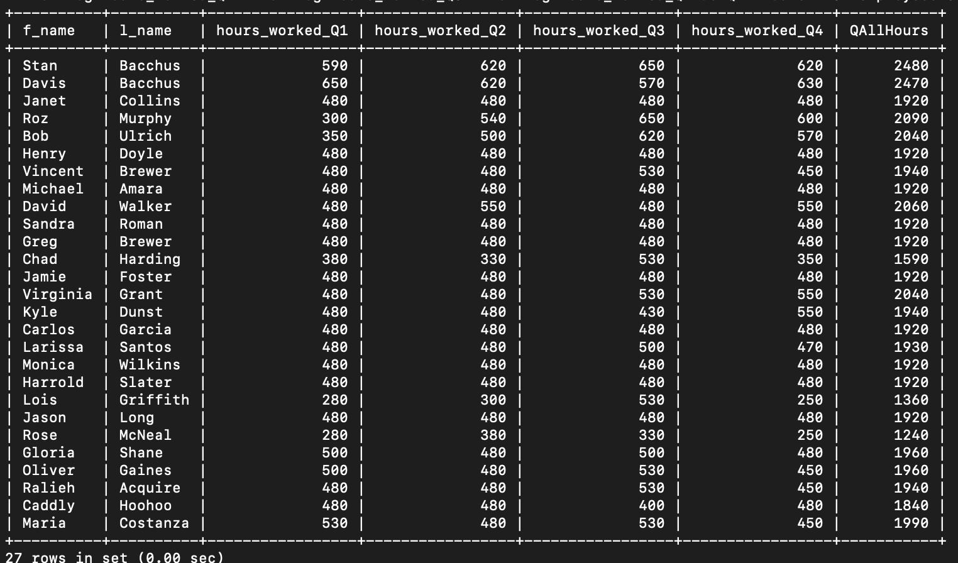

-currently the CEOs are contributing the most amount of hours

-those with the least amount of total recorded hours are not full-time employees

-Q1 has the least amount of hours

Suppliers:

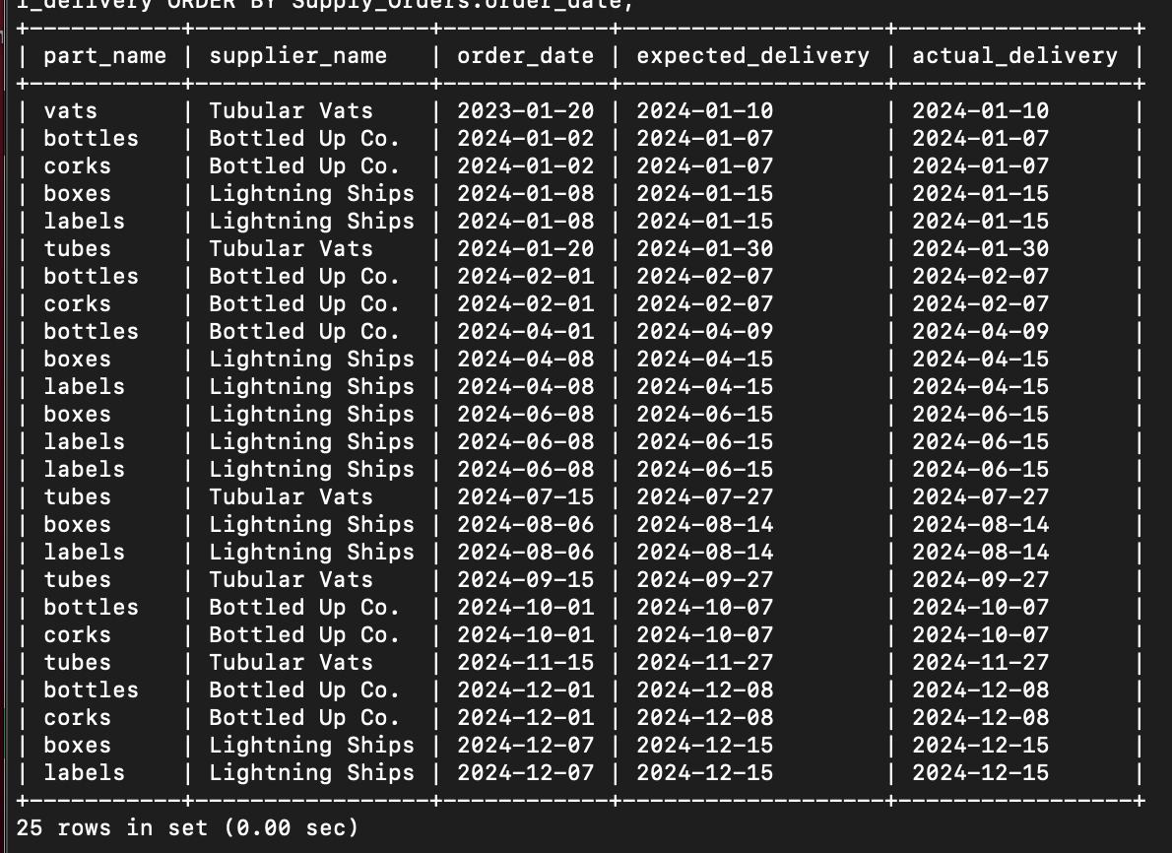

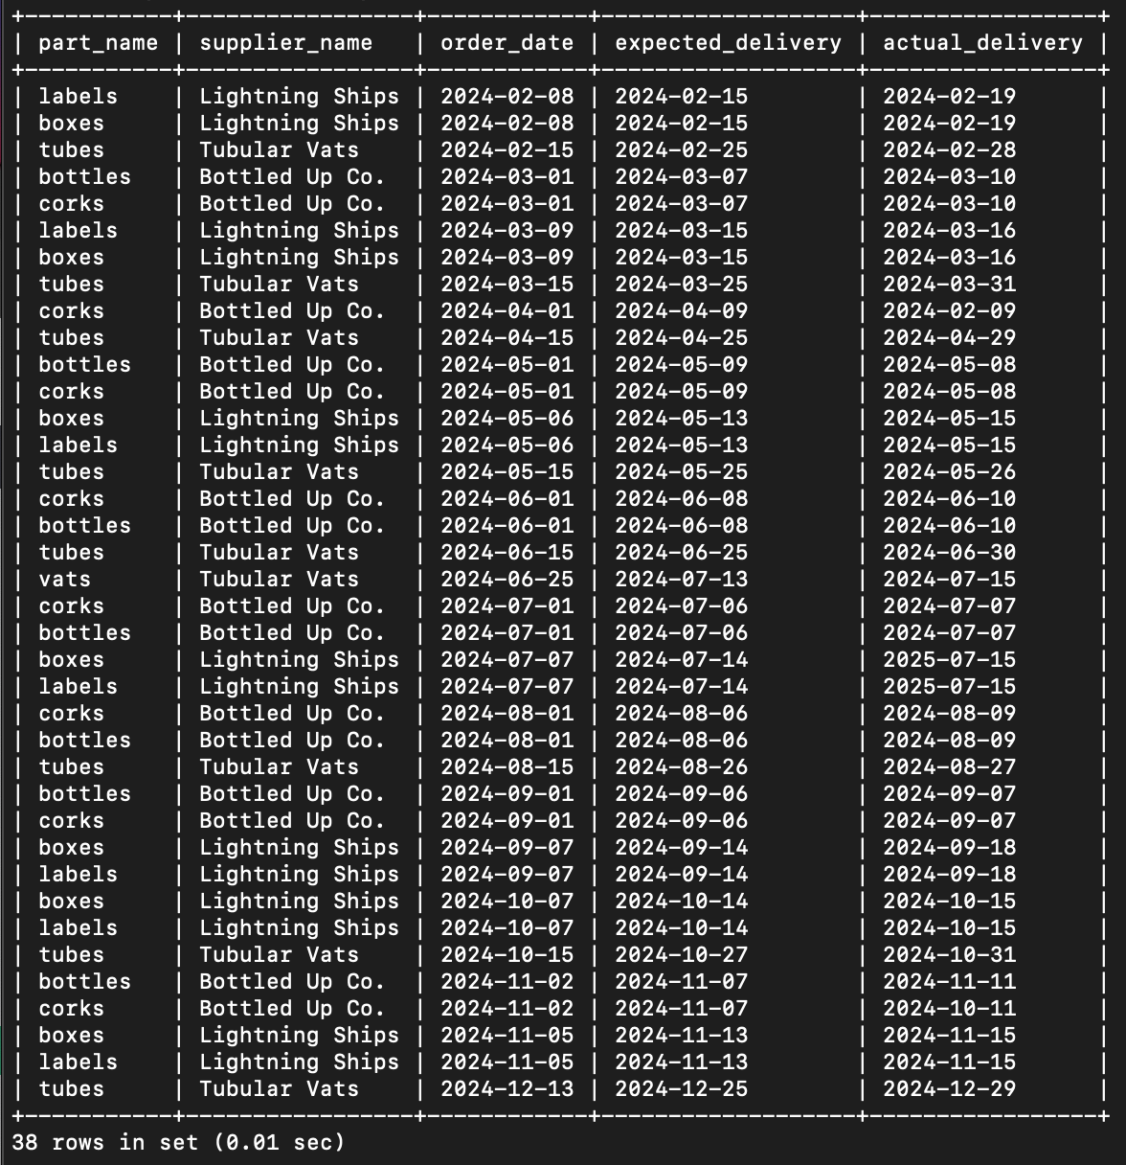

-25 deliveries on time, 38 late

-Lightning Ships and Bottled Up Co. have the most late arrivals

-we suspect problems with the trucks themselves or the delivery routes.

-January has the most amount of on-time deliveries; all deliveries in May are late

-late deliveries were at most 4 days late

Wine Distribution:

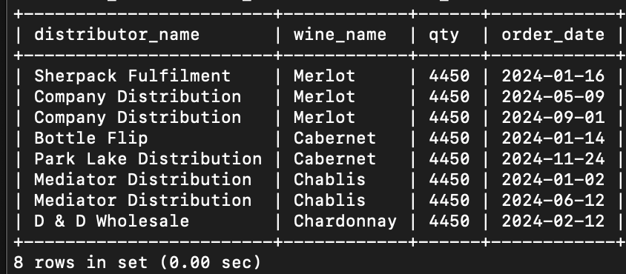

-merlot is extremely popular, chardonnay is not quite selling

-possible distribution contract needed to expand

-Sherpack and Company carry Merlot, Bottle Flip and Park Lake carry Cabernet, D & D carrie Chardonnay, Mediator carries Chablis

-Cabernet popular in cold season

-plan for Merlot in the warm season, Chardonnay in the spring season