diagram

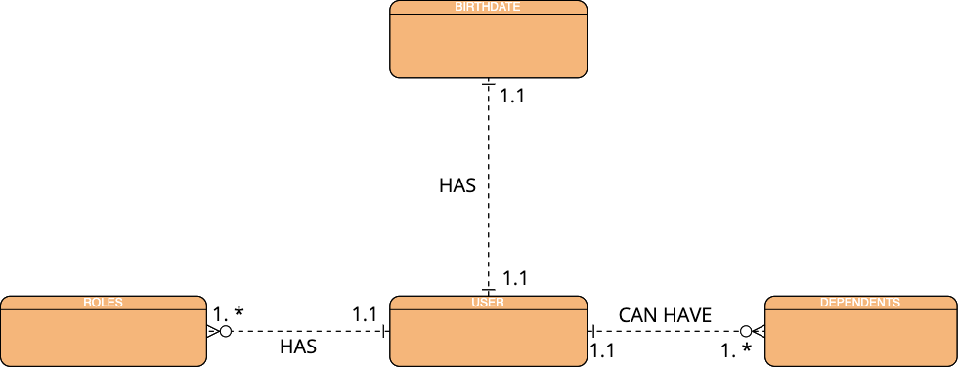

Example structure from diagram:

{

user: "Dipu Shitte",

birthday: {

month: "February",

day: "7",

year: "2000"

}

roles:[

{

job: "software developer",

salary: "$110,000"

start_date: "January 5, 2022"

end_date: "current"

}

{

job: "pharmacy technician",

salary: "$44,000"

start_date: "May 9, 2018"

end_date: "December 2, 2021"

}

]

dependents:[

{

id: "001",

name: "John"

}

{

id: "002",

name: "Joe"

]

}