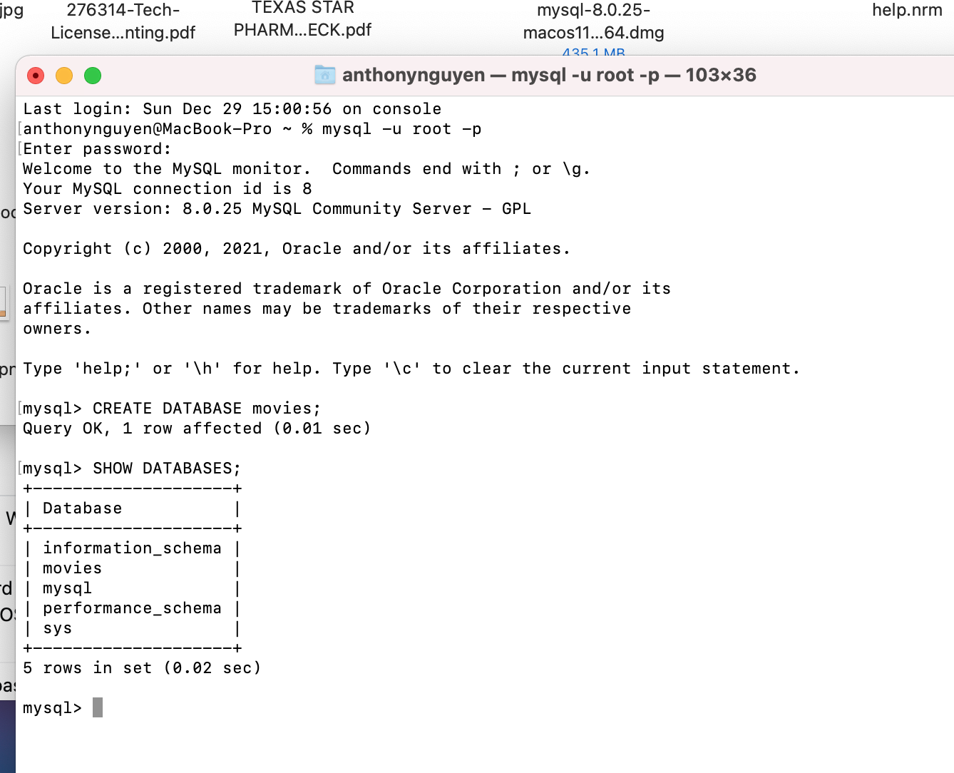

I did not use MySQL Workbench for this assignment. I may regret that…