Anthony Nguyen, Assignment 5.2

Function: CURRENT_USER() - capture the username and host name for the MySQL account currently being accessed

Uses: check if the user has appropriate access (during work hours, access privileges, etc.)

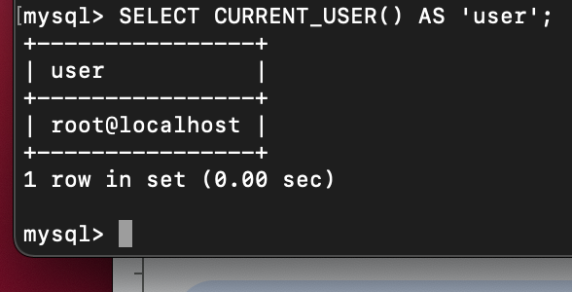

Function: FORMAT() - round a number to the specified number of decimal places

Uses: pricing related (tax, payroll, average spend, etc.)

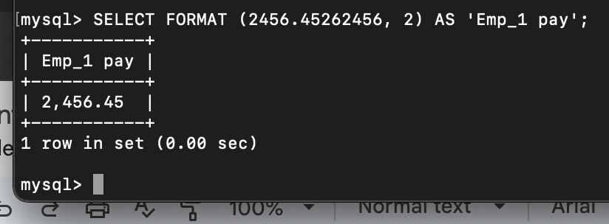

Function: NOW() - returns current date and time at time of function call

Uses: capture timestamp of certain database-related activities

