Anthony Nguyen, Assignment 6

After running db_init_2022.sql:

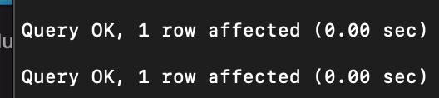

After showing tables in SQL:

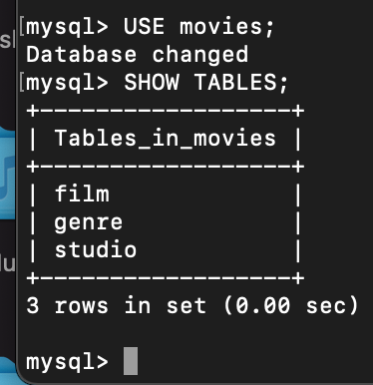

After running mysql_test.py

