The films table before running the program: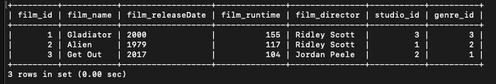

—-----------------------------------------------------------------------------

The output while running the program:

-running show_films for the first time

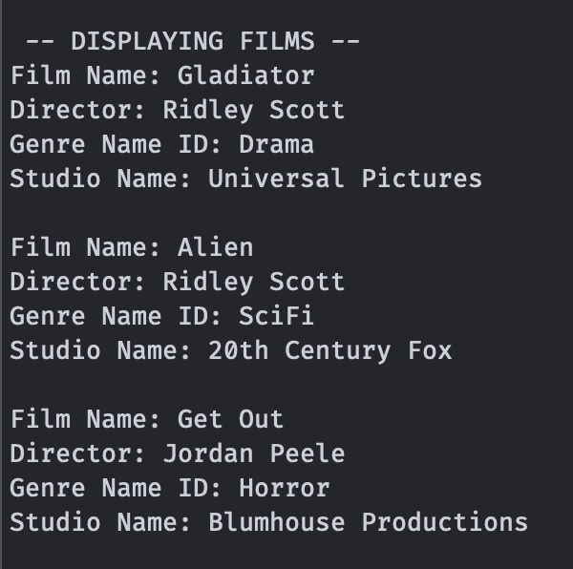

-running show_films after insert:

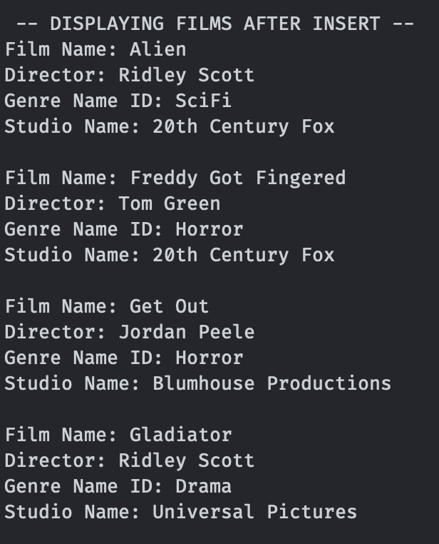

-running show_films after changing an attribute:

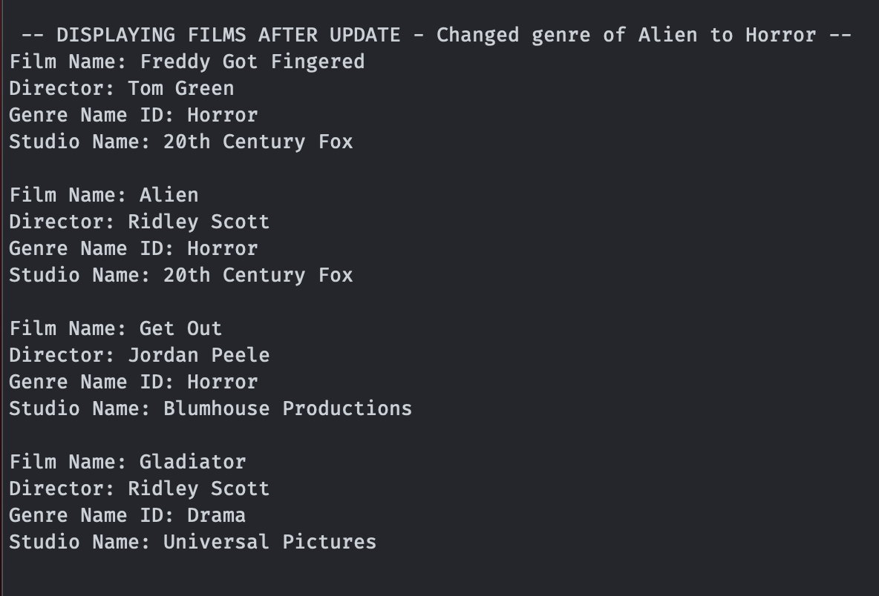

-running show_films after deleting a record:

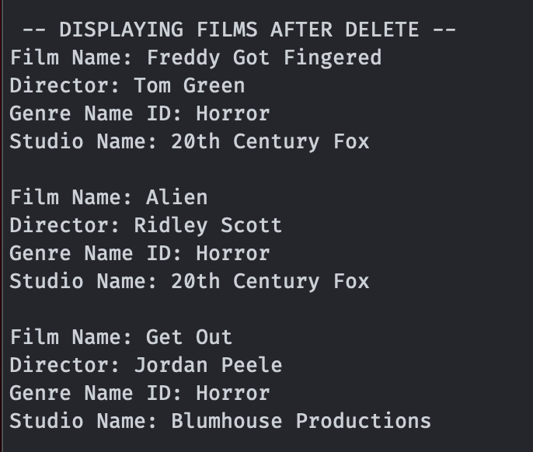

—------------------------------------------------------------------------

The films table after running the program:

