Anthony Nguyen, assignment 10

The program, without modifications:

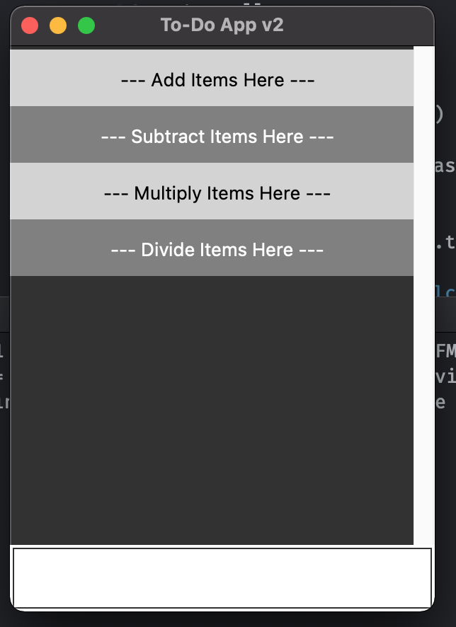

The program, with modifications (adding tasks only):

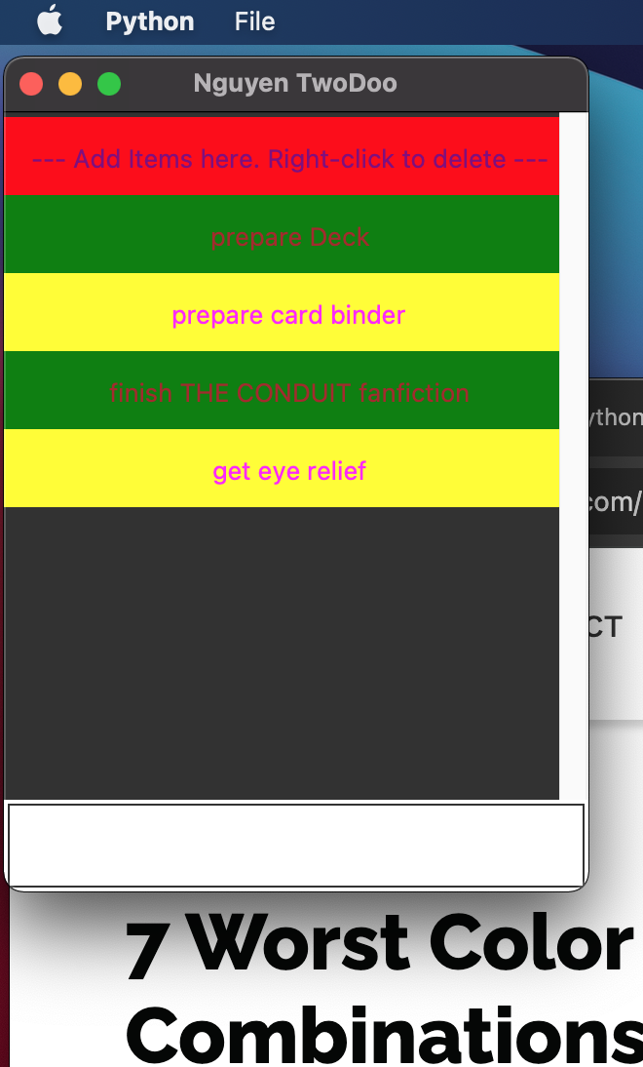

The program, with modifications (deleting a task):

