Anthony Nguyen, Assignment 11

Screenshot before altering the urls and views page:

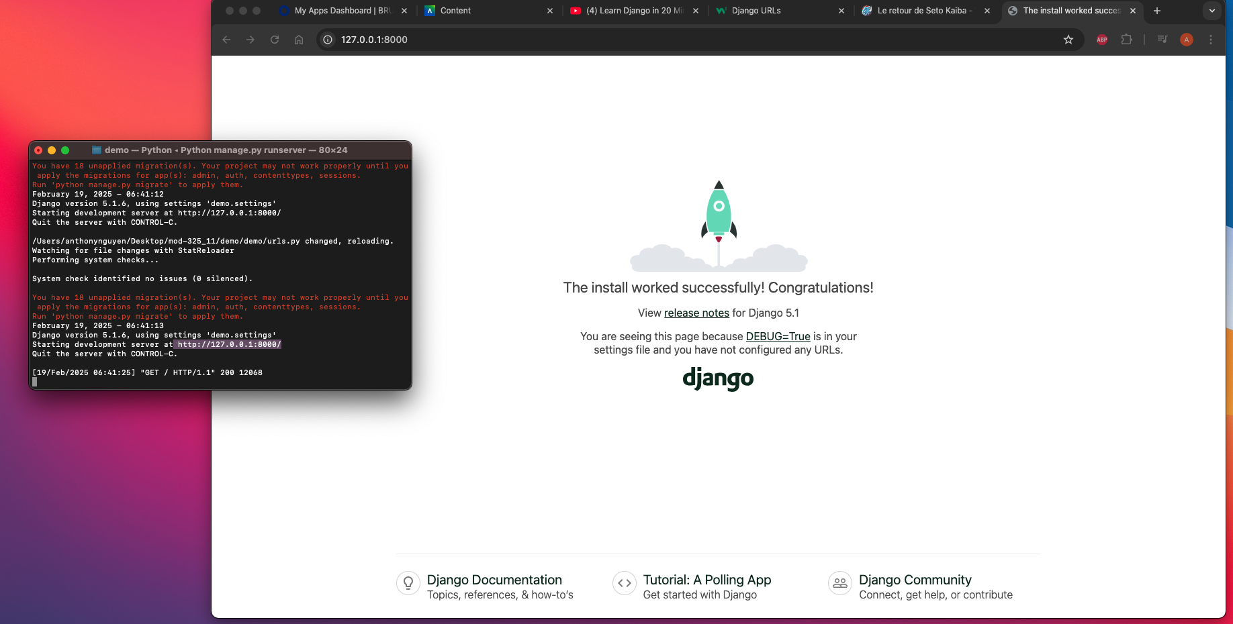

Screenshot after altering the views and urls page:

