Anthony Nguyen, Assignment 12 (Redo Assignment 4)

Flowchart of sitka_highs.py:

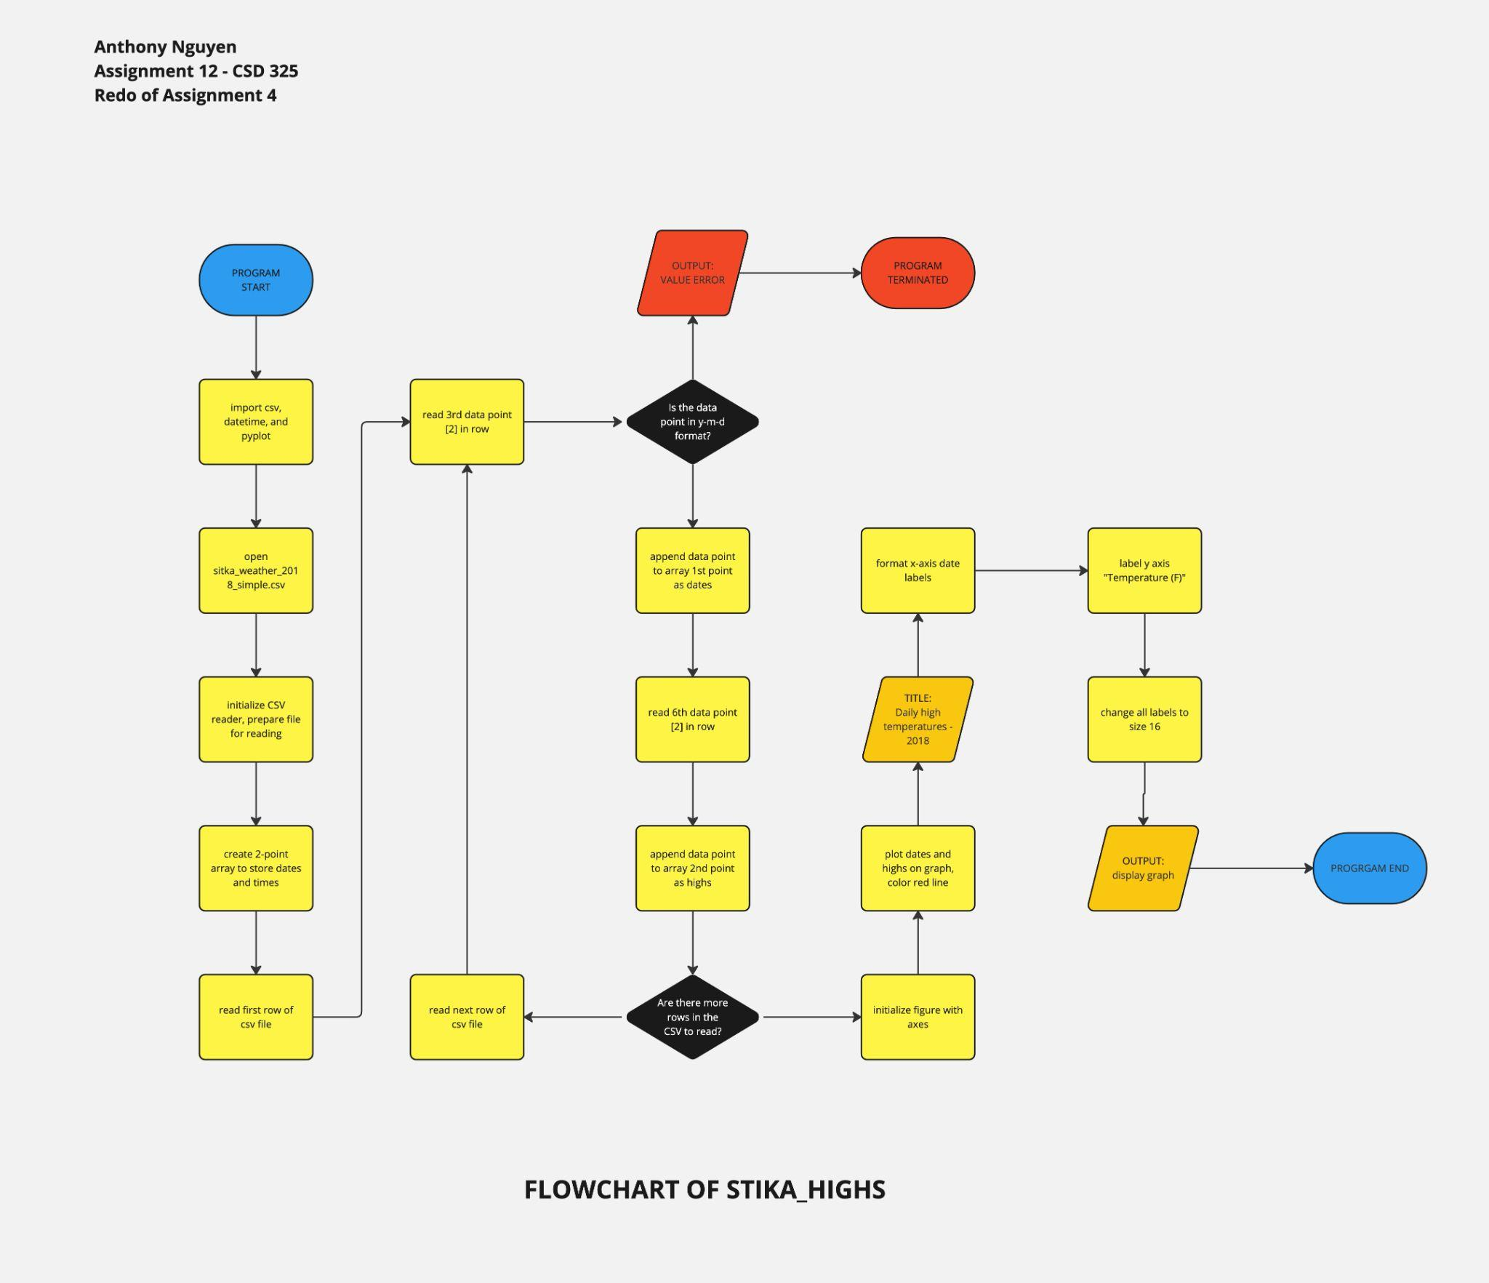

Flowchart of sitka_high_low: Main flow-

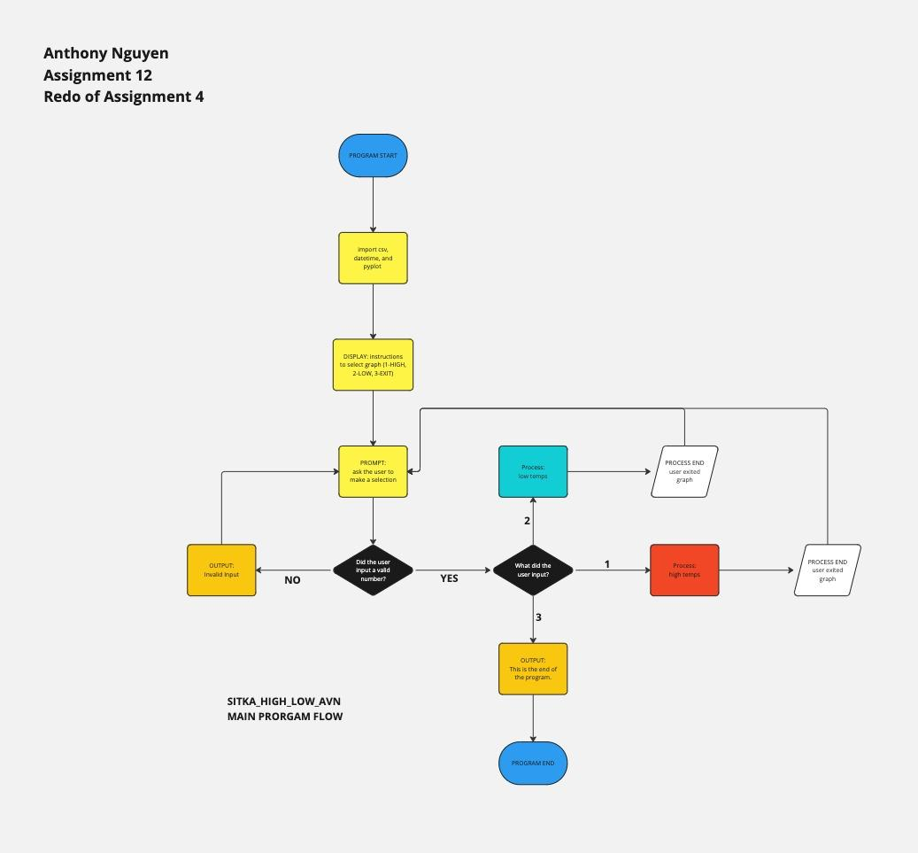

If the user chose the high graph

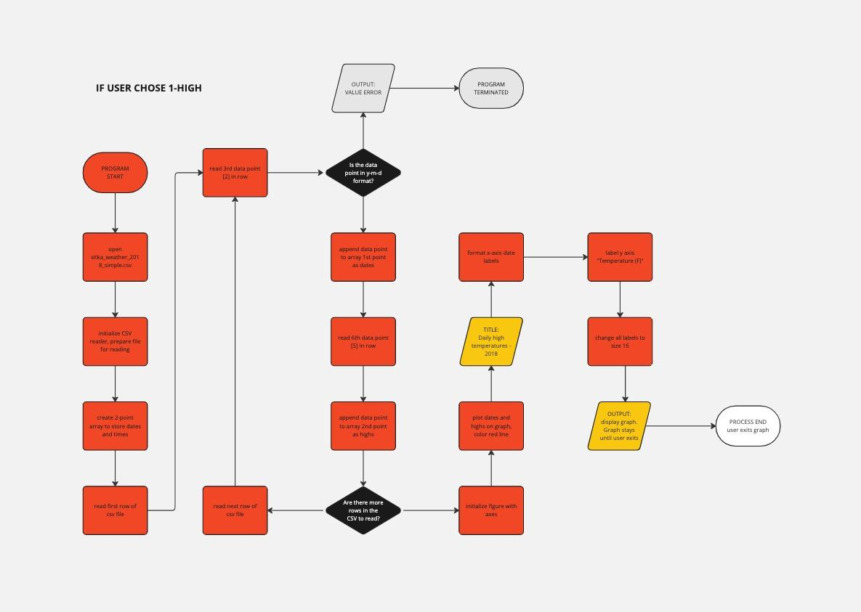

If the user chose the low graph

