Anthony Nguyen

CSD-325 Assignment 2.2

Stepping into the name_check function of student gpa:

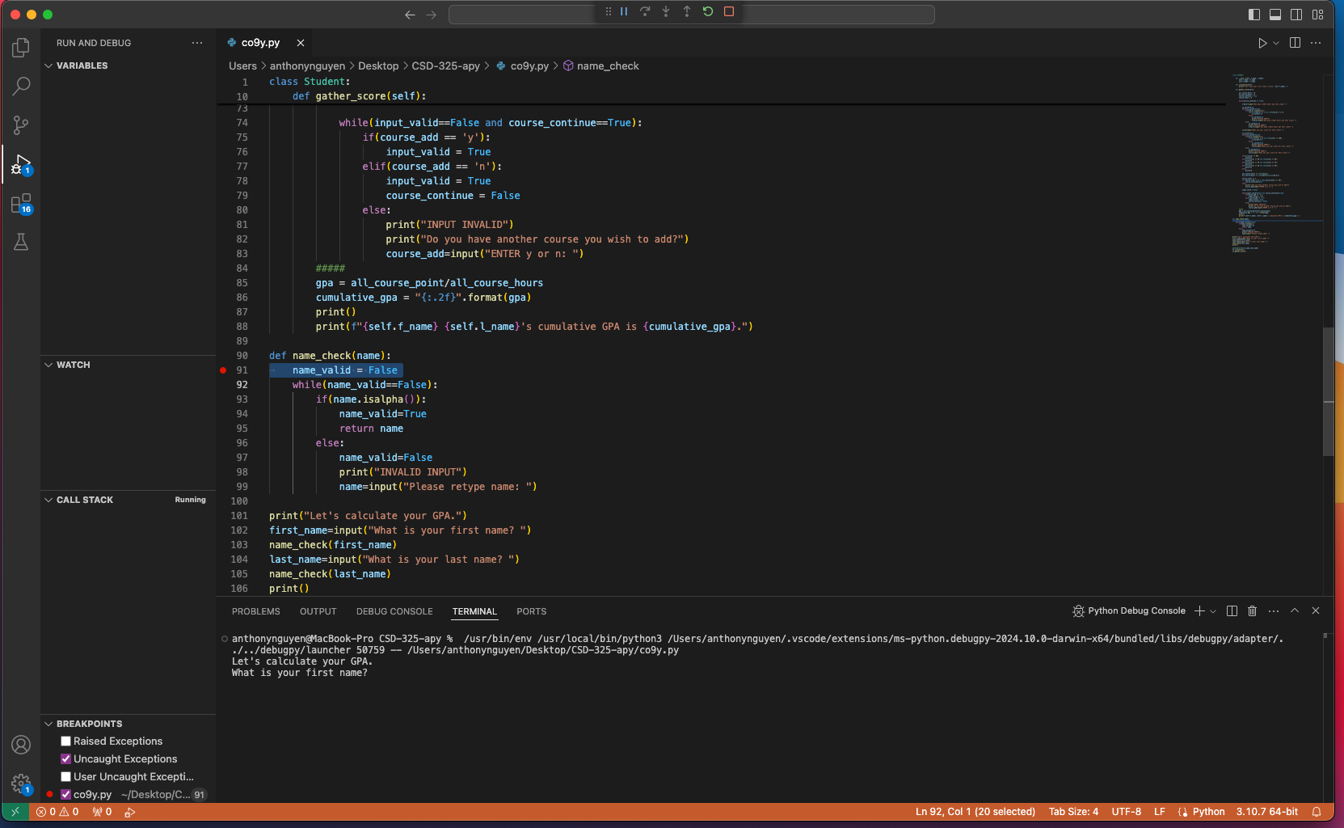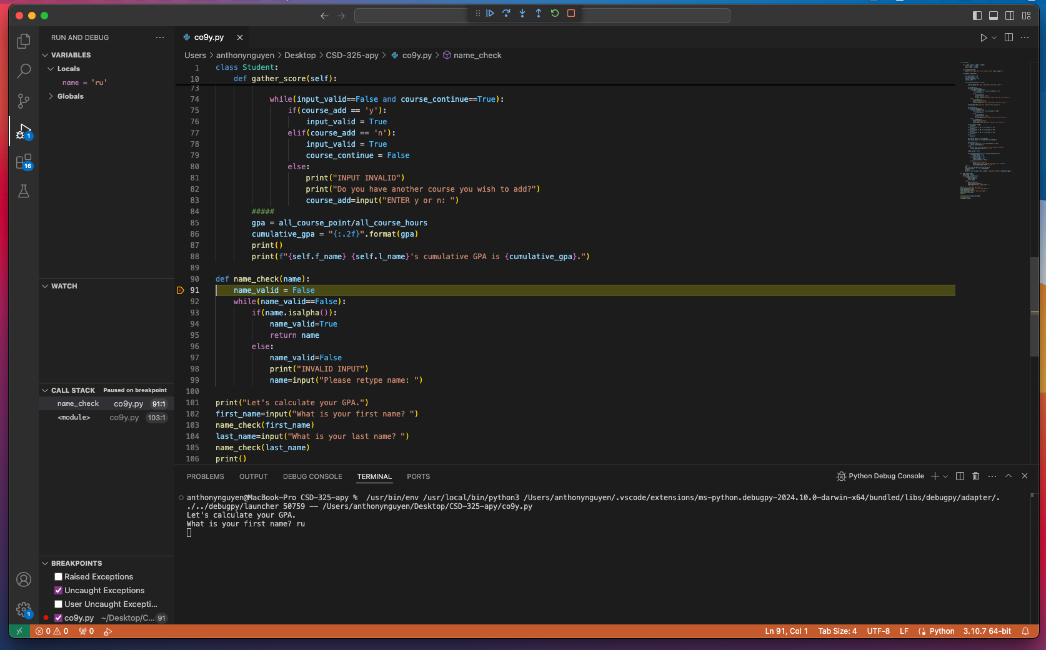

Altering a variable’s name mid program causes this:

