Anthony Nguyen, Assignment 7

Screenshot of city_functions:

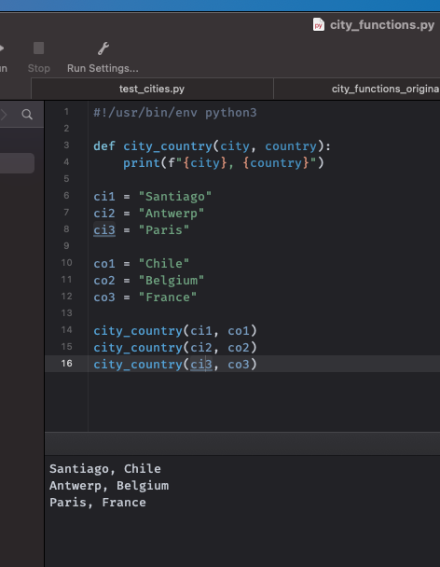

Screenshot of test_cities first test:

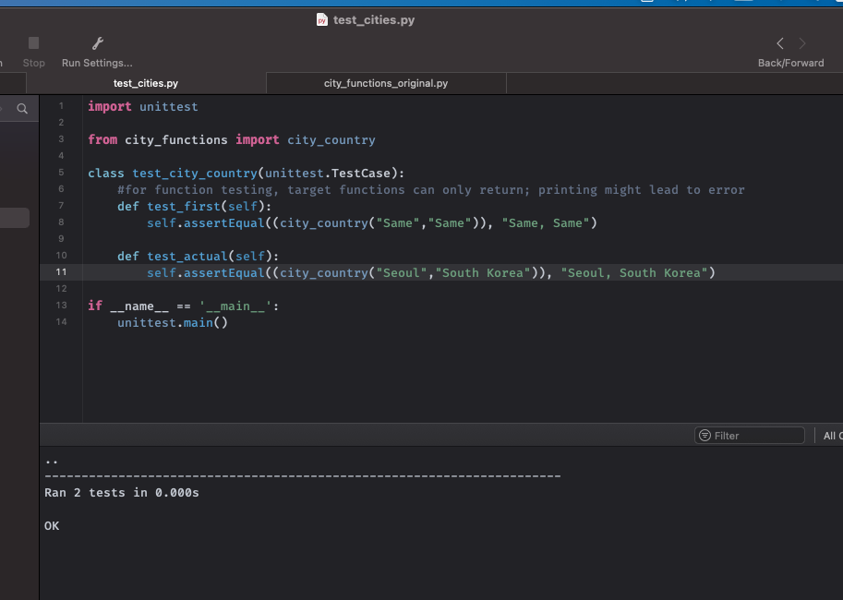

Screenshot of test_cities failing (population):

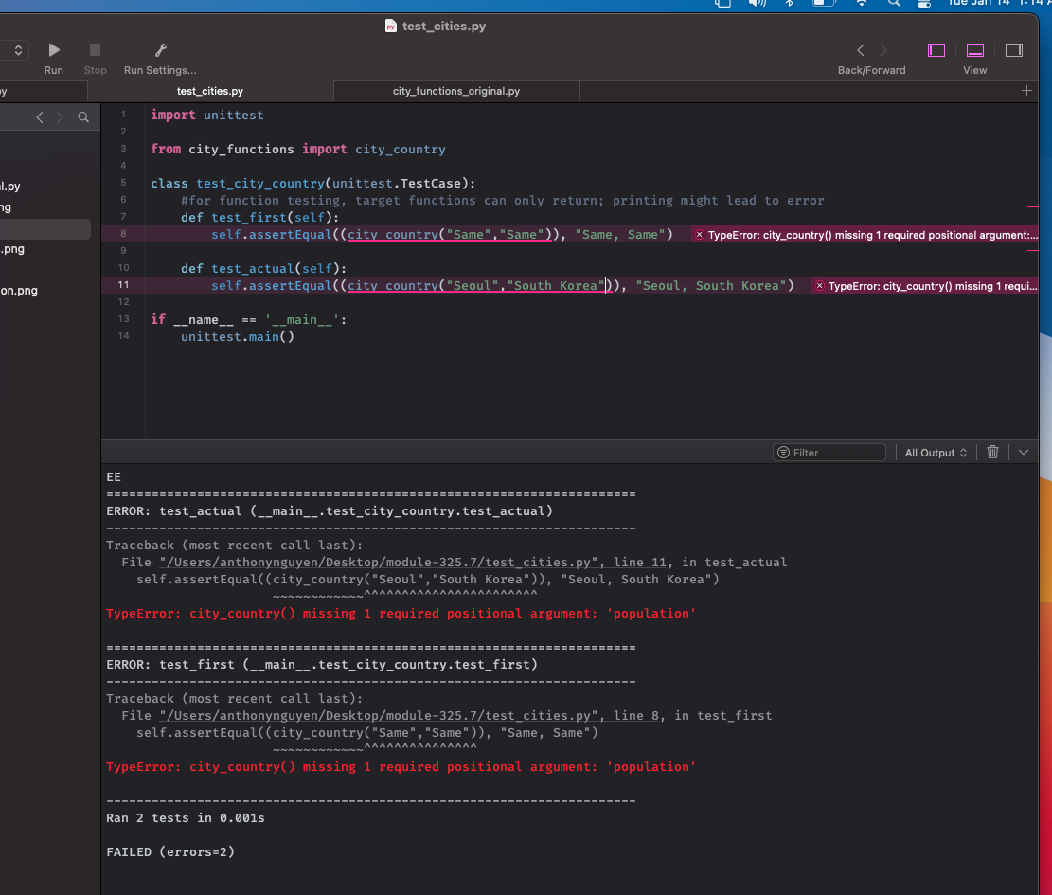

Screenshot of test_cities after making population optional:

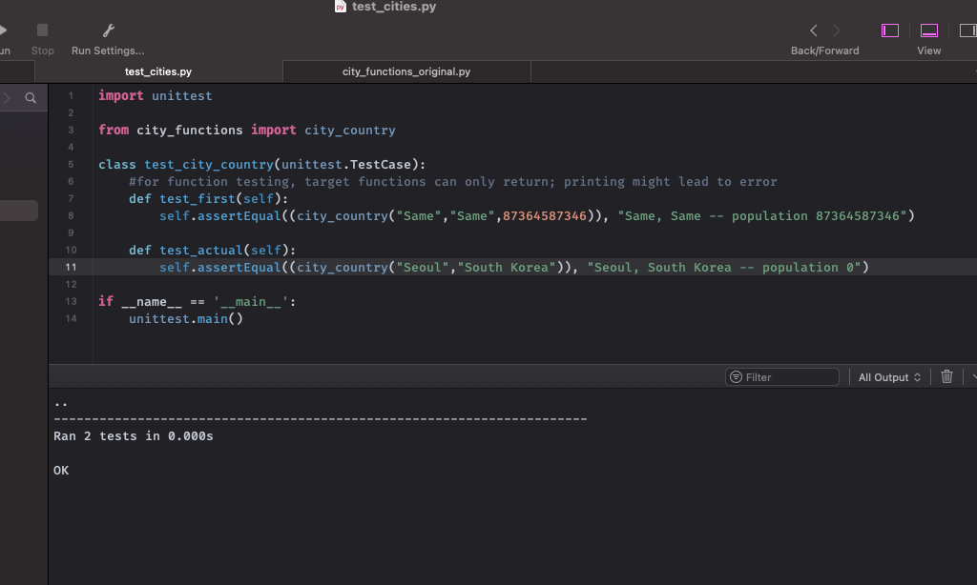

Screenshot of test_cities failing after adding language:

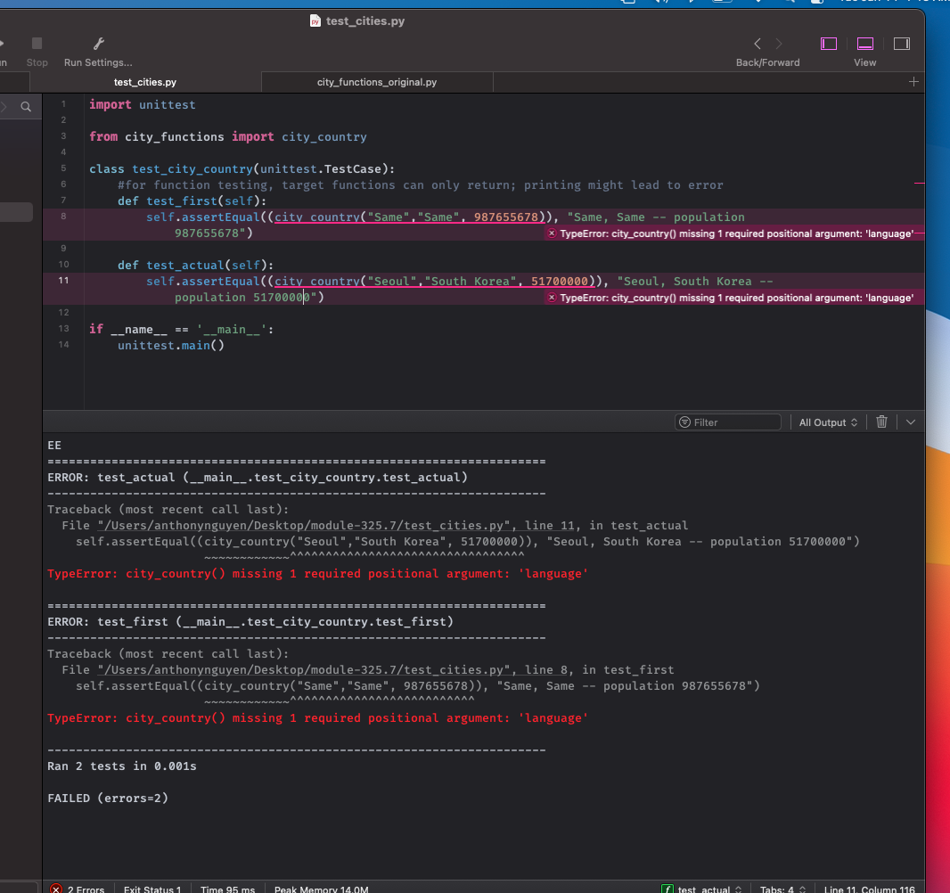

Screenshot of test_cities after making language optional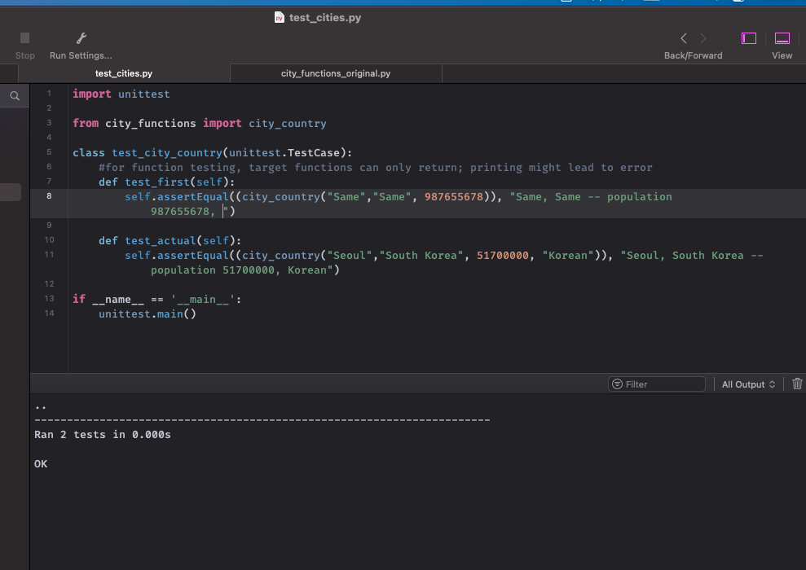

Screenshot of city_functions after all modifications:

