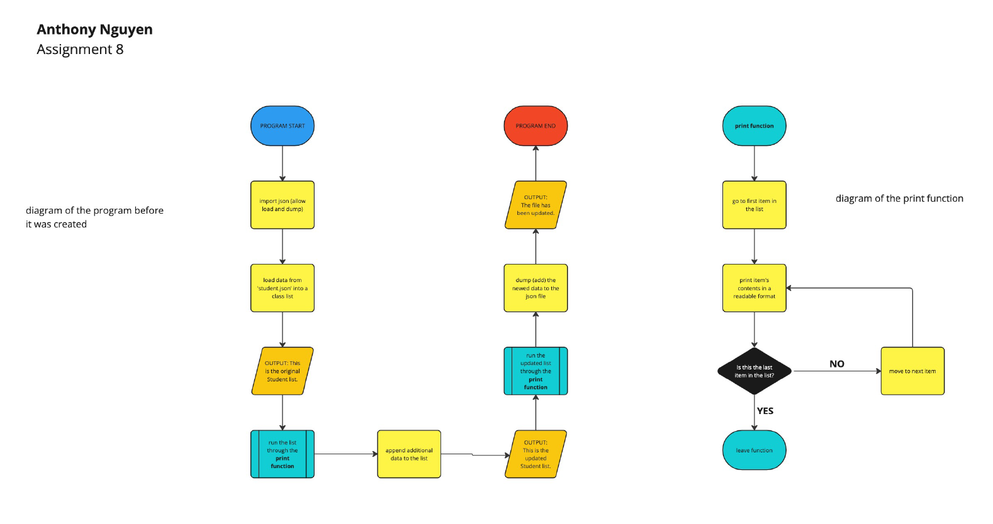

Screenshot of the program running:

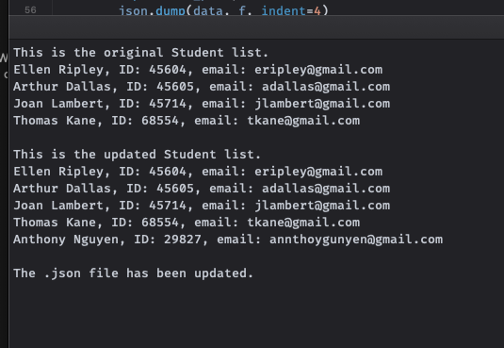

\*\*There is no screenshot of the notification because it did not show when the program ran. I tried to redownload the json file and run it then, but it still did not ask if I wanted to save.