Anthony Nguyen, Assignment 1.2

Github repository link: <https://github.com/Lotania/csd-340>

Screenshot of result of “ls”:

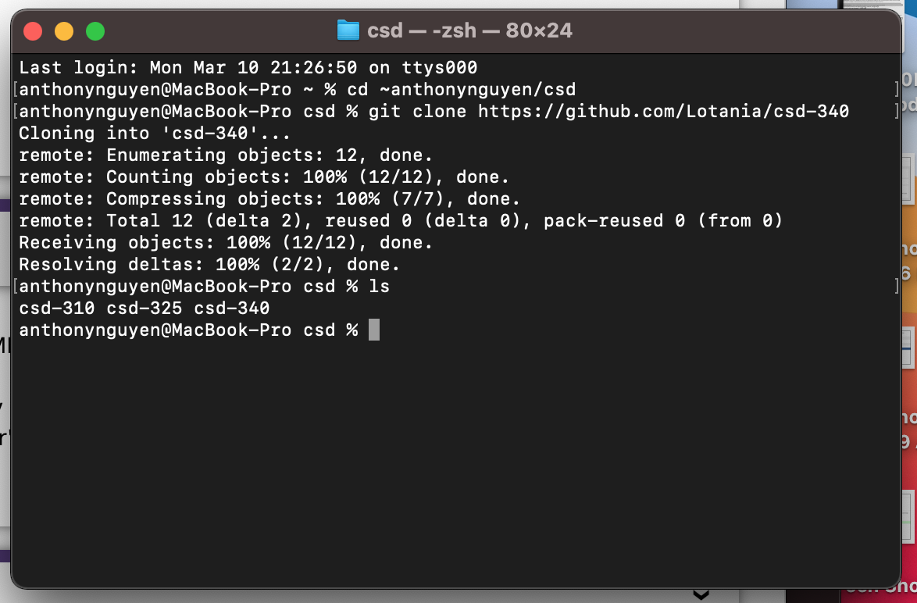

Screenshot of repository landing page:

