Anthony Nguyen, CSD-340 Assignment 1.3

Screenshot of first validator first attempt:

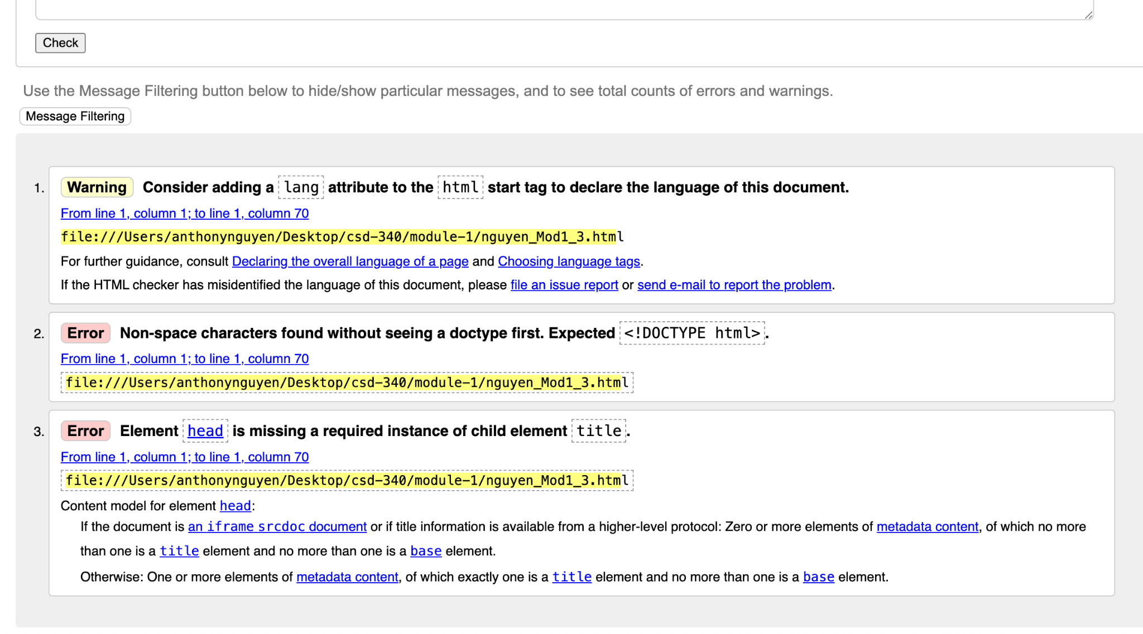

Screenshot of validator after using file upload:

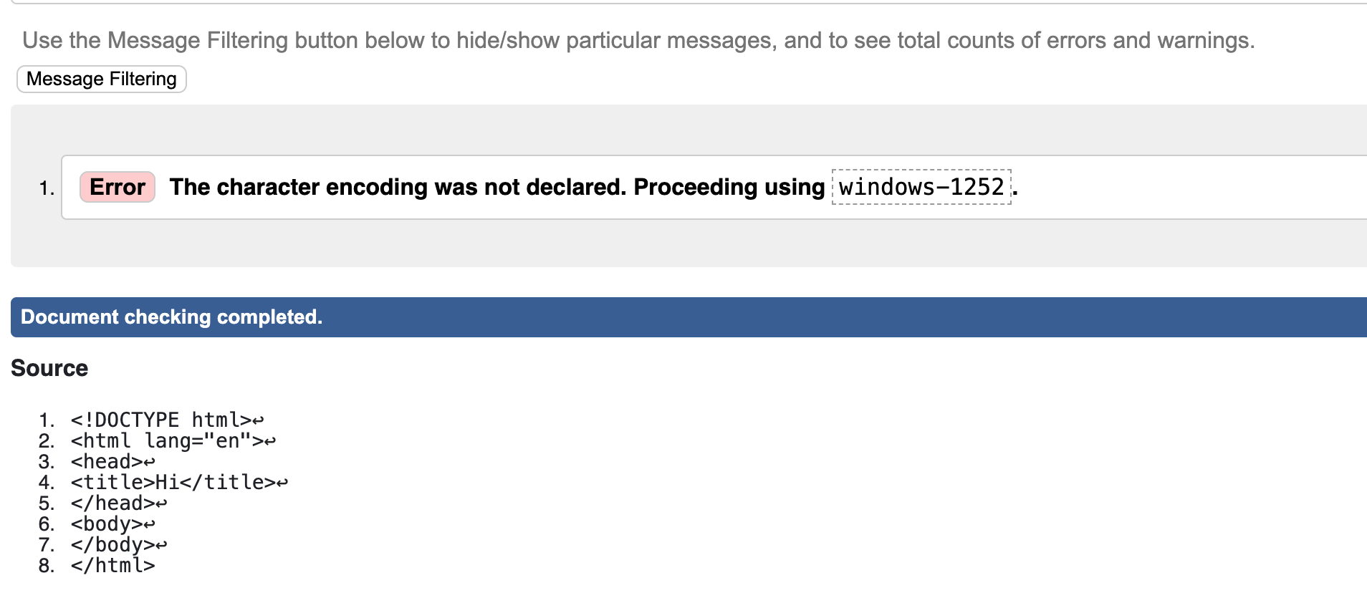

Screenshot of validator after fixing error:

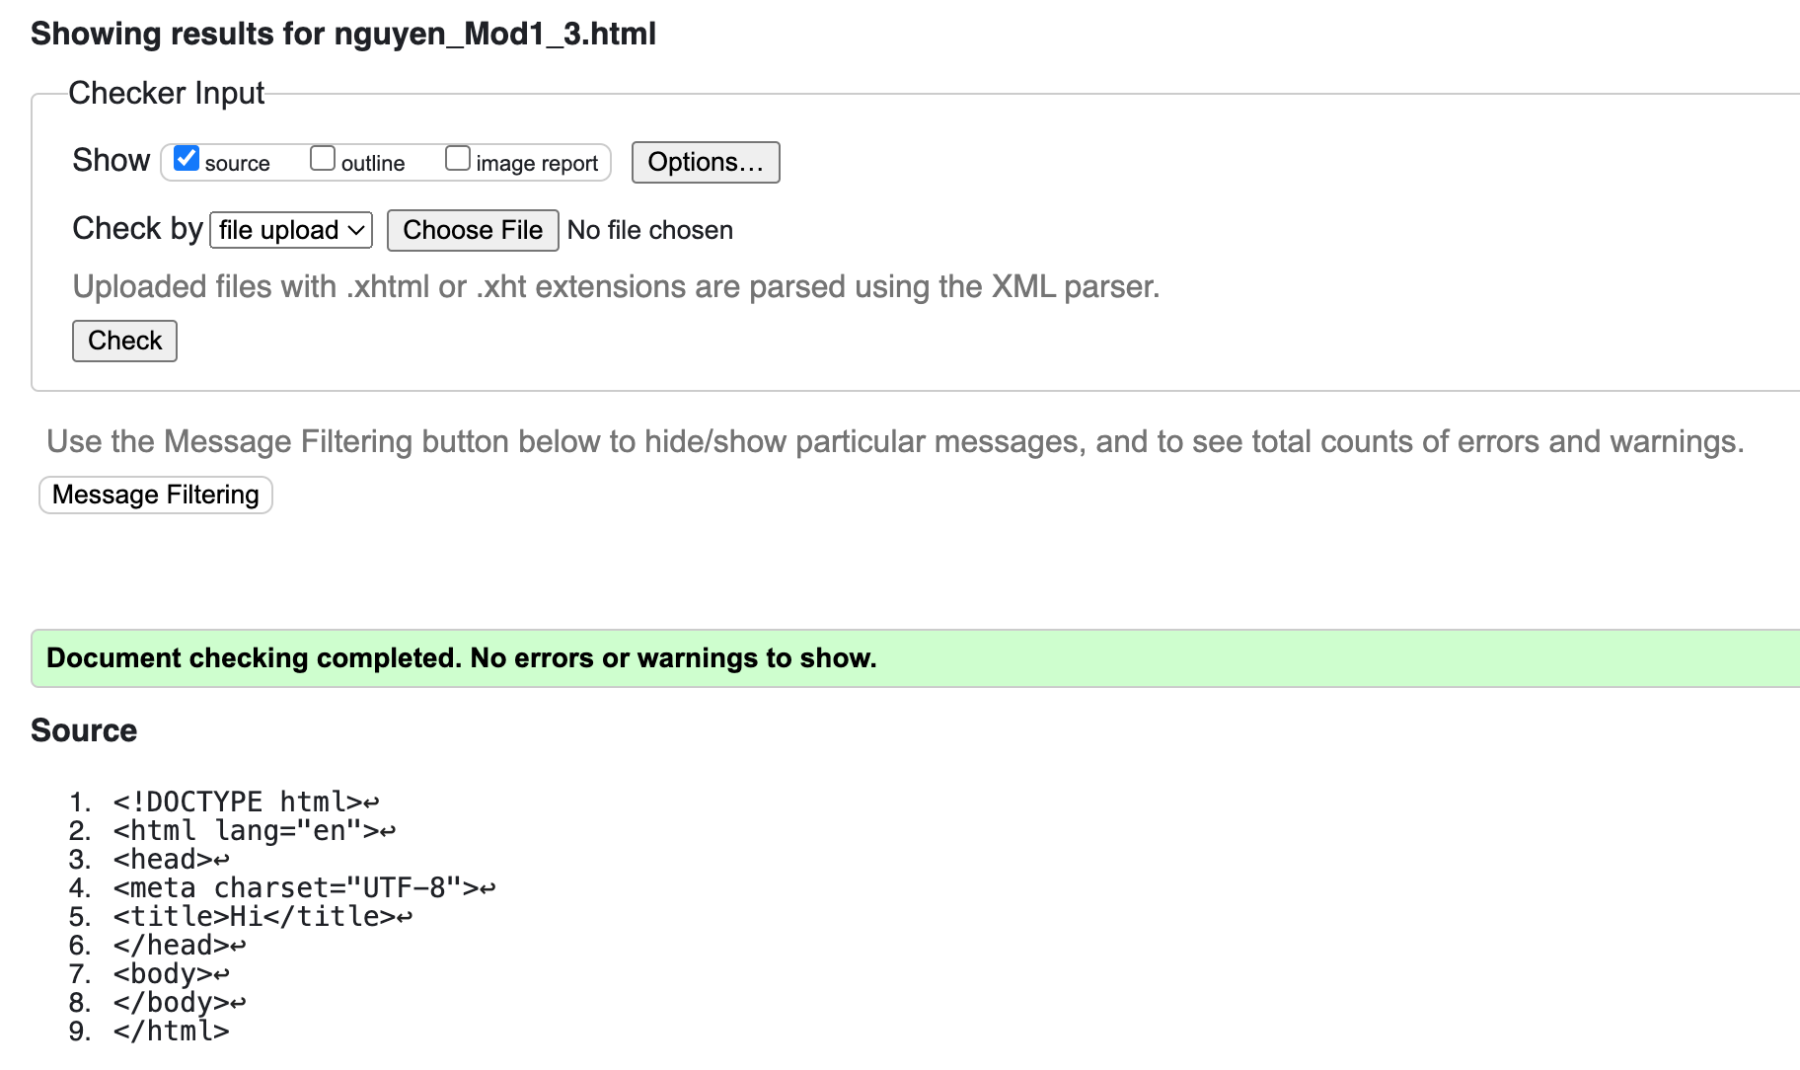

Screenshot of validator after edits:

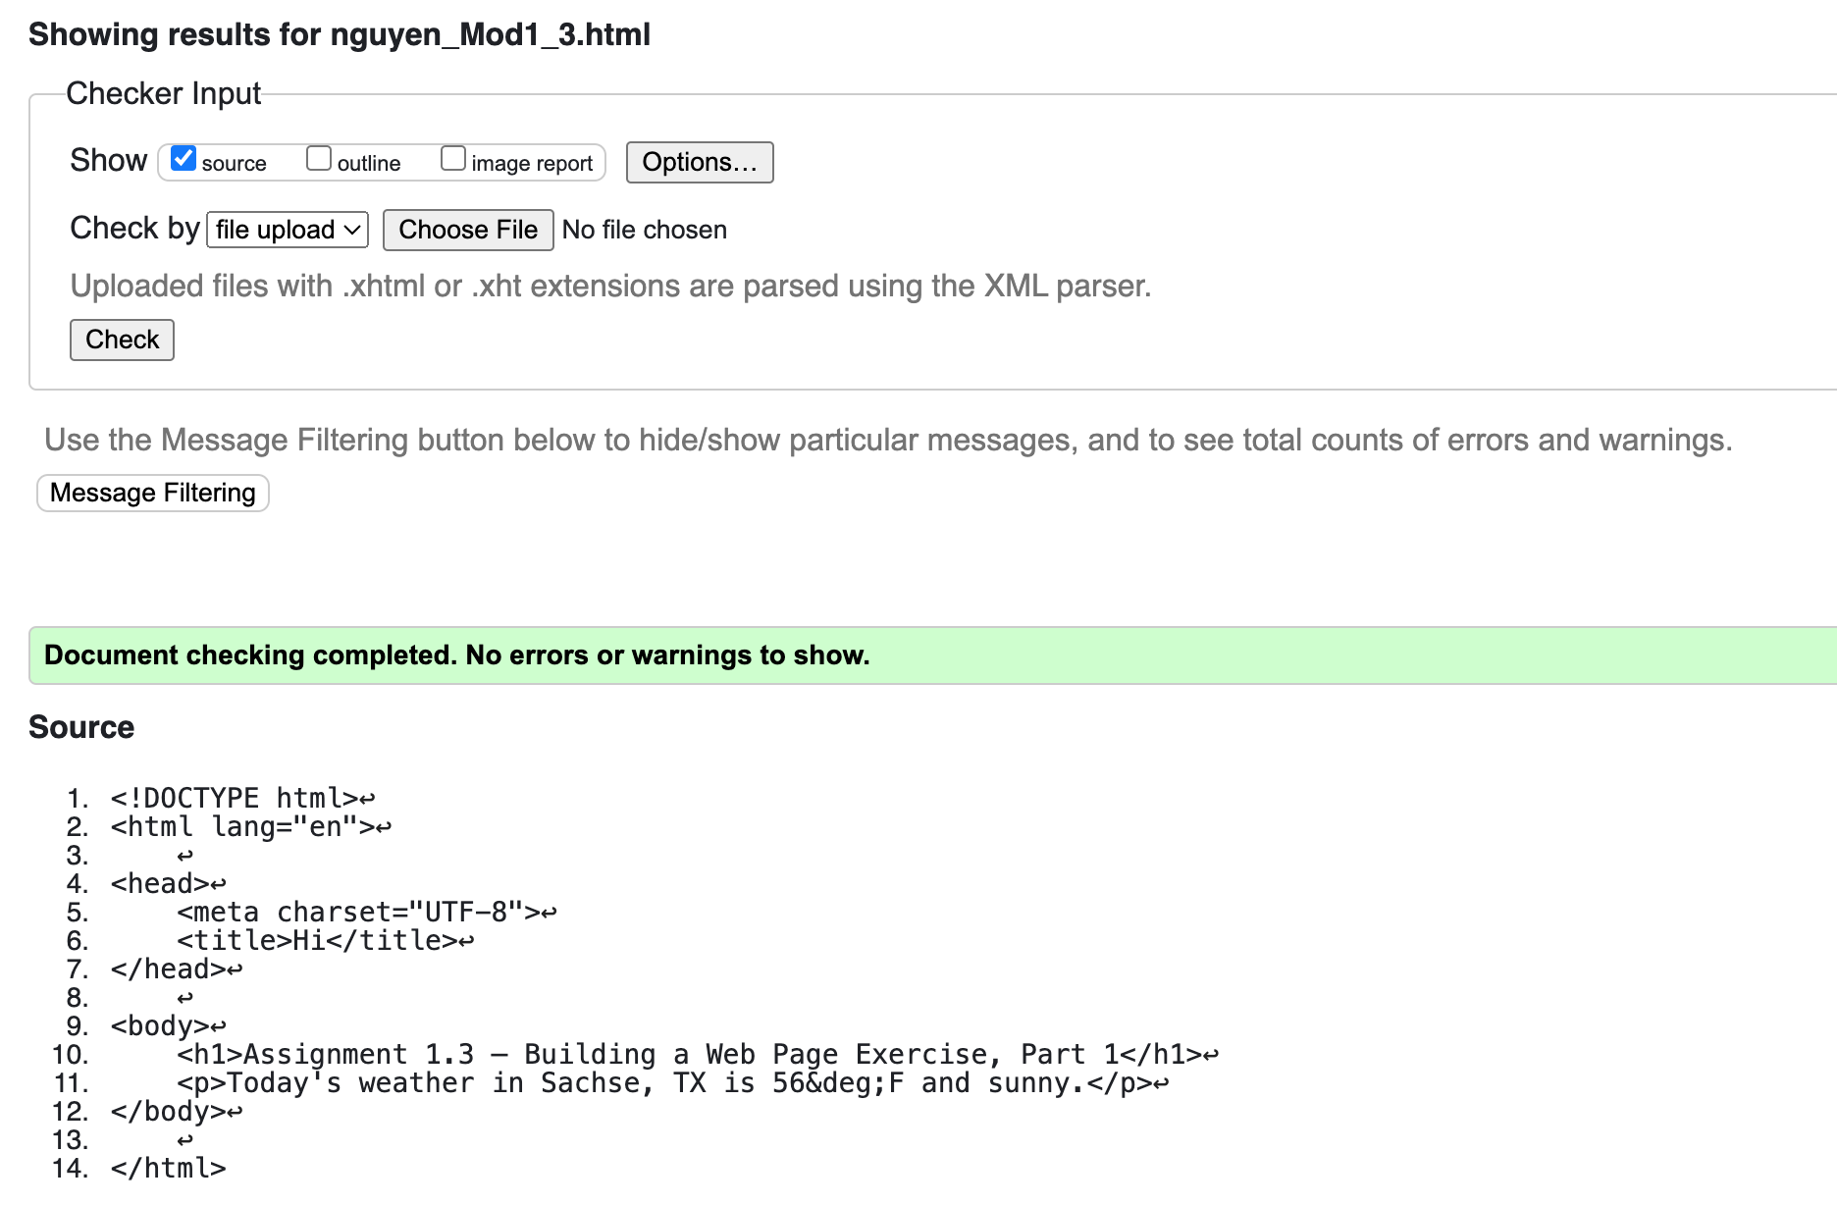

Screenshot of final page:

