Anthony Nguyen, Assignment M1.2

Link to GitHub repository: https://github.com/Lotania/csd-402

Screenshot of folder after cloning:

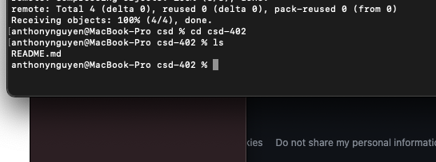

Screenshot of folder after adding module-1 folder
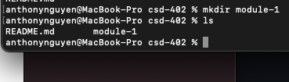

Screenshot after committing to push to origin:
