Anthony Nguyen, Assignment M1.2

Screenshot of folder after cloning:

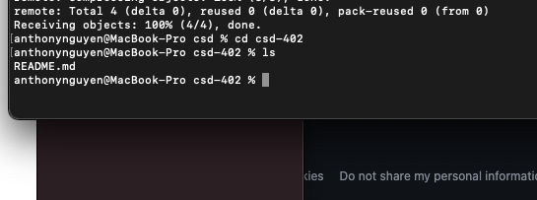

Screenshot of folder after adding module-1 folder

