**Ensemble :**

|  |  |  |  |  |  |  |  |  |  |  |  |  |  |  |  |  |  |  |  |  |  |  |  |  |
| --- | --- | --- | --- | --- | --- | --- | --- | --- | --- | --- | --- | --- | --- | --- | --- | --- | --- | --- | --- | --- | --- | --- | --- | --- |
|  | | |  | | | | | | | | | | | | | | | | | **LAKHDHAR Lotfi** | | | | |
| PIECES |  |  |  |  |  |  |  |  |  |  |  |  |  |  |  |  |  |  |  |  |  |  |  |  |
| Rep |  |  |  |  |  |  |  |  |  |  |  |  |  |  |  |  |  |  |  |  |  |  |  |  |
| Qté | **1** | **1** | **2** | **1** | **2** | **2** | **2** | **1** | **1** | **2** | **1** | **1/1** | **1/1** | **1** | **1** | **1** | **1** | **1** | **1** | **4/4** | **1** | **3** | **2** | **3** |



Positionner

Visser

Positionner

Visser

Positionner

Visser

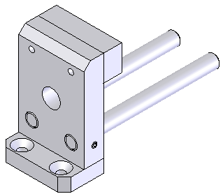

Positionner

Visser

Visser

Positionner

Positionner

Positionner

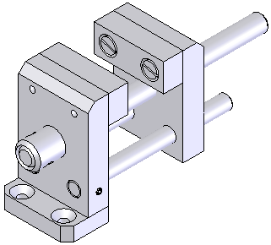

Positionner, fixer

Positionner, fixer

Positionner, fixer

Positionner, fixer

Positionner

visser, serrer

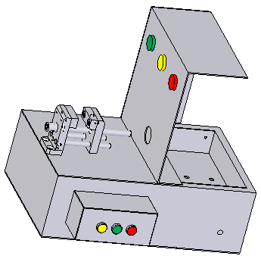

Positionner, fixer

Positionner, souder

Positionner, régler,

Visser, installer la partie électrique

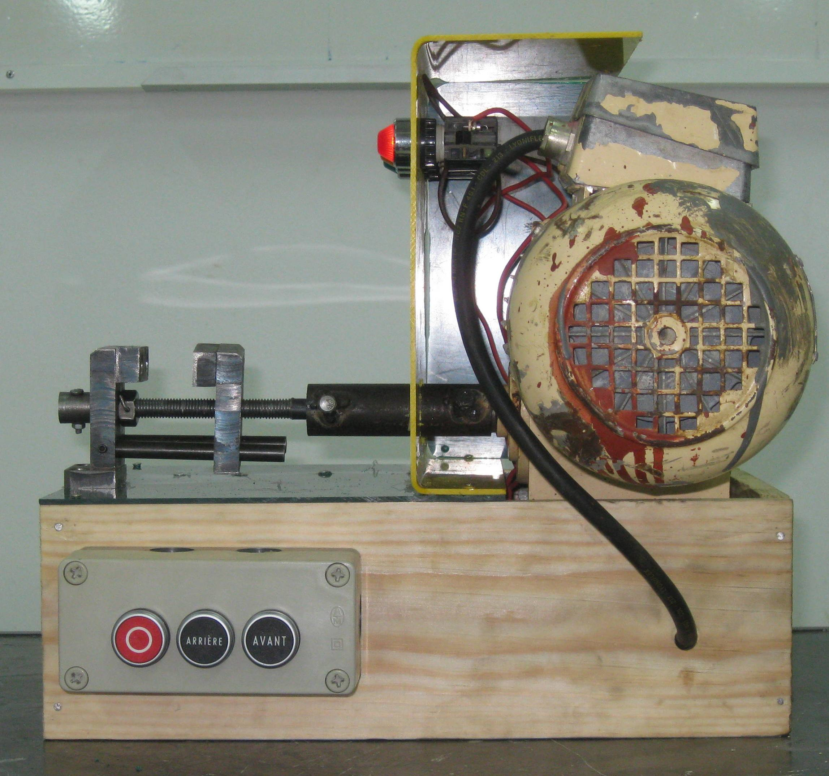

**Etau de modéliste**

**GRAPHE de MONTAGE 2**

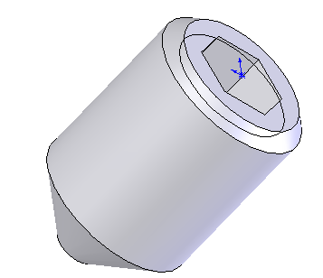



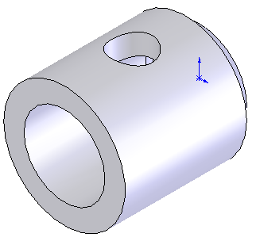

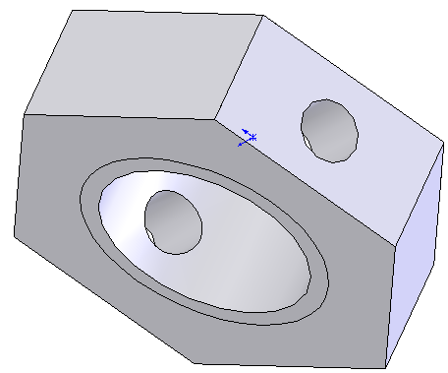

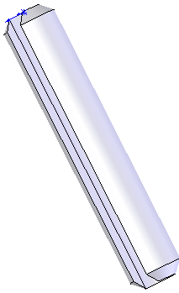

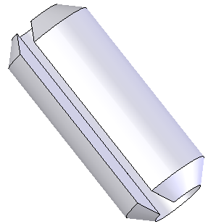





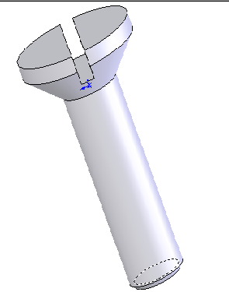

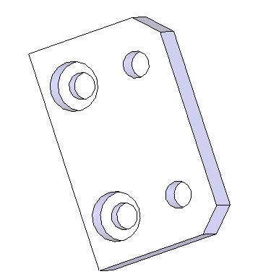

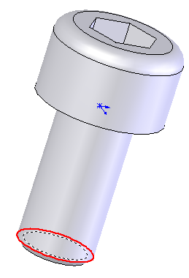



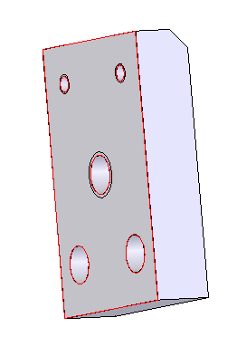



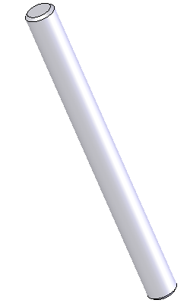

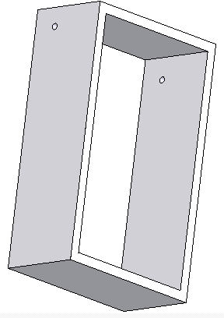

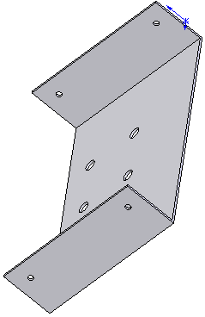

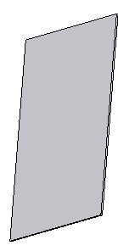

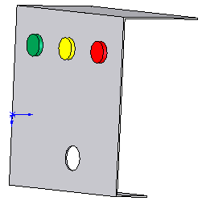

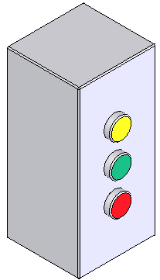

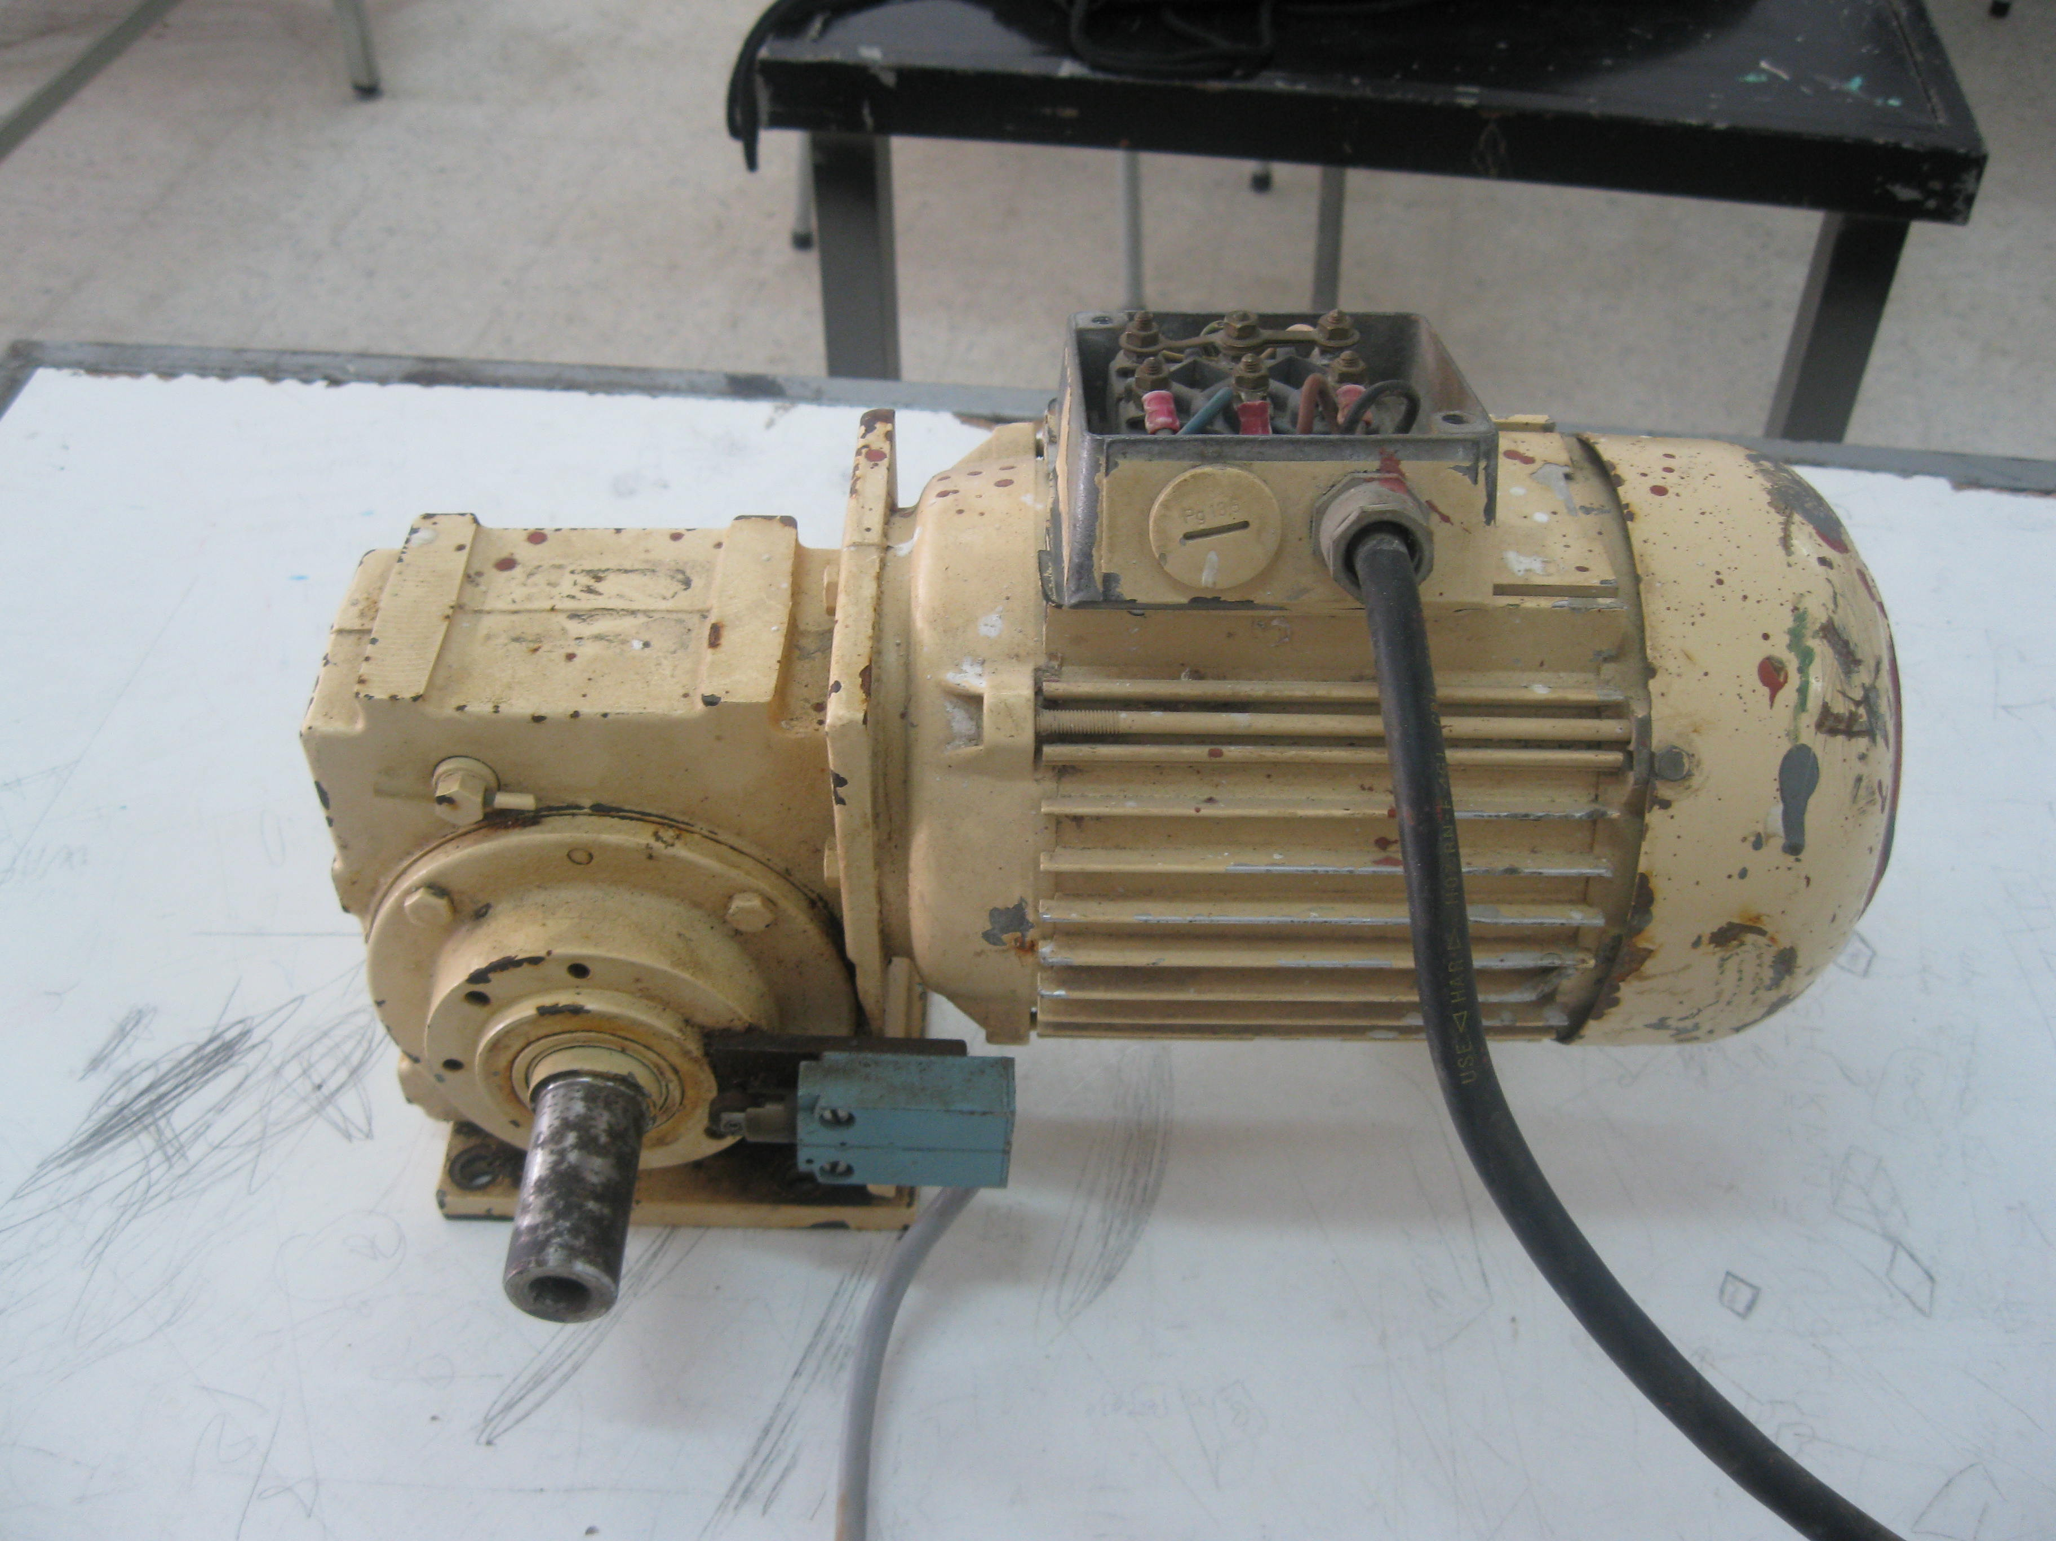

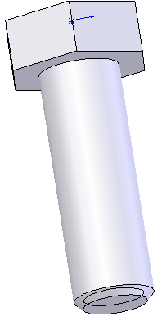

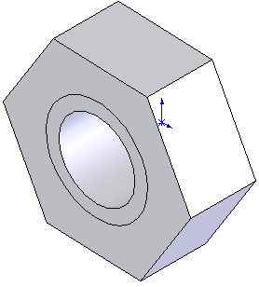

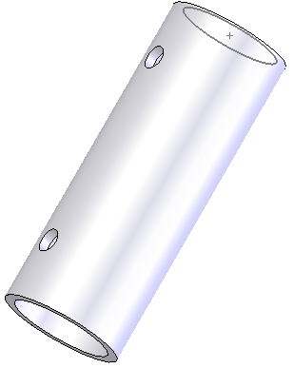





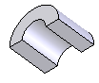

|  |  |  |  |  |  |  |  |  |  |  |  |  |  |  |  |
| --- | --- | --- | --- | --- | --- | --- | --- | --- | --- | --- | --- | --- | --- | --- | --- |
|  | | |  | | | | | | | | | | |  | |
| PIECES |  |  |  |  |  |  |  |  |  |  |  |  |  |  |  |
| Rep | **02** | **05** | **04** | **10** | **11** | **01** | **03** | **04** | **12** | **13** | **06** | **14/07** | **08** | **09** | **15** |
| Qté | **1** | **1** | **2** | **1** | **2** | **1** | **1** | **2** | **2** | **2** | **1** | **1/1** | **1** | **1** | **2** |

**Ensemble :**

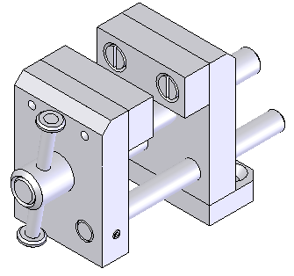

**Etau de modéliste**

**GRAPHE de MONTAGE 1**

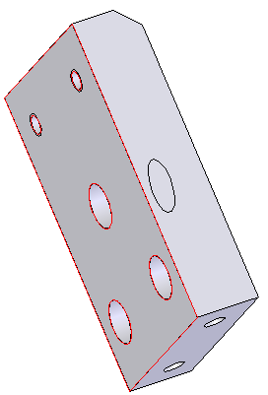

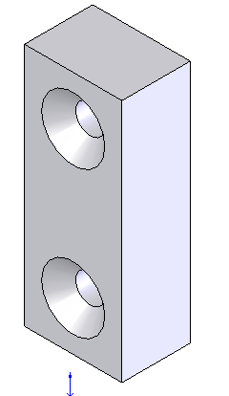



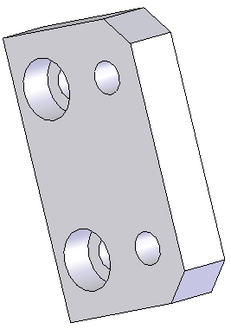

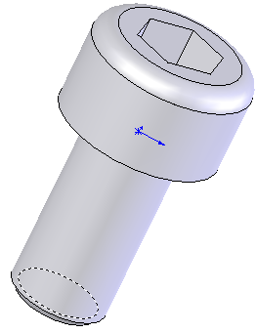

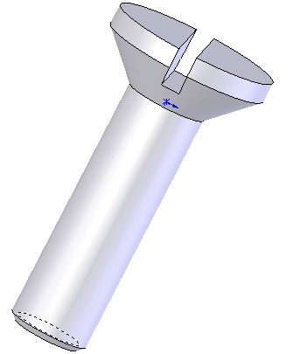



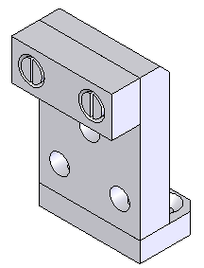

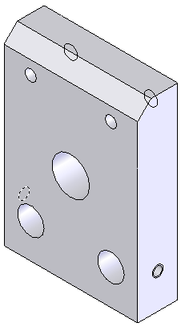

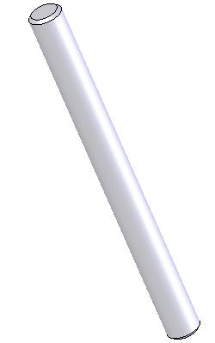



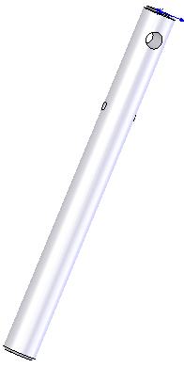

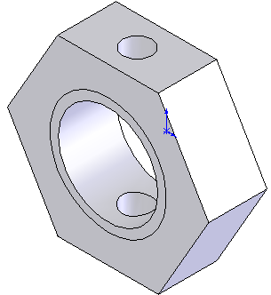

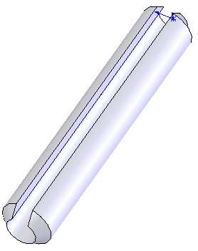

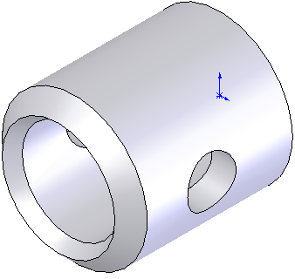

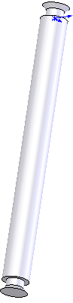

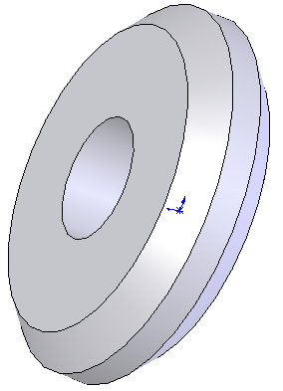

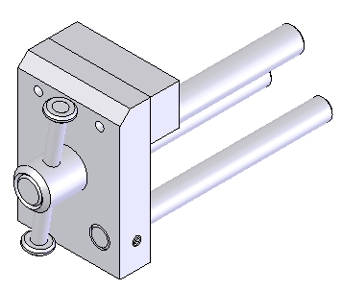



visser

Positionner, assembler

visser

Positionner

Positionner, assembler

Positionner

Positionner, assembler

Positionner

visser

Positionner

Positionner

visser

Positionner

**LAKHDHAR**

**Lotfi**

**LAKHDHAR**

**Lotfi**