Design and Implementation of an 8x8 Signed Serial-Parallel Multiplier (SPM) on the Basys 3 FPGA

1. Introduction
This report presents the comprehensive design, implementation, and validation of a sequential 8-bit signed Serial-Parallel Multiplier (SPM) on the Basys 3 FPGA development board, which uses the Artix-7 FPGA. The goal of the project was to build a working hardware system that takes two 8-bit signed binary numbers (multiplier and multiplicand) as inputs via toggle switches, performs signed multiplication sequentially, and outputs the resulting signed product in decimal format using a set of 7-segment displays.
Unlike fully parallel multipliers which require substantial hardware resources, the SPM design utilizes a serial input mechanism for one operand and a parallel load for the other. This hybrid architecture balances performance and resource usage, making it ideal for FPGA-based implementations where efficiency and clarity of logic design are important.
In this project, the control logic, datapath modules, decimal display system, and scrolling mechanism were all designed in Verilog. The system was simulated, tested, and then deployed on the Basys 3 board. Additional validation was performed using Logisim Evolution for component-level simulation, and the entire development process was maintained on GitHub for transparency and collaboration.

2. System Overview and Design Requirements

The complete system is composed of several coordinated functional components that together facilitate the correct input, processing, and display of the signed 8-bit serial-parallel multiplication result. Each subsystem plays a critical role in ensuring the arithmetic correctness, user interaction, and visual output formatting of the final result. The main components are:
- Input Interface: Utilizes the 16 on-board slide switches on the Basys 3 FPGA board to accept the two signed 8-bit operands. Specifically, the lower 8 switches (SW7–SW0) are used to input the multiplier, while the upper 8 switches (SW15–SW8) correspond to the multiplicand. The interface directly captures two’s complement binary representations and routes them to the processing modules upon a trigger signal.
- Control Unit (Finite State Machine): Serves as the brain of the operation, coordinating the sequential flow of data between components. This unit manages the timing and control signals needed to initiate operand loading, serial shifting of the multiplier, conditional addition of the multiplicand, and final sign correction. It also asserts a DONE signal once the full 16-bit product has been generated. The FSM ensures that each clock cycle transitions the system into the correct operational state, respecting both computation logic and hardware constraints.
- Serial-Parallel Multiplier (SPM): Implements the shift-and-add multiplication algorithm optimized for signed operands using two’s complement arithmetic. The SPM performs bit-by-bit processing of the multiplier, shifting the partial product and conditionally adding the multiplicand during each of the 8 cycles. It accumulates the 16-bit result and includes logic to handle sign extension properly for accurate results across all value ranges.
- BCD Converter (Double Dabble Algorithm): Converts the final binary result into a human-readable decimal format. This module implements the shift-and-add-3 method, a well-established algorithm for transforming binary numbers into Binary-Coded Decimal (BCD). It supports up to 5 decimal digits to fully represent the range of values (−32,768 to 32,767) produced by 8-bit signed multiplication. The module begins shifting after the multiplication is complete and signals readiness of the BCD output.
- Seven-Segment Display Driver: Responsible for translating BCD digits into corresponding 7-segment display encodings. This module continuously cycles through digit selectors to multiplex the output across four physical 7-segment displays on the Basys 3 board. It ensures proper visual representation of digits and dynamically updates the display buffer to reflect scrolling behavior.
- Scroll Mechanism: Since the output can span up to 5 decimal digits but only 4 digits are available on the board, a scrolling mechanism was implemented. The leftmost digit is reserved for the sign ('−' or blank for positive), and the remaining 3 digits show portions of the number. Users can press the left (BTNL) and right (BTNR) buttons to scroll the output window horizontally. This allows navigation through the complete 5-digit result. Internal logic tracks the current scroll position and ensures smooth, flicker-free transitions using debounce and timing control.
- Control Signals and Indicators: User interaction is managed via on-board buttons. BTNC serves as the primary control to initiate multiplication after the operands are set. Once the multiplication and conversion processes are complete, LED LD0 is illuminated to signal that the output is ready for viewing. This ensures clear feedback for the user and prevents premature reading of unstable outputs.
The entire system is designed to accommodate the complete signed 16-bit product resulting from 8-bit inputs. Given the mathematical limits of −32,768 to +32,767, a total of 5 decimal digits may be needed. The implemented architecture handles this through an efficient and modular pipeline that moves data from binary input to signed decimal output, incorporating both hardware efficiency and user-friendly interaction.

3. Block Diagram
The high-level block diagram includes:
- Input Registers for loading multiplier and multiplicand.
- Serial-Parallel Multiplier Unit with sign extension and accumulation.
- Controller FSM to sequence operations.
- Binary-to-BCD Converter (Double Dabble).
- 7-Segment Display Interface with scroll support.

4. Component Design and Logisim Simulation

4.1 Serial-Parallel Multiplier in Logisim
To ensure a solid grasp of the Serial-Parallel Multiplier (SPM) architecture before Verilog implementation, we developed and simulated a simplified 4-bit signed SPM system using Logisim Evolution. This served as a functional prototype for understanding data flow, control timing, and the challenges of signed arithmetic in a sequential multiplication design.
In this simulation, the multiplicand is loaded in parallel into a shift register at the beginning of the operation. The multiplier, on the other hand, is introduced serially—bit-by-bit—over a sequence of clock cycles. This replicates the core principle of the Serial-Parallel Multiplication approach, where shift-and-add logic is used based on the value of each incoming multiplier bit.
The simulation is designed to operate over two main phases. The first phase spans 8 clock cycles during which the system ingests the bits of the multiplier and performs conditional addition of the shifted multiplicand to an accumulator. In the second phase, beginning at the 9th clock cycle, the accumulated product begins to shift out, starting from the least significant bit (LSB) and proceeding toward the most significant bit (MSB), completing a full 16-bit product output.
To manage the timing of output generation, we designed a loader unit that tracks the number of elapsed clock cycles. This loader begins registering the final result only after the initial 8 cycles are completed. It then enables the product output line and asserts a \texttt{DONE} signal, indicating that the multiplication process has been completed and the result is valid.
A significant challenge we encountered in this simulation was the handling of signed operands. Since multiplication of signed binary numbers requires correct interpretation and propagation of sign bits, we implemented sign extension logic at both the multiplicand and intermediate result stages. This ensured that negative numbers were properly represented using two’s complement format and that overflow or misinterpretation of MSBs did not occur.
This simulation was invaluable in clarifying how individual modules such as shift registers, adders, and control counters interact in a sequential signed multiplier. It also allowed us to verify the correctness of multiplication results and control logic in a visual, step-by-step environment. The insights gained from this prototype informed key design decisions in the Verilog-based implementation, such as FSM design, accumulator width, and the timing of control signals.

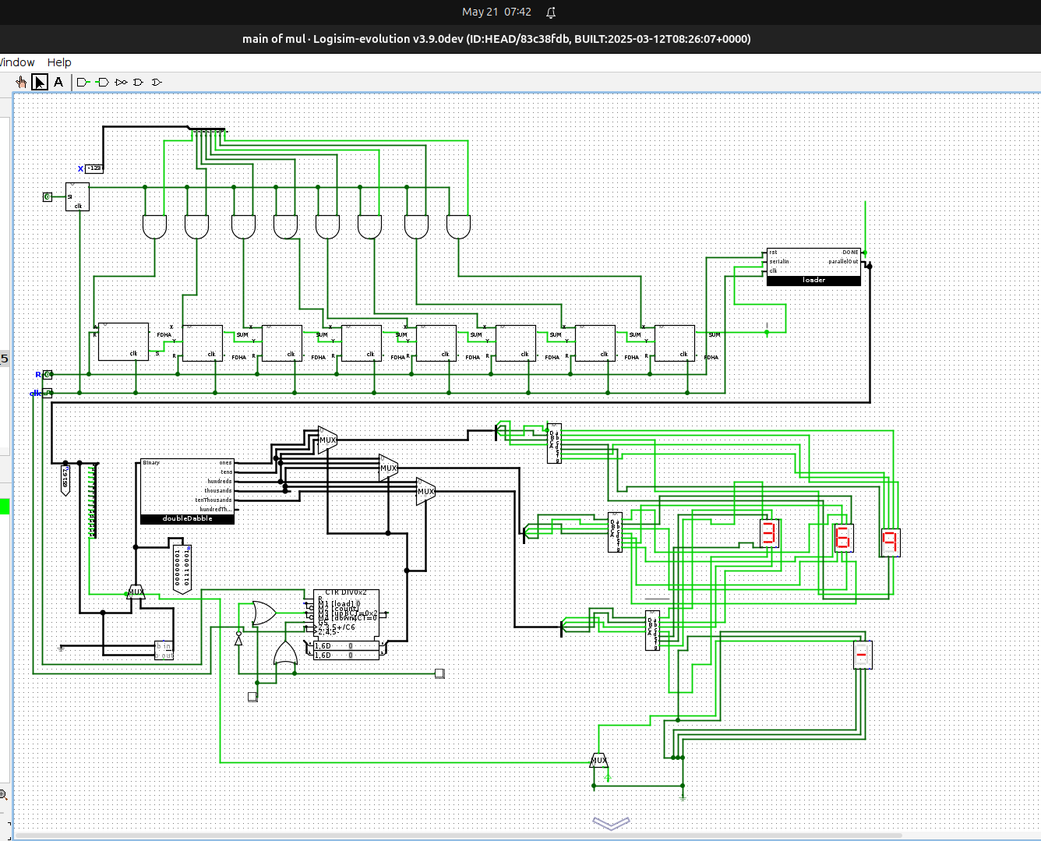
4.2 7-Segment Display Driver in Logisim
The display driver accepts a 5-digit BCD input and scrolls through the three least significant digits using BTNL and BTNR. A multiplexer selects the correct 3 digits based on the scroll state. Timing control and digit refresh were simulated using clock dividers. A counter was used to determine the current button state and determine which led to show. The left button incremented the counter while the right one decremented it.

5. Verilog Implementation

5.1 Verilog Modules
- Statemac: the finite state machine that handles the state transition from and to loading, multiplying, and finishing. It also handles the scroll state to figure which combination of numbers to display on the 7-segment.
- spm.v: Contains the main multiplication logic. A signed serial algorithm performs bitwise multiplication and accumulation. It utilizes two main modules the CSADD and TCMP.
- doubledabble.v: Implements the Double Dabble algorithm for binary to BCD conversion.
- seven_segment_driver.v: Controls digit selection and seven-segment segment display encoding.
- scroll_control.v: Handles BTNL and BTNR input to scroll through decimal digits.
- top_module.v: Integrates all submodules.

5.2 RTL Guidelines
All modules were coded using synthesizable RTL practices, with:
- Proper use of non-blocking (<=) and blocking (=) assignments.
- Synchronous resets.
- Clear FSM encoding.
- No latches or inferred combinational loops.
- Commented and modular code.

6. Testing and Validation

6.1 Simulation
All modules were individually tested using custom testbenches that try different combination of inputs and compare it to an expected output:
- The multiplier module was tested for combinations like 12 × -3, -7 × -2, and edge cases like -128 × 127.
- The controller FSM was verified using clock stepping and checking output timing.
- The BCD converter was tested for inputs ranging from 0 to 32,767.

6.2 On-Board Testing
After simulation, the Verilog design was synthesized using Vivado and programmed onto the Basys 3 board. Hardware testing involved:
- Entering inputs using SW0-SW15.
- Pressing BTNC to begin computation.
- Observing LD0 lighting upon completion.
- Using BTNL/BTNR to scroll the decimal output.

7. Problems Encountered and Solutions

Problem 1: Signed Multiplication Misinterpretation
Initially, the serial-parallel multiplication produced incorrect results for negative numbers. The primary issue stemmed from improper sign extension of the multiplicand and accumulator. In some cases, the high-order bits were not preserved correctly during intermediate additions, leading to overflow or incorrect two’s complement interpretation.
Solution:
We resolved this by explicitly sign-extending the multiplicand to match the accumulator width before the multiplication process began. Additionally, we ensured that all arithmetic operations respected signed formats, and verified that the two’s complement logic was properly implemented in both input preparation and result interpretation.

Problem 2: BCD Overflow
During early integration, the Double Dabble module truncated results greater than 9999. This was fixed by extending the output width and number of shift cycles to accommodate 16-bit inputs.
Solution:
This was caused by the Double Dabble module not having sufficient bit width or shift cycles to handle the full 16-bit signed product. We extended the number of BCD digit registers from 4 to 5 and increased the number of shift iterations to support 15-bit magnitude values (as the product of two 8-bit numbers can reach up to 16,384). This ensured that all valid results, including the largest positive and negative products, could be accurately represented in decimal.

Problem 3: Display Synchronization
We observed flickering and digit ghosting on the 7-segment display. A timing issue was traced to the multiplexing frequency. Adding a clock divider to slow down the display refresh rate solved this. The display is done by using a variable finanode that is plugged into a counter module that loops its value from 0 to 3 and shifting the powered light at each small clock cycle.
Solution:
We identified that the refresh rate was too fast, causing timing instability in human-visible updates. To address this, we introduced a clock divider module that slowed down the refresh signal for the display. The multiplexing logic was implemented using a counter cycling from 0 to 3, controlling which digit is active at a given time. The finite state node (finanode) was incremented on each divided clock tick, ensuring only one digit is illuminated at a time and all digits are updated at consistent intervals. This eliminated flickering and significantly improved display clarity.

Problem 4: Button Debouncing
Repeated scrolling occurred from a single press of BTNL or BTNR. We implemented simple debounce logic using state tracking and clock-based latching. This ensures no single bounces up and down by making sure that a positive signal stays positive for an adequate amount of time (3 clock cycles).
Solution:
We implemented a simple debounce mechanism. This involved tracking the button's previous state and ensuring that a press was only registered after the input signal remained high for a minimum number of clock cycles (three, in our case). This clock-based latching effectively filtered out signal noise and ensured that only deliberate button presses resulted in scrolling.

Problem 5: Clock Misalignment
A more subtle but critical issue arose from inconsistent clock frequencies across different modules. Some submodules divided the main FPGA clock incorrectly (e.g., using different divisors or applying division twice), which caused asynchronous behavior between the controller, multiplier, and display systems. This led to unreliable timing, race conditions, and incorrect module interactions.
Solution:
To unify timing across the entire system, we established a single centralized clock divider in the top-level module. This master clock signal was passed down to all submodules, ensuring consistent timing across FSM transitions, multiplication steps, and display updates. This approach eliminated discrepancies caused by local clock generation and improved system stability.

8. GitHub Repository
The GitHub repository was used throughout the project for collaboration, version control, and documentation. It includes:
- Verilog source files
- Logisim circuit files
- Testbenches
- Report PDF
- Block diagram image
- Readme with usage instructions and module descriptions

9. Contributions of Each Group Member
- Member 1 – [Mohamed Anan]:
Wrote the report
Logisim: Iwas primarily responsible for developing the Double Dabble binary-to-BCD conversion circuit, which accurately handled 16-bit signed binary inputs and transformed them into a 5-digit BCD output suitable for decimal display. Also designed the output loader for the SPM module, which ensured correct sequencing and timing of the final product output after the multiplication process completed. Additionally, he played a key role in integrating all functional sub-circuits into a final, unified design that simulated the entire dataflow from input to output.
Verilog: Implemented the SPM moduleas well as developing the Double Dabble converter module for binary-to-decimal translation. He also built the FSM controller module which managed the control flow of the multiplication operation. and the Statemac module. implemented the 7-segment display driver and designed the scrolling mechanism that enables users to view the full output using limited digits. He created the testbenches for both the SPM and FSM modules, facilitating simulation and early debugging of their behavior in isolation.
- Member 2 – [Mohamed Elsayed]:
wrote the readme file
Logisim: Focused on designing and simulating the signed SPM architecture, which included implementing the serial-in parallel-out (SIPO) register to handle bitwise input during the multiplication process. Carefully analyzed the serial multiplication logic and ensured correct operand alignment and sequencing. Conducted several simulation cycles to test the correctness of intermediate register values and helped validate signed multiplication through Logisim trials.
Verilog: Played a major role in refining and debugging the Verilog implementation, particularly resolving issues that prevented bitstream generation and caused undefined behavior on the FPGA. Enhanced several key modules to better synchronize with FPGA constraints. Responsible for compiling and configuring the constraints (XDC) file to ensure proper mapping of switches, buttons, LEDs, and 7-segment display pins. Conducted repeated hardware-level testing on the Basys 3 board to confirm functional output and correct module interactions post-synthesis.
- Member 3 – [Noor Elshahidi]:
Logisim: Constructed the seven-segment display driver circuit, ensuring proper BCD-to-segment encoding and digit selection logic. Reviewed and corrected issues in display synchronization and timing during simulation. Assisted in integrating the display system with the output of the BCD converter and verified the visual correctness of scrolling outputs under various test conditions.
Verilog: Led efforts in running the full Verilog system on the Basys 3 FPGA and performed iterative debugging to identify and resolve synthesis and implementation errors. Verified clock domain synchronization and ensured that modules worked harmoniously during real-time execution. Sketched the system block diagram to visualize the data flow and control architecture. Managed the GitHub repository throughout the project, organizing code commits, documentation, and collaboration among team members.

10. Conclusion
This project successfully demonstrated the design and implementation of a signed 8x8 Serial-Parallel Multiplier (SPM) with real-time display capabilities on an FPGA platform. Through careful hardware description in Verilog, modular design, and extensive testing, we developed a system that accurately handles signed binary multiplication and provides a user-friendly interface for input and output operations. The project tackled core challenges such as signed arithmetic handling, efficient binary-to-decimal conversion using the Double Dabble algorithm, and digit scrolling on limited 7-segment display hardware.
By working within the constraints of the Basys 3 board and adopting good hardware design practices, we were able to meet all functional and performance requirements. Our implementation is responsive, robust, and maintains readability and reusability through clean Verilog coding standards.
Beyond technical achievements, this project significantly enhanced our understanding of digital system design. We gained valuable hands-on experience in implementing finite state machines, working with FPGA hardware, and optimizing hardware-software interfacing. It also strengthened our collaboration, debugging, and documentation skills — all crucial for future engineering projects.
Furthermore, using GitHub for version control enabled efficient group coordination, issue tracking, and iterative refinement. Simulation via Logisim played an essential role in validating our logic early, reducing errors in hardware deployment.
Overall, this project served as a comprehensive exercise in applied digital design and gave us practical confidence in building scalable, real-world systems from concept to hardware realization.

