Part 1: Initial Setup

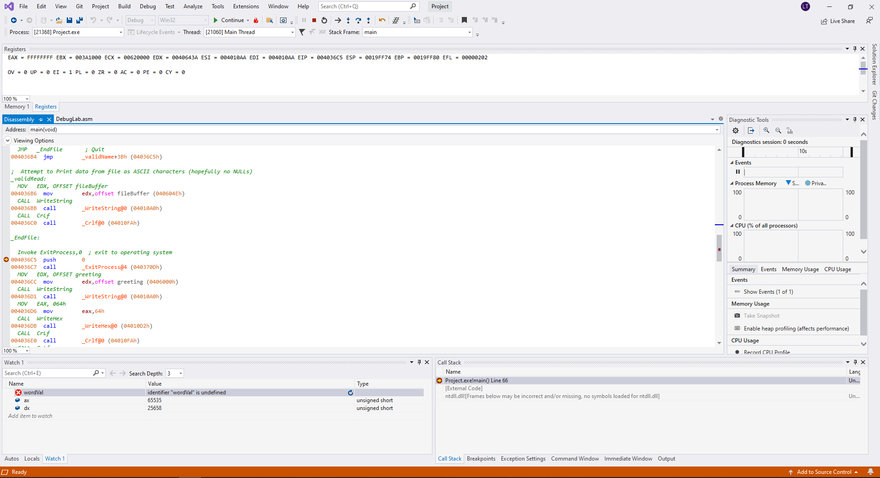

**Disassembly**

**Watch Window**

**Breakpoint**

**Registers (Enable CPU, Flags, Effective Address)**

**Memory Window**

## *Figure 1: Screenshots of IDE state*

Question Part 1.1:



## *Figure 1.1: Current value of EAX*

Current value of EAX = FFFFFFFF

Question Part 1.2:



Carry Flag (CY): Clear

Overflow Flag (OV): Clear

Zero Flag (ZR): Clear

Sign Flag (PL): Clear

Question Part 2:

EAX = 00000419

## *Figure 2: Screenshots of Changing last 3 digits of EAX to OSU ID*

Question Part 3.1:

MOV EDX, OFFSET fileNameError

Question Part 3.2:

00403679

Question Part 3.2:

EIP stores the address of the next instruction, thus the value in EIP will change according to the address of the next execution line.

## *Figure 3.1: Instruction at the validName code label*

Question Part 4.1:

Last 3 digits of OSU ID = 419

Enter: &fileBuffer+420 (equivalent address: 0x004061F6)

ASCII character: s

*Figure 4.1: Address of (n+1)th byte*

Question Part 5:

Before execution of the line (MOV fileHandle, EAX): 0

After execution of the line: 256

*Figure 5: Value of fileHandle*