**Ginga**

Game Design Document

Version: 1.0

**Author:**

Bruno Gontijo Batista

Belo Horizonte – MG Brazil,

1 st of July of 2019

Index

Y

**1.** **History** 3

**2.** **Gameplay** 4

**3.** **Characters** 5

**4.** **Controls** 6

**5.** **Camera** 7

**6.** **Game universe** 8

**7.** **Enemies** 9

**8.** **Interface** 10

**9. Cutscenes** 11

**10. Schedule** 12

1. **History**

- The protagonist is a capoeira fighter called Paranaueh that appears in a parallel reality after his own death having the opportunity to help strangers that wore victims of prejudices for his own redemption.

- The history takes place in several different environments that are vague memories from where Paranaueh has been on earth, facing enemies that are monstrous personifications of prejudices which he has to fight against using his capoeira abilities that slowly comes back to his mind as he progress in his journey.

1. **Game play**

- The game has a side scroller movement with a beat’em mechanics ;

- The player will have to face hords of minor enemies that will come to his encouter trying to protect the personification of a major prejudice. For that the player will have to count on his fighting skills.

- As the player progresses in the game, at the end of each stage, he remembers some of his capoera skills that he need’s to use the defeat stroger enemies to come. Until he faces the final challenge which is the personification of the suprem prejudice.

- For each defeated enemy the player will receive a amount of experience that will be added to his ignorance bar, when the ignorance reachs 0% the player will gain a wisdom level and unlock a capoeira skill.

- The winning condition is to defeat the suprem prejudice at the end of the final stage of the game.

- The player will loose the game when his heath bar reachs zero points. When this condition accomplished, the player will receive the option to restart the stage or quit the game.

1. **Characters**

- The main character is a 35 years old man called Paranaueh.

- Paranaueh is a humble capoeira master that use to teaches his techniques for the most needed children which were born of violence. Paranaueh died also violently trying to protect a homeless from a group of people that has attacking him cowardly, just because he was wandering a wealthier area and the attackers couldn't accept a different person from them beaning at the same spot. After that the only thing that Paranaueh remembers is been summoned in this strange place and feeling a grandiose presence that fulfill his existence with warm and peaceful sensation. At that moment some words were marked in his mind as if they were some kind of uncontrollable thinking but with a different voice. The voice said that he found a a way to wipe out all kind of prejudices from human kind, concentrating this negative energy in to monstrous forms of matter. But to transform them into positive energy, a hero that has been a victim of a prejudice was needed to fight them. So Paranaueh accepts the task and the adventure begins.

- Regarding his personality, Paranaueh is a character that acts by law, and has his own personal code. He believe in order for all and favor a strong, organized government. Usually follows his discipline, mostly without being swayed by the demands of those in need nor by the temptations of evil. Beeing reliable and honorable without being a zealot. Yet, he has tendencies of goodness regaring his students.

3.1 Character Skills

3.1.1 Primary attack:

Activated by clicking at an enemy. If the enemy is in range, the character performs a *Benção* dashing up to 3 meters at the enemy’s direction, following by a *Martelo* attack. If the enemy has died on the first attack, Paranaue aim and dashes to the nearest enemy in range, followed by a third projectile attack, an *Armada* kick.

Martelo / Benção

Damage type: (Phisical + Sonic) * 1.0;

Armada:

Armada is the third and final hit of the primary attack combo. During the animation this skill fires a wall of fire in the direction where the character is facing, hitting all emenies in front at the range of 2 meters

Damage type: (Phisical + Sonic + Fire) * 1.5;

- Ilustração visual dos personagens;

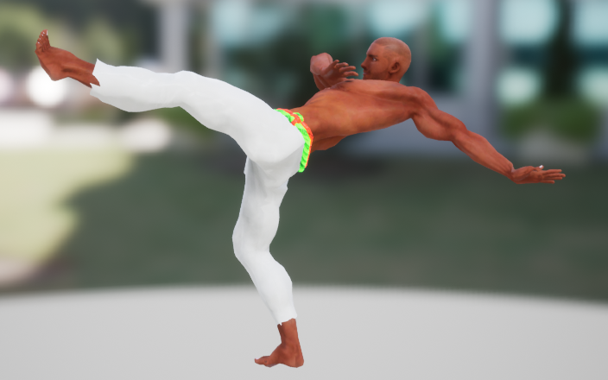

- Ações que os personagens pode executar (andar, correr, pular, pulo duplo, escalar, voar, nadar...);

- Metricas de gameplay do personagem principal;

**4.** **Controls**

4.1 Character movement controls

4.1.1 Keyboard & Mouse Controls

|  |  |
| --- | --- |
| Move up | W |
| Move down | S |
| Move left | A |
| Move right | D |
| Primary attack | Left Mouse Button |
| Secodary attack | Right Mouse Button |
| Dash/Defence ability | Left Shift |
| Ability 1 | Middle Mouse Button |
| Ability 2 | E |
| Ability 3 | Space Bar |
| Ability 4 | F |
| Use Health Potion | Q |
| Interact | R |
| Inventory | I |
| Map | M |
| Emotes | B |
| Show loot | Left Alf |
| Toggle Show Loot | X |
| Toggle Visible UI | F10 |

4.1.2 Gamepad Options

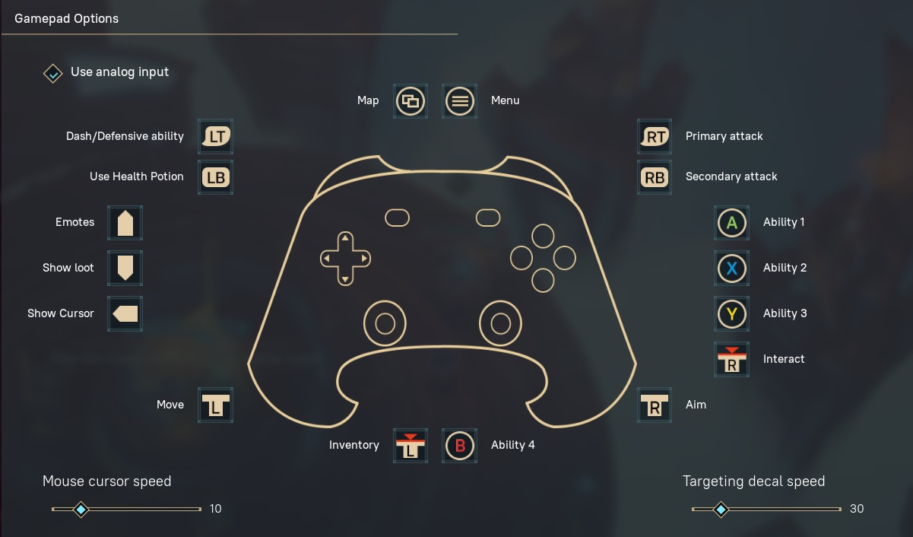

1. **Camera**

The camera is top-down 3rd person as the most ARPG games are.

1. **Universo do Jogo**

- Descrição e ilustração dos cenários do jogo;

- Como as fases do jogo estão conectadas?

- Qual a estrutura do mundo?

- Qual a emoção presente em cada ambiente?

- Que tipo de música deve ser usada em cada fase?

- Inclua ilustrações de todos os mapas e fases do jogo;

1. **Inimigos**

- Descrição e ilustração dos inimigos que existem no universo do jogo;

- Em qual ambiente/fase cada inimigo vai aparecer?

- Como o jogado supera cada inimigo?

- O que o jogador ganha ao derrotar cada inimigo?

- Qual o comportamento e habilidades de cada inimigo?

- Qual o comportamento e habilidades de cada inimigo?

1. **Interface**

- Design e ilustração do HUD (head-up display);

- Posicionamento dos elementos do HUD;

- Design e ilustração das interfaces do jogo: tela inicial, menu de opções, tela de pause, menu de itens, tela de loading, etc...

1. **Cutscenes**

- Descrição dos filmes que serão incluídos no jogo;

- Descrição dos roteiros;

- Qual método será usado para a criação dos filmes?

- Em quais momentos eles serão exibidos?

1. **Cronograma**

- Descrição detalhada do cronograma de desenvolvimento;

- Modelo de cronograma:

|  |  |  |  |  |  |  |  |  |  |  |  |  |  |  |  |  |  |  |  |  |  |
| --- | --- | --- | --- | --- | --- | --- | --- | --- | --- | --- | --- | --- | --- | --- | --- | --- | --- | --- | --- | --- | --- |
|  | **Março** | | | | **Abril** | | | | | **Maio** | | | | | **Junho** | | | | |  | |
| **Tarefa/Semana** | 1 | 2 | 3 | 4 | | 1 | 2 | 3 | 4 | | 1 | 2 | 3 | 4 | | 1 | 2 | 3 | 4 | | **Progreso** |
| Escrever o GDD |  |  |  |  | |  |  |  |  | |  |  |  |  | |  |  |  |  | | Completo |
| Apresentar GDD |  |  |  |  | |  |  |  |  | |  |  |  |  | |  |  |  |  | | Completo |
| Selecionar/desenhar a arte dos personagens |  |  |  |  | |  |  |  |  | |  |  |  |  | |  |  |  |  | | Em Progresso |
| Selecionar/desenhar a arte dos cenários |  |  |  |  | |  |  |  |  | |  |  |  |  | |  |  |  |  | | Em Progresso |
| Desenvolver o sistema de controle do jogador |  |  |  |  | |  |  |  |  | |  |  |  |  | |  |  |  |  | | Planejado |
| Desenvolver sistema de mapas e fases |  |  |  |  | |  |  |  |  | |  |  |  |  | |  |  |  |  | | Planejado |
| Implementar a detecção de colisão |  |  |  |  | |  |  |  |  | |  |  |  |  | |  |  |  |  | | Planejado |
| Desenvolver sistema de pontuação |  |  |  |  | |  |  |  |  | |  |  |  |  | |  |  |  |  | | Planejado |
| Implementar inimigos |  |  |  |  | |  |  |  |  | |  |  |  |  | |  |  |  |  | | Planejado |