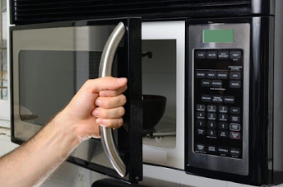This design does not consider constraints; where the knob is made of metal which is heat conductor, also there is no label preventing the user from using the knob with bare hands

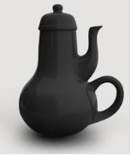

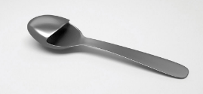This two products does not consider affordance; as we don't even know how to use them or their purposes

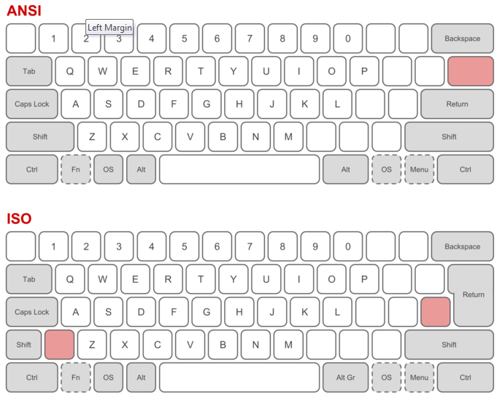

The two keyboards are inconsistent here though they can do different functions

**Name: Louay Magdy Abdel-Halim Ali**

**ID: 19016195**