**What is the best visualization type to represent the relationship between salary and job title in a software house classified by gender. Aid your answer with sample visualization on any dummy data**

Clustered Column Chart

Eg.

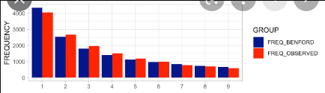

By mapping each number to a job title ,each color from both colors represent a certain gender ,and the frequency mapped to salary