Report for COMP432 – Network Security Lab Assignment 1
University of Nicosia
Assigned Date: Week 1
Due Date: Week 4 Submit via Blackboard
Name: Loucas Mouttotou
Network Security Monitoring with Suricata (IDS/IPS)

Lab Environment
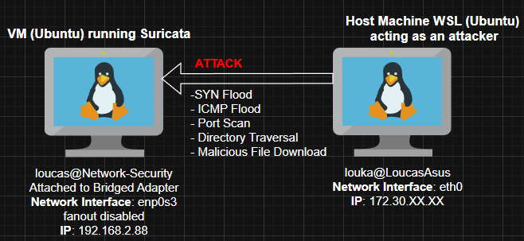

SYN Flood Attack
is a type of denial-of-service (DDoS) attack which aims to make a server unavailable to legitimate traffic by consuming all available server resources, by repeatedly sending initial connection request (SYN) packets. It mainly affects Availability in terms of the CIA triad but can also lead to data loss-Integrity as overwhelmed servers may not be able to save new data. Suricata quickly sends multiple alerts for these type of attacks (SURICATA STREAM packet with invalid ack).

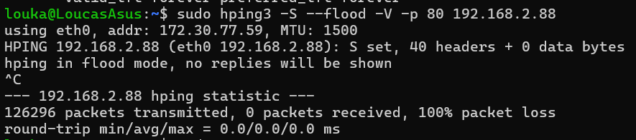
Figure 1: Example of a SYN Flood Attack on Suricata VM using hping3.
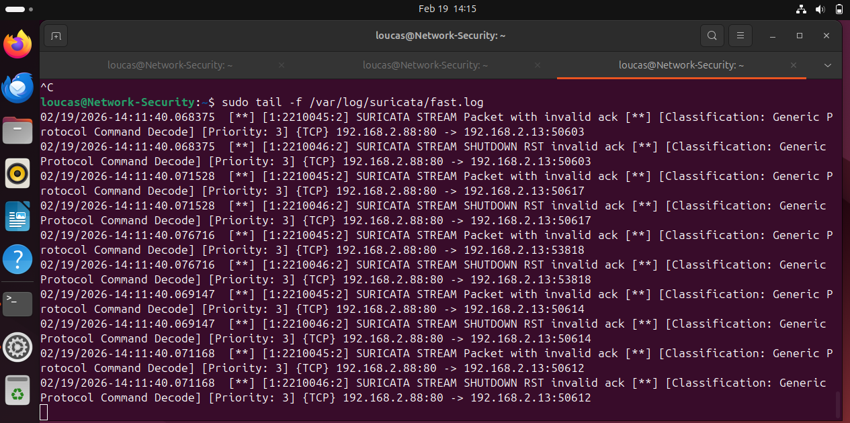
Figure 2: Suricata TCP alerts after SYN Flood attack.

ICMP Flood Attack
is a denial-of-service attack in which the attacker attempts to overwhelm a targeted device with ICMP echo-request packets, causing the target to become inaccessible to normal traffic, effectively targeting the Availability section of the CIA triad. Suricata also quickly detected this attack (ICMPv4 invalid checksum).

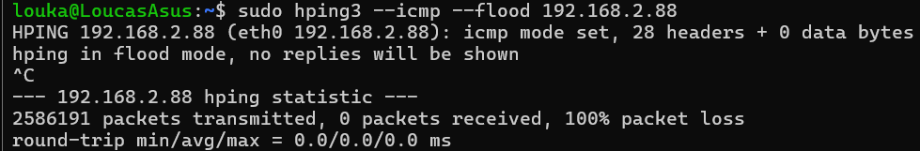
Figure 3: ICMP Flood attack on Suricata VM using hping3

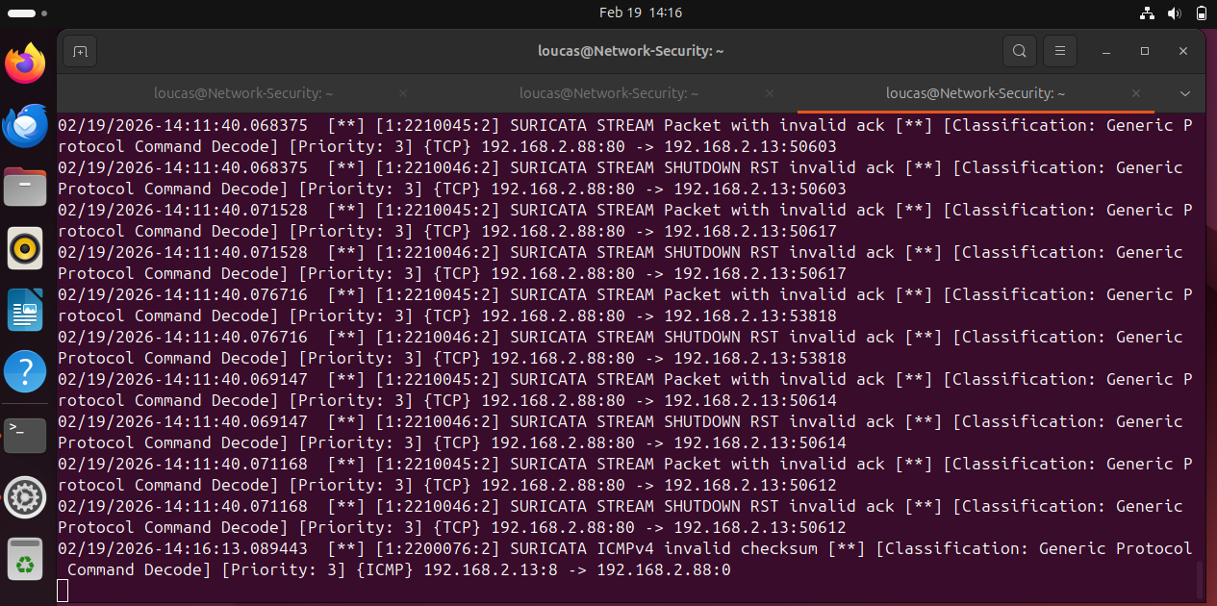
Figure 4: ICMP attack alert.

Port Scan
is a network reconnaissance technique that sends client requests to a range of server port addresses on a host to determine which ports are open, closed, or filtered. Suricata doesn’t seem produce any alerts for passive scanning as it might reassemble legitimate behaviour, through it might produce for more aggressive scans.

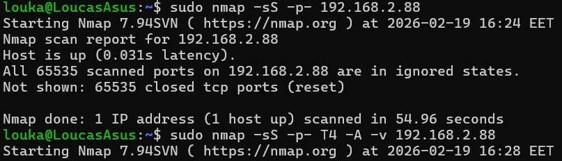
Figure 5: Attempting passive scanning with nmap.

CIA Triad Impact
- Confidentiality: Port scanning identifies open services that may expose sensitive data.
- Integrity: Information gathered may later be used to exploit vulnerabilities.
- Availability: While scanning itself does not directly disrupt services, it enables future DoS attacks.

Directory Traversal Attack
attempts to access restricted files by manipulating input paths. For this attack, I started a web server on port 80 using Python and simulated an attack using the curl command to see if Suricata detects it. A directory traversal attack affects the Integrity in terms of the CIA triad as an attacker could manipulate/change sensitive user or system data.

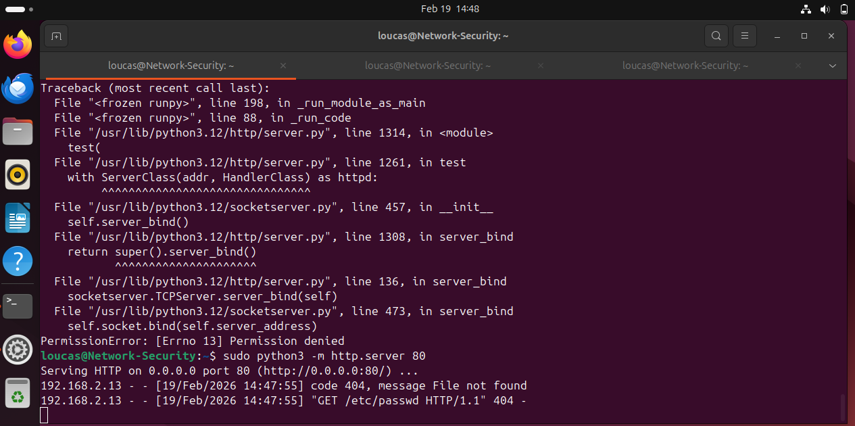
Figure 6: Command to start web server on port 80

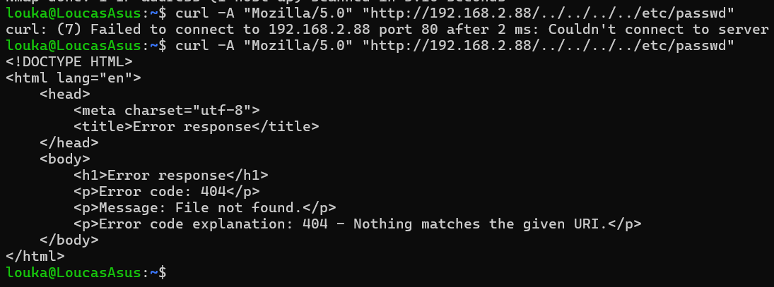
Figure 7: curl command leads to no file found

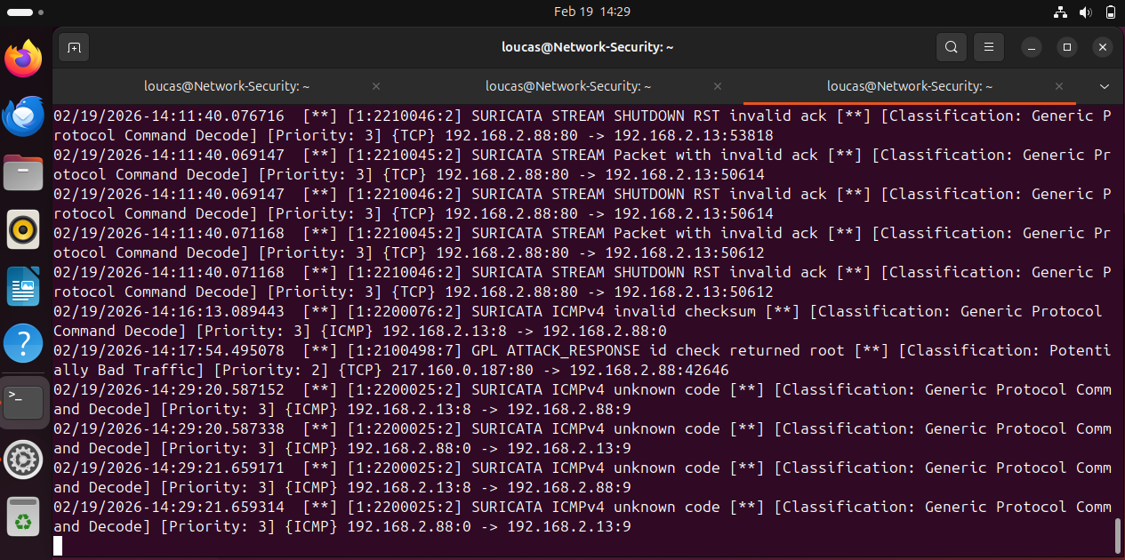
Figure 8: Alerts triggered by Suricata (ICMPv4 unknown code).

Malicious File Download
For this simulation the command wget http://testmyids.com was used in the VM machine running Suricata. Suricata flagged the download of the file as Priority 2, the highest of all the attacks until now.
The high priority alert was expected because downloading a potentially malicious file from an untrusted external source poses a significant security risk. Such files may contain hidden payloads, backdoors, or modified configurations designed to compromise the target system. Even if the file appears harmless when executed, it may alter system settings or weaken security control, while everything would seem to be working as usual.
Among the CIA triad components, this scenario primarily threatens Integrity, as malicious files often modify system configurations or force unauthorized changes. However, depending on the payload, Confidentiality and Availability may also be affected.

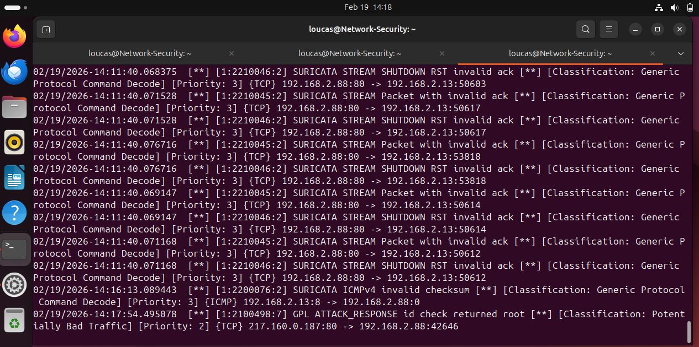
Figure 9: Alert triggered by Suricata (GPL ATTACK_RESPONSE).

Conclusion
This lab provided a practical introduction to the Suricata IDS/IPS application and its role in detecting and analysing network-based threats. Through configuring and testing Suricata, I was able to observe how different types of malicious activity trigger alerts and how these alerts relate to the CIA triad (Confidentiality, Integrity, and Availability).
During the lab, I encountered initial difficulties with getting Suricata to generate alerts correctly. After troubleshooting, I discovered that the issue was related to the HOME_NET configuration. The default setting did not accurately reflect the virtual machine’s internal network. Updating HOME_NET to 192.168.2.0/24 ensured that Suricata properly identified traffic originating from and directed to the internal network. Once this change was made, alerts were triggered as expected.
Overall, the lab demonstrated how Suricata can detect suspicious activity in real time and highlighted the importance of monitoring network traffic to protect system integrity and security.
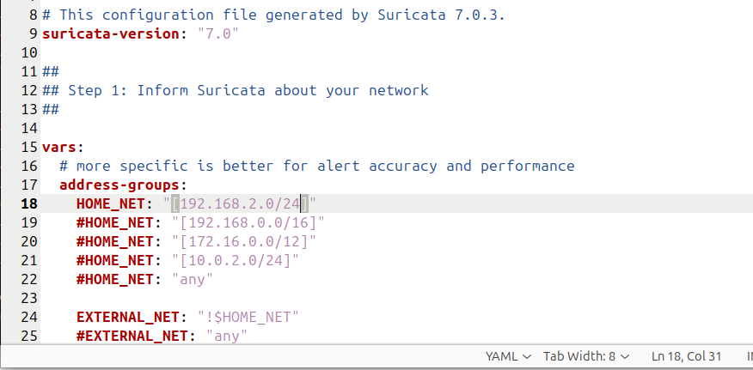
Figure 10: Example of changing HOME_NET.

