**5.<in aeternum>**

**Software Requirements Specification**

**Version <2.1>**

**Revision History**

|  |  |  |  |
| --- | --- | --- | --- |
| **Date** | **Version** | **Description** | **Author** |
| 25.10.2016 | 1.0 | Initial fill up | Louisa, Marco |
| 03.12.2016 | 1.1 | Updating | Louisa |
| 07.05.2017 | 2.0 | Updating Languages | Louisa |
| 20.06.2017 | 2.1 | Updating | Louisa |

**Table of Contents**

1. Introduction

1.1 Purpose

1.2 Scope

1.3 Definitions, Acronyms and Abbreviations

1.4 References

1.5 Overview

2. Overall Description

3. Specific Requirements

3.1 Functionality - Website

3.1.1 Register for a new account

3.1.2 Login for existing account

3.1.3 Overview page

3.1.4 General informations

3.1.5 Create a guest list

3.1.6 Save as pdf

3.1.7 Integrating a playlist

3.1.8 Specify your budget

3.2 Usability

3.3 Reliability

3.3.1 Availability

3.4 Performance

3.4.1 response time for a transaction

3.5 Supportability

3.5.1 Language Support

3.6 Design Constraints

3.7 On-line User Documentation and Help System Requirements

3.8 Purchased Components

3.9 Interfaces

3.9.1 User Interfaces

3.9.2 Hardware Interfaces

3.9.3 Software Interfaces

3.9.4 Communications Interfaces

3.10 Licensing Requirements

3.11 Legal, Copyright, and Other Notices

3.12 Applicable Standards

4. Supporting Information

**Software Requirements Specification**

# **1.** **Introduction**

## **1.1** **Purpose**

This SRS gives an overview about the specifications for our project “in aeternum”

## **1.2** **Scope**

## We want to build a website where you can plan your own funeral.

## **1.3** **Definitions, Acronyms and Abbreviations**

User A user is one person, who is registered at our website. The user can interact with our website. He is identified by his username and user password.

## **1.4** **References**

|  |  |  |
| --- | --- | --- |
| **Title** | **Date** | **Author** |
| [Blog](https://inaeternumblog.wordpress.com/) “in aeternum” | 25.10.2016 | in aeternum Team |
| [Github](https://github.com/Louicha/inaeternum) repository | 21.06.2017 | In aeternum Team |
| [Codacy](https://www.codacy.com/app/Louicha/inaeternum/dashboard) code review | 21.06.2017 | In aeternum Team |
| [Django](https://djangoproject.com/) Framework | 07.05.2017 |  |

## **1.5** **Overview**

# **2.** **Overall Description**

*2.1 Vision*

When we die, our family and friends are in deep mourning. Added to this, they must also organize our funeral. But what if we don’t want a funeral where everyone wears black and listen to sad music? What if we want the people to wear colorful clothes and listen to “Highway to hell”?   
  
We decide to make a Website, where you can plan your funeral. Because dead is a topic which goes more with older people we decide to make a layout which is senior friendly.

2.2 Overall use cases diagram

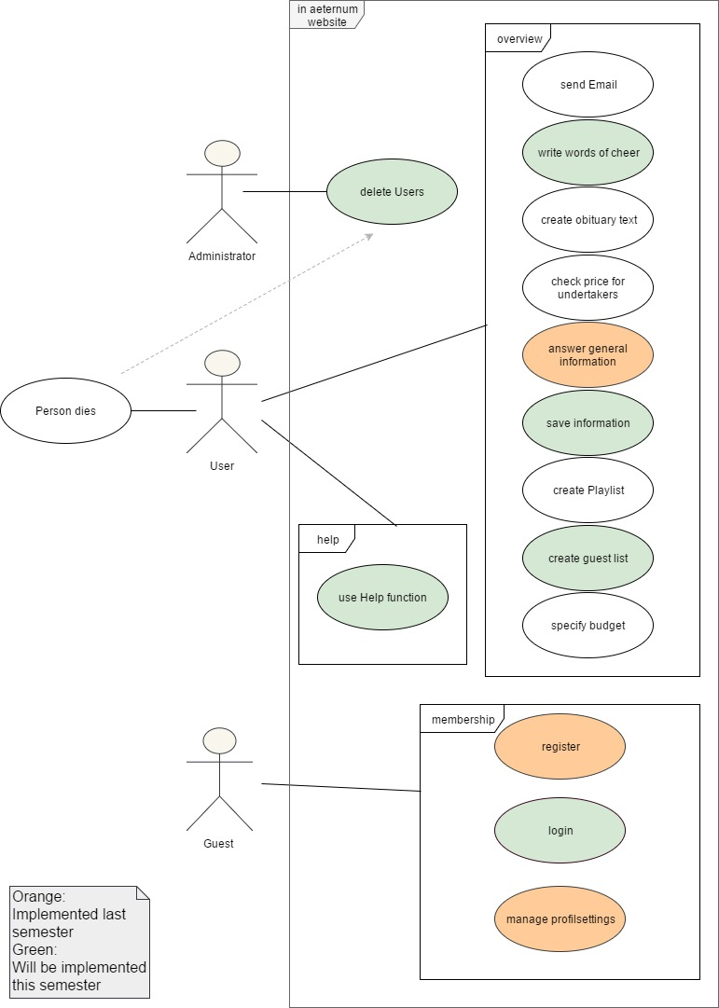

# **3.** **Specific Requirements**

## **3.1** **Functionality - Website**

### *3.1.1* *Register for a new account*

### There is the possibility to register for a new user.

### *3.1.2 Login for existing account*

### There is the possibility to login for an existing account.

### *3.1.3 Overview page/Profil age*

### A page for the user, where he or she can maintain her profil and change answers.

### *3.1.4 General informatio*

### The user can save general data about their funeral, e.g. their burial method.

### *3.1.5 Create a guest list*

### *The user can create a guest list.*

### *3.1.6 Save as pdf*

### The user can save all the information about his funeral as pdf.

### *3.1.7 Integrating a playlist*

### The user can integrate a playlist from e.g. Deezer to his or her account.

### 3.1.8 *Specify your budget*

### The user is able to specify his or her budget for the funeral.

3.1.9 *Write words of cheer*

The user can write some last words for his or her loved ones

3.2.0 *Use help function*

The user can click a help button to get more information about a topic and what to do

3.2.1 *Manage Profilsettings*

The user can manage his or her profil settings, e.g. change his email address.

## **3.2** **Usability**

### *Our Website should be user-friendly. It should have a simple design with an intuitive interface.*

## **3.3** **Reliability**

### *3.3.1* *Availability*

The website should be available 90% of the time. When a downtime is needed to for data loads or bug fixes it should be between 10pm. and 6am.

## **3.4** **Performance**

### *3.4.1* *Speed*

The response time for a transaction should be as short as possibly to get a great user experience

## **3.5** **Supportability**

### *3.5.1* *Language Support*

### The following languages will be used:

### Internet Standards HTML5, CSS3

### PHP 7

* Python
* My SQL

We use the Framework [Django](https://www.djangoproject.com/).

## 

## **3.6** **Design Constraints**

The website is designed to be extendible, so later on, there might be other functions e.g. upload a video, .. With our framework we follow model view control concept.

## **3.7** **On-line User Documentation and Help System Requirements**

The website will have a senior friendly, intuitive design. Also there will be a help button, where a user can get more information about the current page and background information about the topic.

## **3.8** **Purchased Components**

*-*

## **3.9** **Interfaces**

### *3.9.1* *User Interfaces*

(tbd)

### *3.9.2* *Hardware Interfaces*

The software is running on a webserver.

### *3.9.3* *Software Interfaces*

The software is based on the Django Framework.

### *3.9.4* *Communications Interfaces*

No statement can be made at this time of development.

## **3.10** **Licensing Requirements**

No statement can be made at this time of development.

## **3.11** **Legal, Copyright, and Other Notices**

No statement can be made at this time of development.

## **3.12** **Applicable Standards**

No statement can be made at this time of development.

# **4.** **Supporting Information**

None so far