**Delivery Underground Man**

*A game about a guy try to deliver food from the underground to people living on the ground*

Gameplay Overview

Description: You start at the bottom of the underground city, need to climb your way up to the ground and deliver the food to your customer as soon as possible. You don’t want to be penalized because of late delivery. You need to overcome obstacles on the way which will be different depending on the area. The player experience should be intense on dodging obstacles/crazy people trying to rob the food, finding items that lead to a shortcut while focusing on time management.

Win state: You delivered the food to the customer

Lose state: You were hit by obstacles / Fail to deliver the food in time limit

Controls

Left: move left

Right: move right

A: pick up item

B: use item

Up: if on ladder, move up; if on ground, jump

Down: crouch

Start: start the game; if in gameplay, pause the game

Audio

Menu music: intense music, make players feel like that are prepared to fight a war

Game music: heavy metal, to create a sense of madness in the underground and chaos on the ground

Pause music: elevator music

Crazy people yell: voice act

Item pickup: digital noise

Win: upbeat music

Lose: downbeat music

Gameplay Details

Items: collision with the items to pick it up, different items have different effect to speed up the journey (slow the timer, increase movement speed, etc. more details later)

Map: the map will keep scrolling as the player move upward (HOFS & VOFS); different map design for underground and ground (tiles)

Illustration

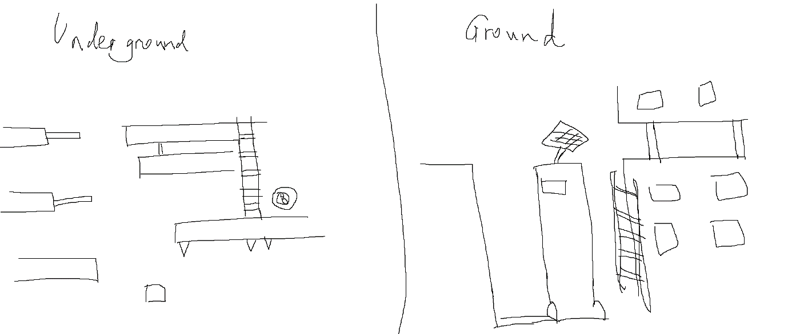

Fig 1.: Demonstrate basic map layouts and level design. Enemies (crazy people) and obstacles will be designed in more detail and distributed in maps.