COSC363 – Assignment 1

OpenGL Museum

Louis Davies

Lda62

94941666

Report:

Camera controls:

‘up arrow’: move forward ‘a’ key: strafe left

‘down arrow’: move back ‘d’ key: strafe right

‘left arrow’: look left ‘w’ key: move camera up

‘right arrow’: look right ‘s’ key: move camera down

Base: The museum building and floor is generated from quads and textured. The whole scene is encapsulated by a skybox textured with a cloudy sky.

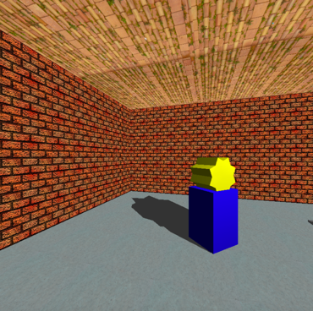Model 1: Star on a stand

Figure 1: Star on a stand

This model is a star prism on top of a stand, the stand is made of a single blue cube and the star is made of two yellow cubes rotated at different angles. As you can see in figure 1 this model casts a planar shadow towards the corner of the museum as light source is elevated in the middle of the room. In figure 1 you can also see three textured surfaces, the concrete floor, the brick walls and the tiled roof.

Model 2: Bouncing ball in a vice

Figure 3: Ball in tightened vice bouncing

Figure 2: Ball in vice sitting still

The second model is a red bouncing ball in a vice that can be tightened or loosened. The red ball in a glut solid sphere and the vice is two cubes. Using 10 units as a metre I generated equations to simulate gravity on the ball. MyTimer is called every 50 milliseconds so using mechanics equations for distance and velocity I could get the new velocity and position of the ball using these equations:

ball_velocity_new = ball_velocity + grav * 0.05;  
ball_height = ball_height + ((ball_velocity + ball_velocity_new) / 2) * 0.05;  
ball_velocity = ball_velocity_new;

where gravity was -98 (remembering I chose to use 10 units as a metre).

Controls for this models animation:

‘b’ key: “Bounce” the ball (add upwards velocity)

‘o’ key: Tighten vice (has a maximum amount)

‘l’ key: Loosen vice (has a minimum amount)

Model 3: Helicopter

Figure 4: Helicopter at 3 different positions

The third model is a helicopter made up of a range of glut objects and objects I made myself. The front of the helicopter was generated using points that form a parabola using a parabolic equation these points were used to form quad strips and triangle fans that make up the cockpit area of the helicopter. The equation and points used are shown below:

// Generate parabola points for quad strips and triangle fans  
float vy[22] = {-10., -9., -8., -7., -6., -5., -4., -3., -2., -1., 0., 1., 2., 3., 4., 5., 6., 7., 8., 9., 10., -10.};  
float vz[22] = {0};  
for (int index = 0; index < 22; index++) {  
 vz[index] = (vy[index] * vy[index])/10; // parabola equation  
}

After the animation is activated the helicopter will move up and down until the start button is pressed again at which time it will start moving down if not already and land and stop moving. Whenever the helicopter is moving both the propeller on the top and on the tail will spin they will spin faster when the helicopter is ascending than when it is descending. The helicopter also has a spotlight on the bottom of its body which moves up and down as seen in the last two positions of figure 4.

Controls for animation:

‘h’ key: Start animation/Make land and stop animation

Instructions for build:

Unzip folder and open it in an IDE of your choice set the working directory and run Museum.out

(Note: I haven’t tested the if statement in the includes to check if it works on other OS that do not have glut as I am on mac so this might need to be replaced with just #include <GL/freeglut.h> or #include <GLUT/glut.h> depending on what you are running.)

currently it has:

#ifdef __APPLE__  
#include <GLUT/glut.h>  
#else  
#include <GL/freeglut.h>  
#endif

References:

Sky Box: <https://opengameart.org/content/sky-box-sunny-day>

Concrete: <http://texturelib.com/texture/?path=/Textures/concrete/floor/concrete_floor_0052>

Roof Tiles: <http://texturelib.com/texture/?path=/Textures/roof/roof_0110>

Bricks: COSC363 labs