*Table 1 – Matrix Expressions*

|  |  |
| --- | --- |
| Expression | Result |
| A./B | [3,1,3; 0.5,1,0.5; 1,4/3,1/3] |
| A.*B | [3,1,3; 2,4,2; 9,12,3] |
| A.^2 | [9,1,9;1,4,1;9,16,1] |
| rank(A) | 3 |
| rank(B) | 1 |

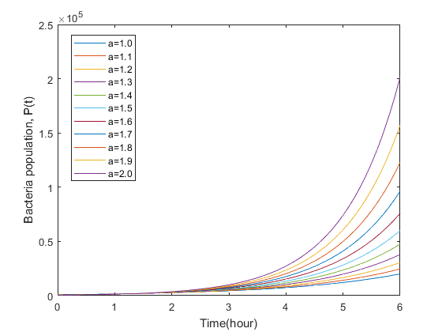

1. Faster the populations of the bacteria increases, the bigger a.
2. The population with a = 2.0 increases fastest when 𝑡 → ∞. When t is around 1.38h, the exponential function of a = 2.0 becomes the biggest population.
3. Analyze the function to find the period when f(t1) 🡪 f(t2) = 2f(t2), $e^{0.5at_{2}}=2e^{0.5at_{1}}$,

$t_{2}-t_{1}=\frac{ln⁡(2)}{0.5a}$.

I chose a = 1.0, 1.5 and 2.0.

|  |  |  |
| --- | --- | --- |
| A-value | Doubling time (estimate) | Doubling time (analysis) |
| 1.0 | 1.4 | 1.386 |
| 1.5 | 0.9 | 0.924 |
| 2.0 | 0.7 | 0.693 |

From the table above, the error between estimate and analysis doubling time is small. The estimate doubling time matches the analysis.

1. The similarities of doing matrix by using matlab and by-hand is the same result, however the computer can give a result faster but with some small error. It is better to use matlab when the matrix is complex, the numbers in the matlab are complex or the operation is complex. However, it is more appropriate to do matrix math by-hand when the matrix is easy and involves fraction result because the matlab gives the result in the form of decimal.

When using “for” loop, it is important to consider whether it is a finite loop, and the efficiency of the loop.