**Lab 8**

**Pumpkin-throwing contest problem**

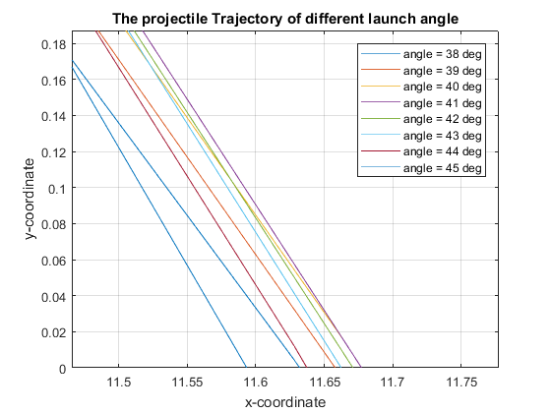

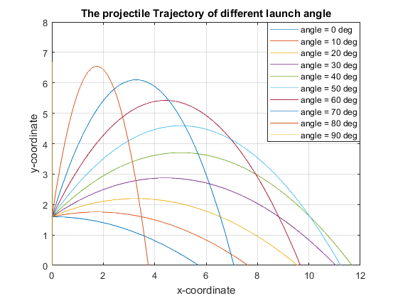

In the process of solving the problem, I assume that the initial height of the launch is 1.6m which is approximately as high as the arm of an adult. The gravitational acceleration is 9.81 m/s2. The initial speed is 5 m/s. Under these conditions, I decompose the acceleration of the objects in x and y directions, which is 0 m/s2 and -9.81 m/s2 respectively.

According to the physical principle, v = at, s = v0t + ½ at2. I calculate the formula for vx, vy, sx, and sy with respect to t and related to angle theta.

Vx = cosd(theta) * vi (vi: the initial speed, same as below)

Vy = -1 .* g .* t + sind(theta) .* vi

Sx = cosd(theta) .* vi .* t + 1/2 .* ax .* t .^ 2(ax: the horizontal acceleration which is zero)

Sy = sind(theta) .* vi .* t - 1/2 .* ay .* t .^ 2 + yi (yi: the initial height, ay: the vertical acceleration which equals to negative g, 9.81 m/s2)

To best find the farthest trajectory, I plot the graph of sx verses sy choosing ten different angles from 0 degree to 90 degrees [graph on the left]. It showed that when the angle is around 40 degrees, the distance will be the farthest.

To accurately find the angle, I plot the projectile trajectory when the angle is in the range 38 to 45 degrees [graph on the right]. When the angle is around 41 to 42 degrees, the distance of throwing pumpkins is the farthest, about 11.67m.