**Mat188: Lab 9**

**PART (I): Function Plotting**

(a)

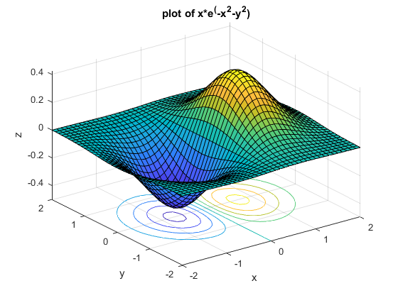

(b)

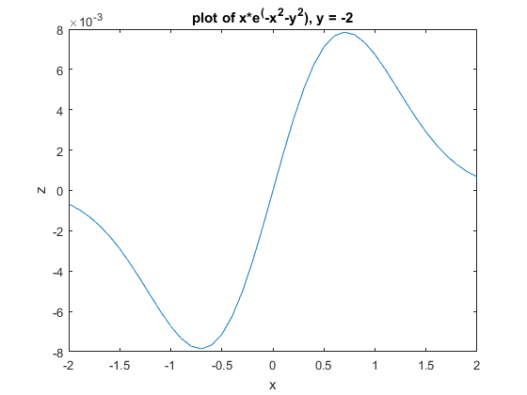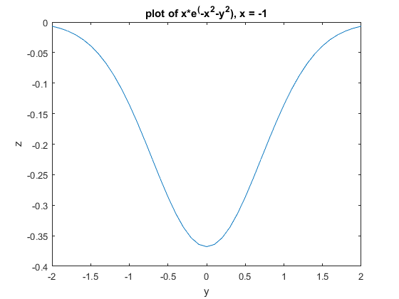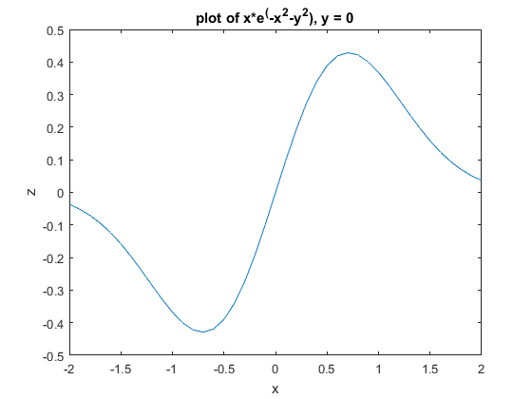

(c) The maximum of this 3D plot is at x = 0.7, y = 0, the value is = 0.4288.

The minimum of this 3D plot is at x = -0.7, y = 0, the value is = 0.4288.

(d) “meshgrid” function is used to create a certain shape of a matrix which has x-value and y-value at each of the point.

(e) when x = 0, z is always 0. Z are always positive when x are positive and z are always negative when x are negative. In part (b) of the problem, compare the plots when y = 0 and y = -2, it is obvious that their shapes are similar, but the maximum of the plot when y = -2 is less than that of the plot when y = 0. It can be identified in the 3-D plot. In the plot when x = -1, it can be identified in the 3-D plot that it has the minimum when y = 0 and the values of z are always negative.

In fact, the plot of an exact x or y is like a cross section of the 3-D plot.