ARCADE

1. Introduction
The Arcade project is a gaming platform that allows for the dynamic loading of graphics libraries and games.
The goal is to provide a modular architecture that makes it easy to add new games and graphical interfaces.

2. General Architecture
The project is divided into three main parts:

2.1 Core
The main program :
- Manages the dynamic loading of libraries
- Display the main menu
- Handle user input
- Manages scores

2.2 Graphics Libraries
Responsible for:
- Displaying sprites and text
- Creating and closing the window
- Retrieving textures, sounds, and text
- Handling events (keyboard, mouse)
Examples :
- ncurses
- SDL2
- SFML

2.3 Games Librairies
Responsible for:
- The game logic
- Manages scores
- Handle key event
Examples :
- Snake
- Demineur

3. Load .so
The project uses the following functions which are in place in the encpasulation folder:
- dlopen, dlsym, dlclose, dlerror

3.1 Objectif
Allows:
• Switching graphics libraries
• Dynamically loading different games
This requires encapsulation because these functions originate from C.

4. Interfaces
A global iterface for manage the libs :
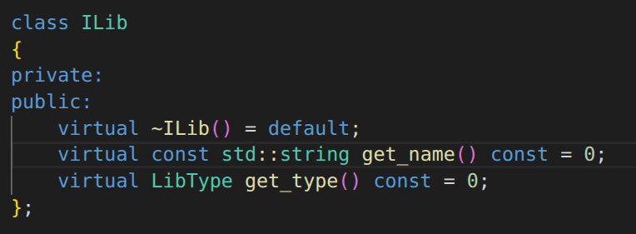
We can therefore distinguish two main types of interfaces

4.1 Graphical Interface (IDisplay)

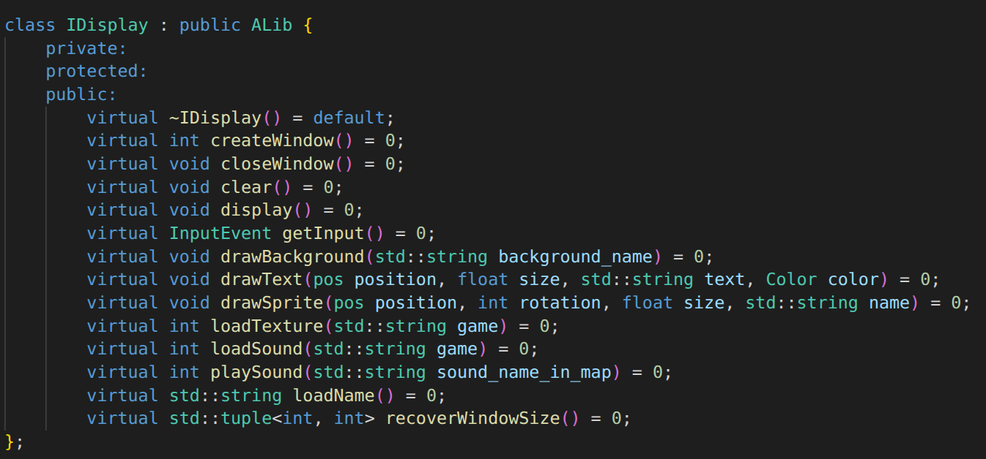
4.2 Game Interface (IGame)

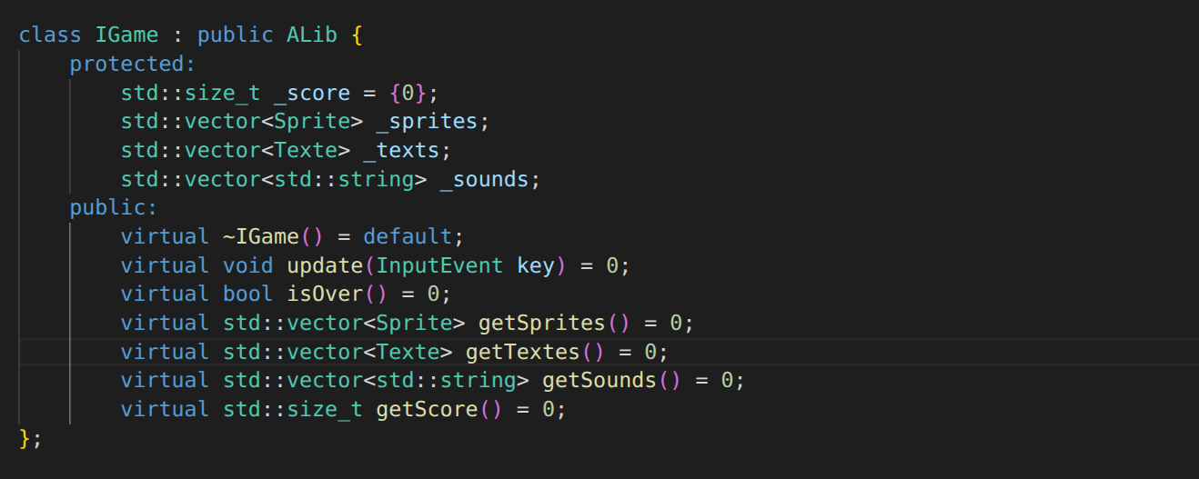
5. Implement a new Display (Example Ncurses)
5.1 Create the graphic :
The Ncurses graphical must be placed in a dedicated folder :
Graphical/Centipede/

This folder must contain at least two files :
- ncurses.hpp
- ncurses.cpp
6.2 For the centipede.hpp :
Include IDisplay.hpp
• Create a Ncurses class
• Inherit from IDisplay

• Copy ALL methods from IDisplay
- remove virtual
- add override
This should give you:
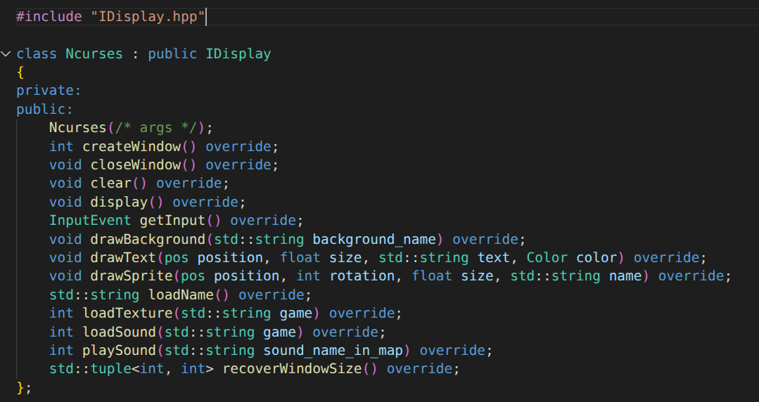
After that, all you have to do is implement your cpp; don't forget to implement your EntryPoint function, otherwise your library will never work.
6.3 For the centipede.cpp :
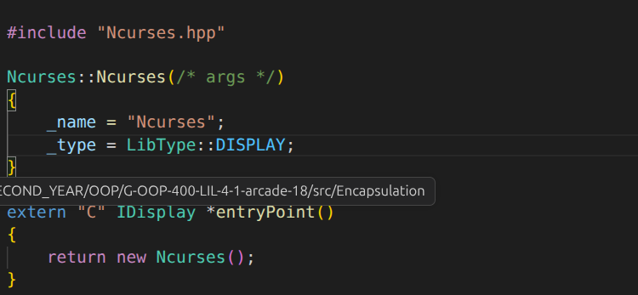
Of course, not all methods are implemented; you'll have to do it yourself. You absolutely must use all the methods from the public HPP.
After that, you can do your game.

6. Implement a new Game (Example Centipede)

6.1 Create the game :
The Centipede game must be placed in a dedicated folder:
Games/Centipede/

This folder must contain at least two files :
- centipede.hpp
- centipede.cpp
6.2 For the centipede.hpp :
Include IGame.hpp
• Create a Centipede class
• Inherit from IGame

• Copy ALL methods from IGame
- remove virtual
- add override
This should give you:
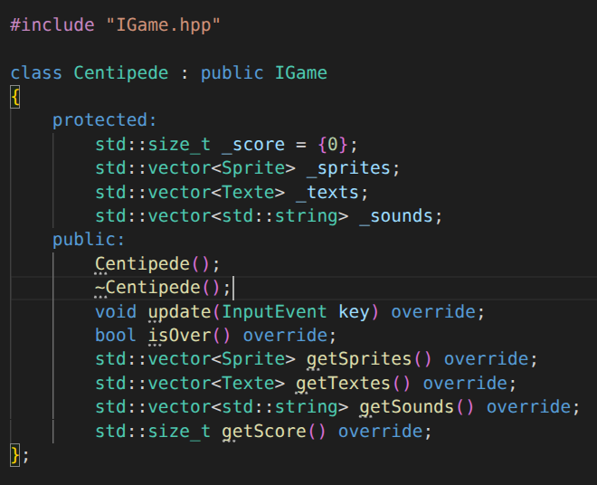
After that, all you have to do is implement your cpp; don't forget to implement your EntryPoint function, otherwise your library will never work.
6.3 For the centipede.cpp :
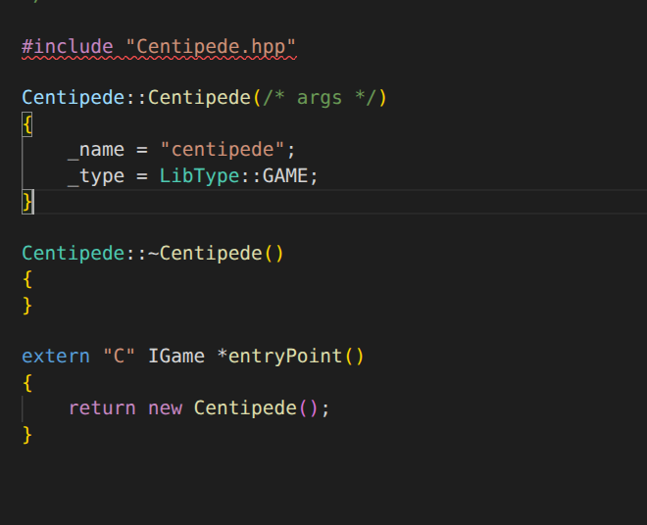
Of course, not all methods are implemented; you'll have to do it yourself. You absolutely must use all the methods from the public HPP.
After that, you can do your game.
And your assets in a folder corresponding to its name:
assets/centipede/ → asccii → your .txt
→ images → your .png
→ sounds your .mp3

6.4. Other case :
If you already have .so files with the same architecture as seen above, you just need to place your graphics and game libraries in the folder:
/lib
And your assets in a folder corresponding to its name:
assets/centipede/ → asccii → your .txt
→ images → your .png
→ sounds your .mp3

7. Authors
Name : Hector Louis, Noam Bouillet
Year : 2026

