Journal #1

Louis Harshman - WaveSpeak

Goals:

* Begin 3D Model/CAD design.
* Assist someone in a small but meaningful way with their project.
* Finish blog section
* Get calculator front plate drawn up.
* Set up website with GitHub pages.
* Help people I am supporting.
* Finish Journal #1
* Buy the Display
* Prepare the model to be changed for possible display dimension mishaps.

**Research Goal**: Learn about how to handle keyboard circuitry.

My Research and What I learned:

I decided to research more into keyboard technology for my button backplane. I still plan on using a PCB with buttons to handle user input with tactility. This following video helped me learn how to do PCB design in KiCad. <https://youtu.be/JqpBKuEVinw?si=k0k1UDmzw2G0xcvK>

I learned that I probably would need to consider a programmable micro controller or sacrifice an existing keyboard for the electronics handling the button circuits.

<https://golem.hu/guide/controllers/>

Accomplishments

The [www.wavespeak.org](http://www.wavespeak.org) website is up and running on GitHub pages. In my opinion it turned out pretty good and after getting a 3D Model fledged out, I think the landing page looks a lot cooler.

The CAD model is reaching a point where I’m waiting for my display to come in so I can measure and make sure my tolerances are correct.

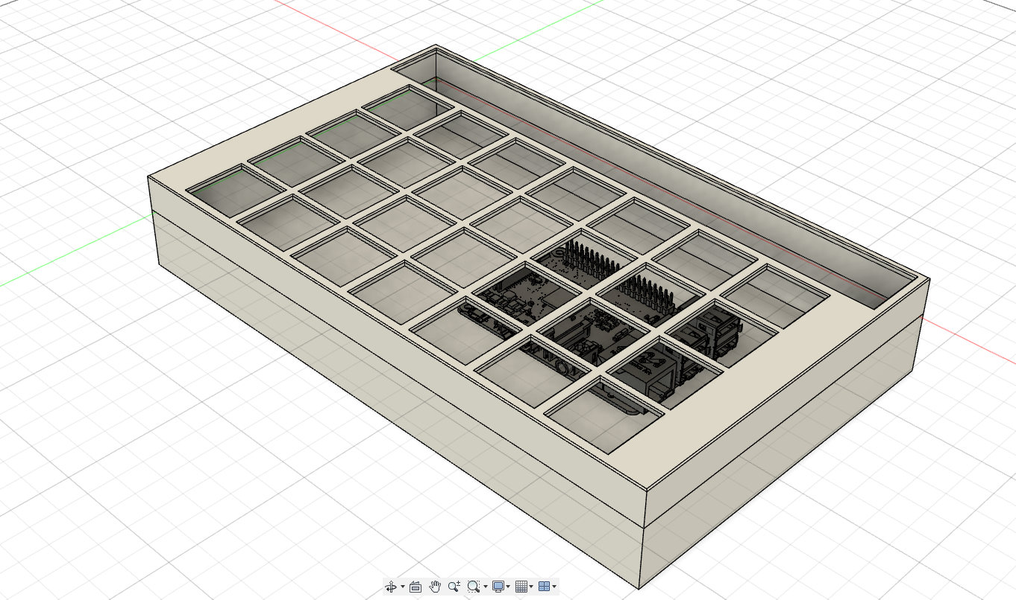

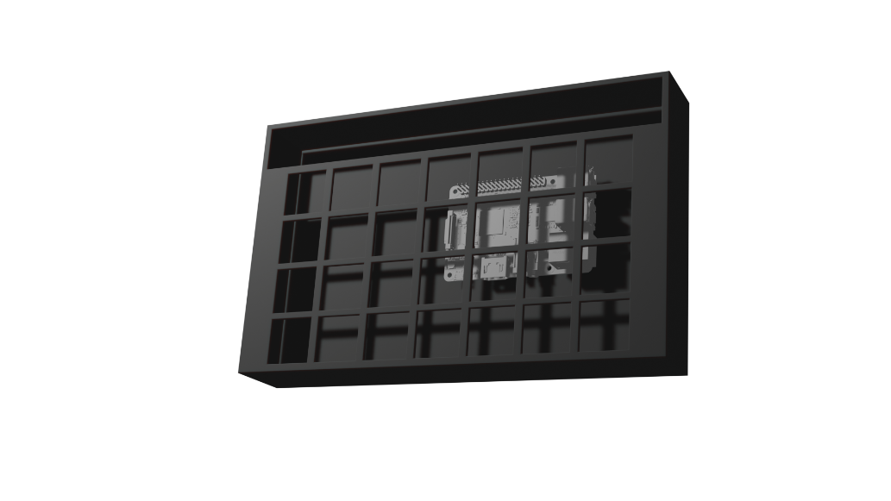

Reflection on goals and Timeline:

I currently believe I’m ahead of schedule by about a week. I need to order the display so I can finish modeling the case so that will set me back in the future. I also need to design the PCB because that is an integral part of the design.

**Goal Reflection:**

* Begin 3D Model/CAD design.
  + I blew this goal out of the water and I’m proud of how fast I was able to learn CAD.
* Assist someone in a small but meaningful way with their project.
  + I helped Jayal setup basic configs for his website. I want to help all the projects in the class in some way.
* Finish blog section
  + I got the blog section made but I need to write the blogs for the last two weeks.
* Get calculator front plate drawn up.
  + This wasn’t too hard but getting the buttons centered was a little difficult.
* Set up website with GitHub pages.
  + I had some difficulties getting the domain, Cloudflare, and GitHub working together but I was able to get the website up and running reliably quickly.
* Help people I am supporting.
  + This week, I assisted brady with getting data for his skateboarding research.
* Finish Journal #1
  + This goal will be absolutely met on Friday.
* Buy the Display
  + …
* Prepare the model to be changed for possible display dimension mishaps.
  + I have set up parameters to scale the models sketches with minimal effort. I am having issues with “over constrained” errors, but I am finding ways around this “error”.