Journal #3

Louis Harshman – WaveSpeak

Goals and reflection:

1. Start Tauri development
   * I have initialized the project folder and dependencies and I have a “hello world” sort of thing running in the Tarui environment.
2. Research Tauri and Rust development
   * I have learned more about Tauri but when It comes to rust, I have a very basic and surface level understanding of it.
3. Reprint Button mold
   * I have printed 2 prototypes with different slicer settings. The biggest problem I am having is my printer leaving holes due to moisture in the filament.
4. Redo the schedule
   * I redid the final stretch of the google calendar.
5. Prepare icons for app
   * I am still looking for a high-quality set of AAC talker tablet icons.
6. Help CalcVox with fusion360
   * Helped grant learn some basic fusion360 workflow and methods of CAD.
7. Finish Journal #3
   * Currently doing that right now
8. Finalize epoxy choice
   * It is in my amazon cart and once I have the money, I’ll buy it.
9. Commit to a software solution
   * The Tauri stack seems like the best mix between powerful and lightweight for the embedded system I am building.

Reflection on Timeline:

I have been keeping fairly on time with the *revised* timeline. I have far less time for software development but due to my proficiency in software development rather than hardware development, this is not detrimental to the project.

Accomplishments:

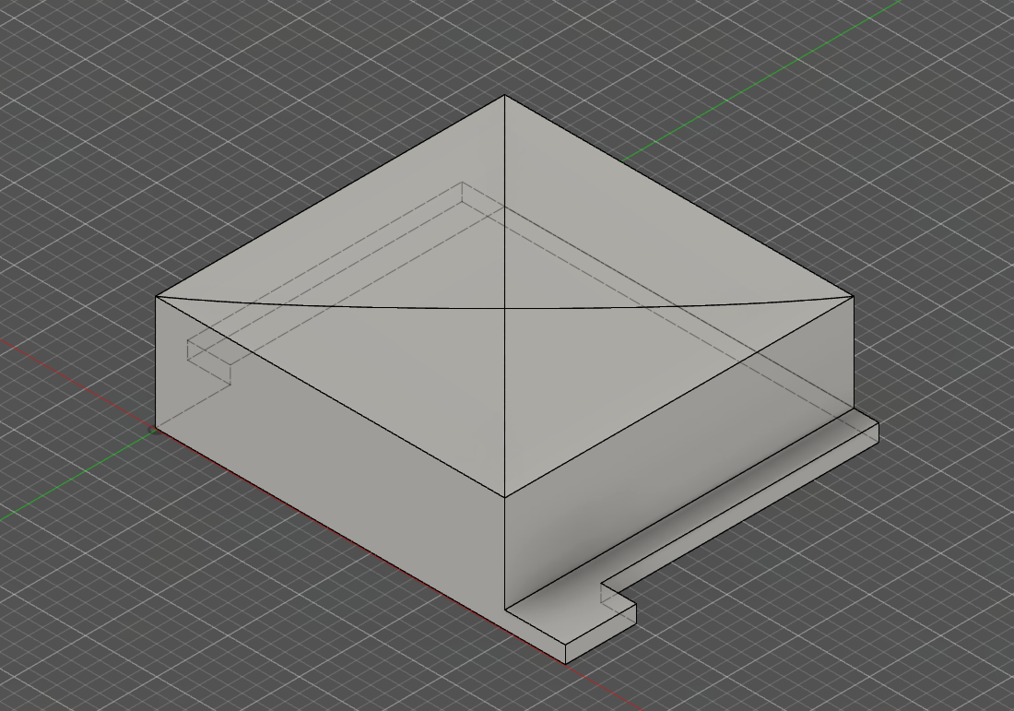

(Button Model)

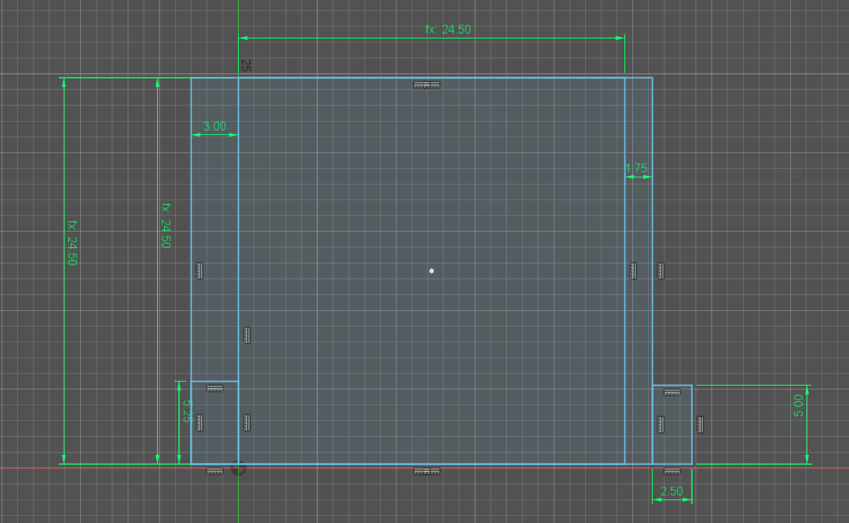

(Button Sketch)

(Various pictures of the 3d printed prototypes)

I have gotten the button completely prototyped and ready for molding. I just need to print out more button molds and prepare to pour the epoxy. The mold has already started prototyping. I’ve 3D printed it in TPU, a more flexible but stiff enough, plastic that will hopefully allow me to mold a- quality final part. 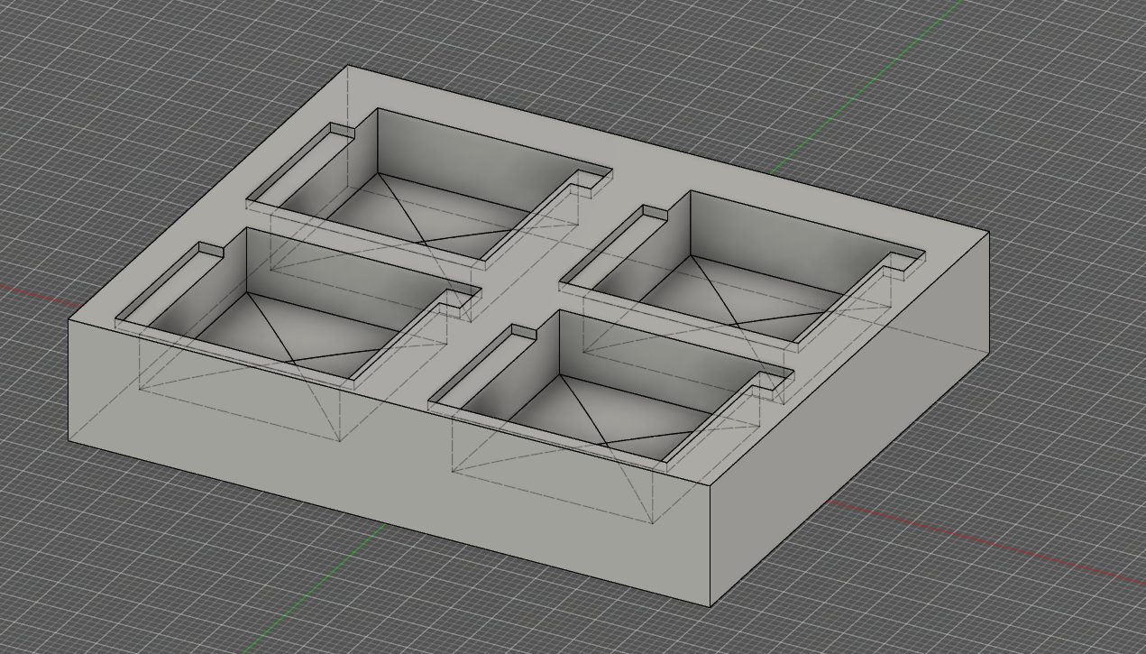

(Button mold part)

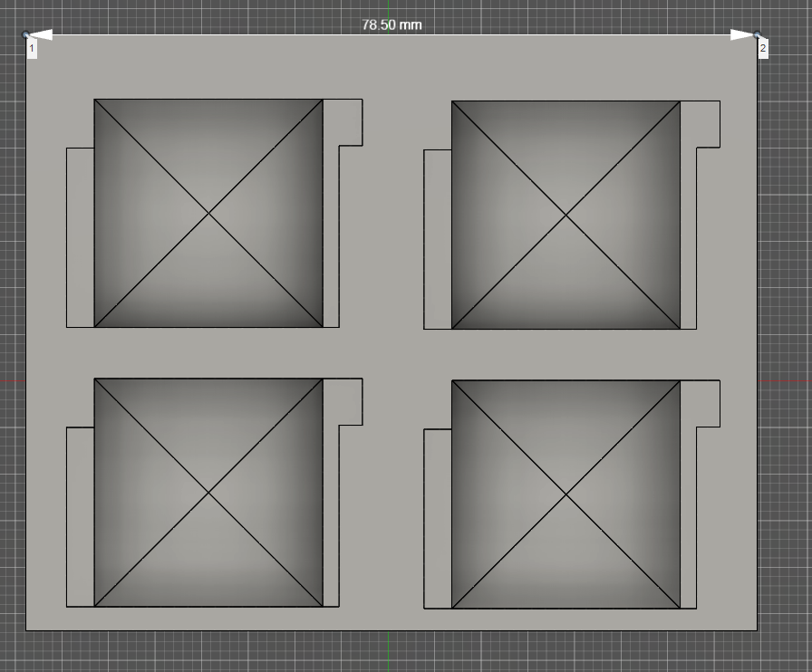

(Top-down mold 3d model)

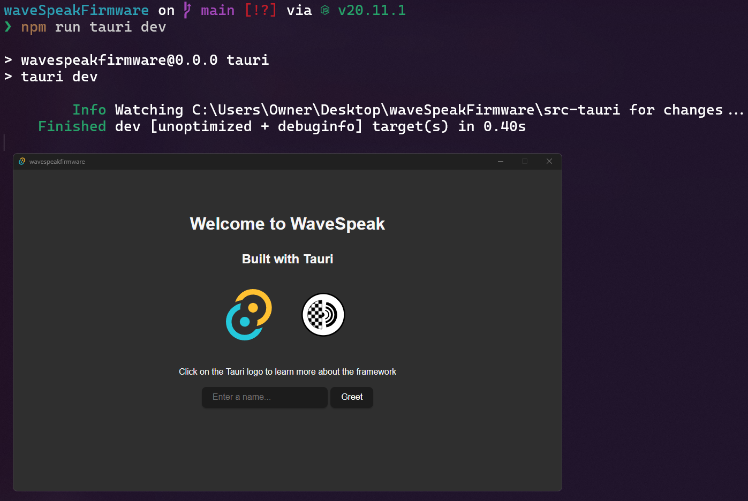

(My software stack successfully compiling and running)

I have also gotten Tauri working and running which means I’ll be prototyping on the tablet soon! In at least 2 weeks, I’ll have buttons rendering and interactive on the tablet.

My Research and What I learned:

I have learned the following topic general and specific topics.

* Programming/Software architecture
  + Rust, Node.JS, HTML, CSS, JS
  + Web Development
  + Linux Embedded development
    - Sources: <https://www.rust-lang.org/learn>, <https://tauri.app/>, <https://www.joshwcomeau.com/>, <https://tauri.app/v1/api/config/>
    - In my research of embedded software architecture, Tauri became an attractive framework, particularly due to its specialization in Rust and its extremely lightweight nature. Tauri's also uses web technologies like HTML, CSS, and JavaScript which means U.I. will be easily templated and reproduced. After downloading it and playing around with it, I finally committed to this being what drives the WaveSpeak tablet.
* Hardware design
  + 3D printing tolerance
  + Epoxy pouring
    - In my research on pouring epoxy molds, I learned the importance of preparation. Proper cleaning and the application of a release agent is going to be critical before pouring. Following the bottles instructions for the epoxy resin and hardener. The final step involves allowing the epoxy to fully cure before demolding. But the most stressed and important part of that process is the preparation. The waiting afterwards is the easy part.