1. **List the variety of methods used to publicise your society within the college community**
2. **Innovation and creativity used in promoting the society within the college community**
3. **Success at raising your profile within the college community**
4. **Overall publicity outside of college**

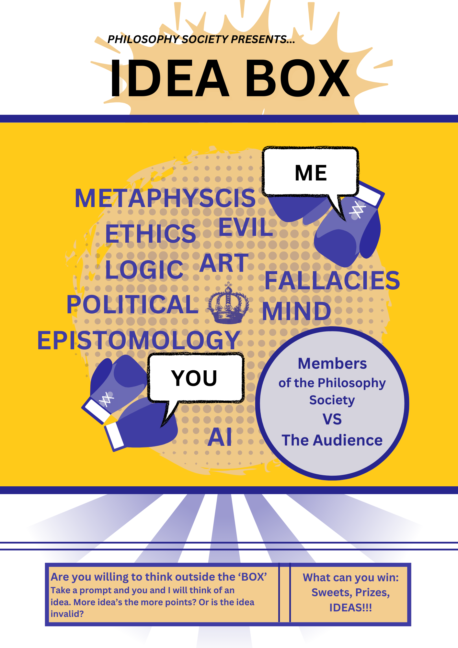

**1.**

* **Idea Box … (1)**

**The idea-box is a shoe-box filled with prompts and were presented to students. For example, ”If an AI powered car got into an accident”, “Ethics scenarios” and other pondering questions created by our members.Here they would pick a random prompt from the box and would discuss with us about the given prompt. This gave us a medium to directly advertise our society’s instagram. Furthermore, making people aware about Maynooth’s Philosophy Society …(2). We had great success with this, gaining about __ members on our instagram, and secondly getting people to be aware about the upcoming events …(3).**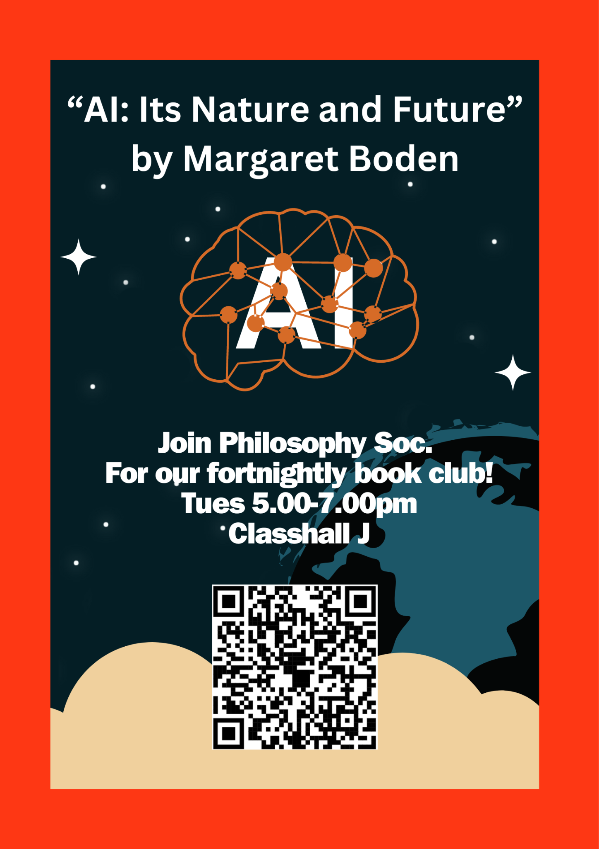

* **Posters …(1)**

**We focused on an AI period where we themed events around the topic of Artificial Intelligence. Two of these events were book readings on Margaret Boden’s: “AI, Its Nature and Future”, and Stuart Russell’s, “Human Compatible, AI and the Problem of Control”. Both of these events enlightened our members on the origins and direction Super AI’s would be going in. Letting us ask riveting questions such as: “What does consciousness even mean”, “What is the difference between an Artificial Brain and a Biological Brain”, tying these to questions that have been asked before like the ‘Ship of Thesus’, thought experiment or the ‘Simulation Hypothesis’. …(2). We had new members show these up to meetings, facilitating them to contemplate on the future of AI …(3).**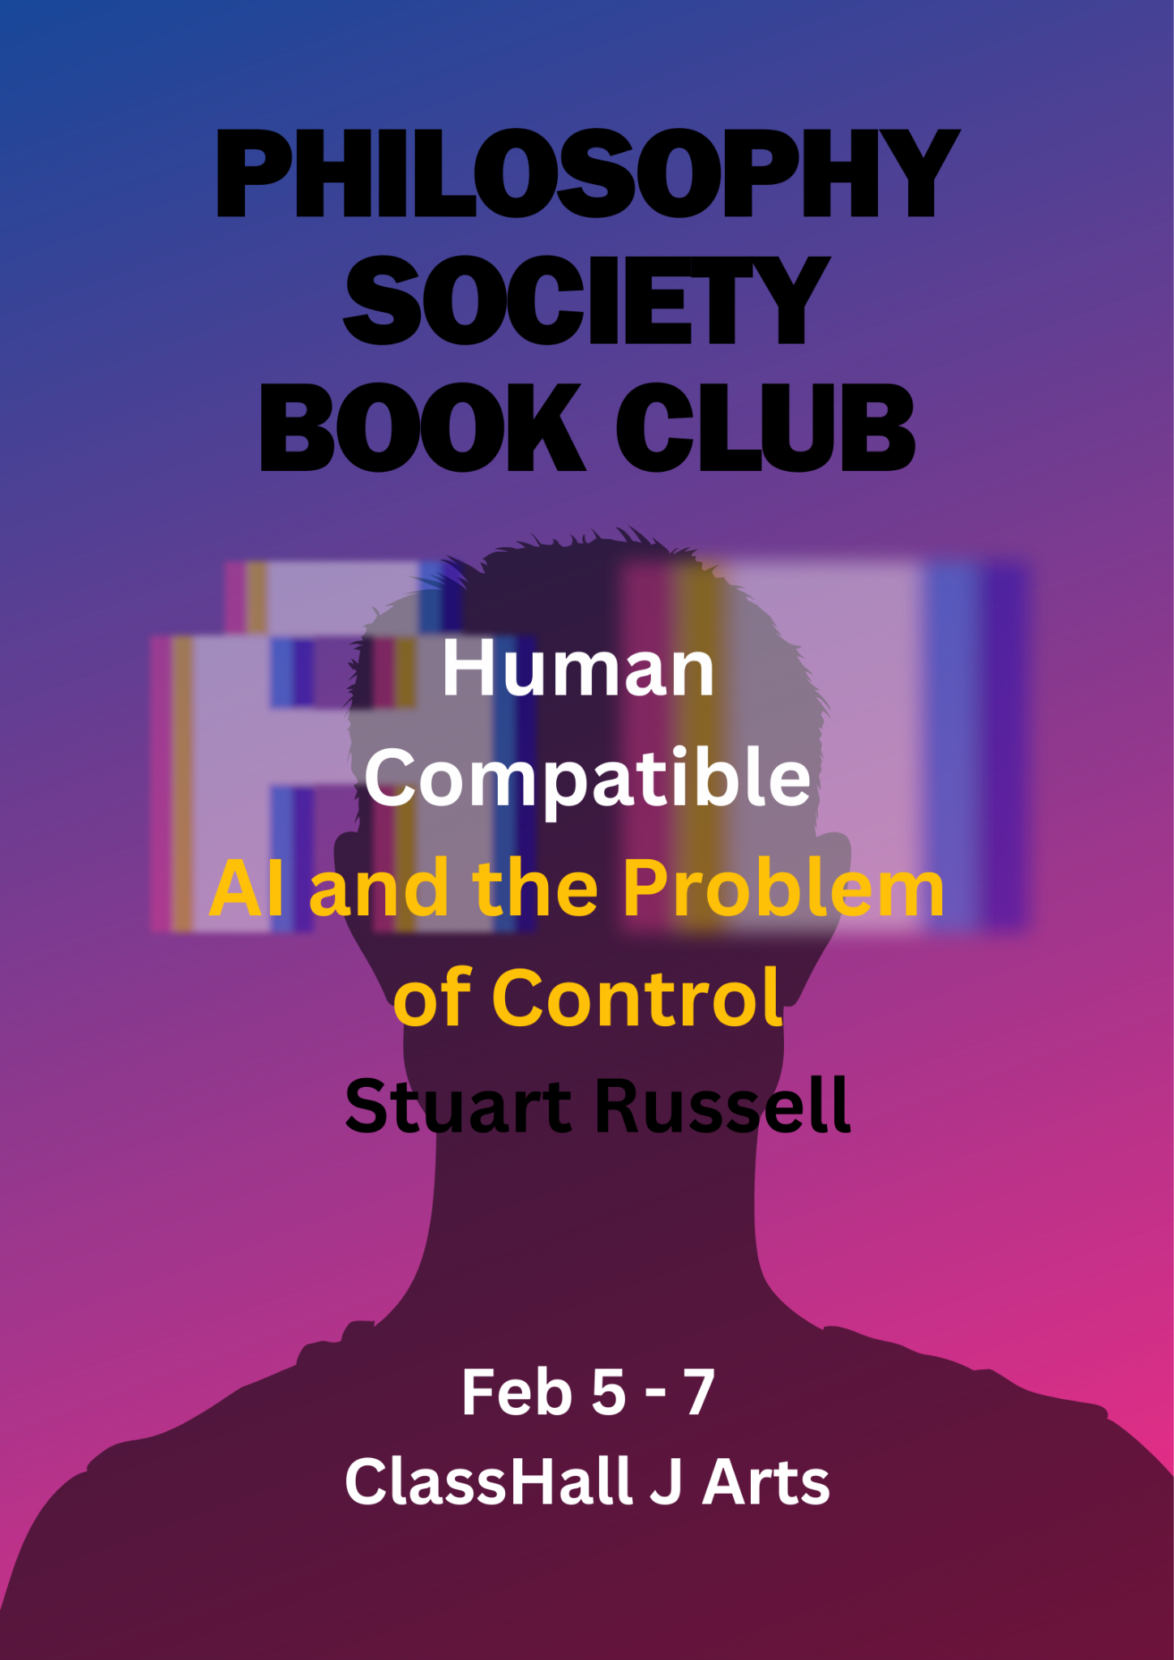

* **This has been a big improvement to the events we had done last year: SHOULD GET SOMEONE WHO WAS IN THE COMMITTEE TO FINISH THIS**

**Wireframes:**

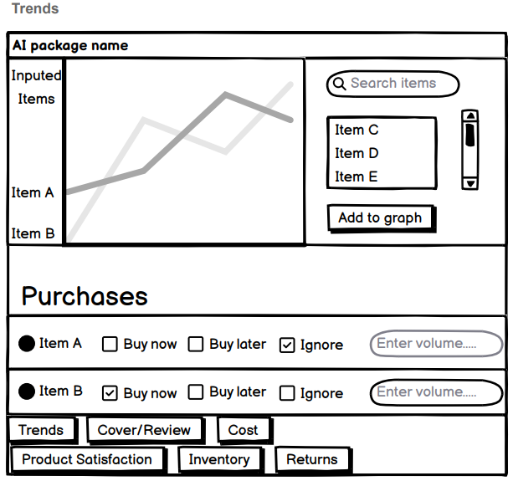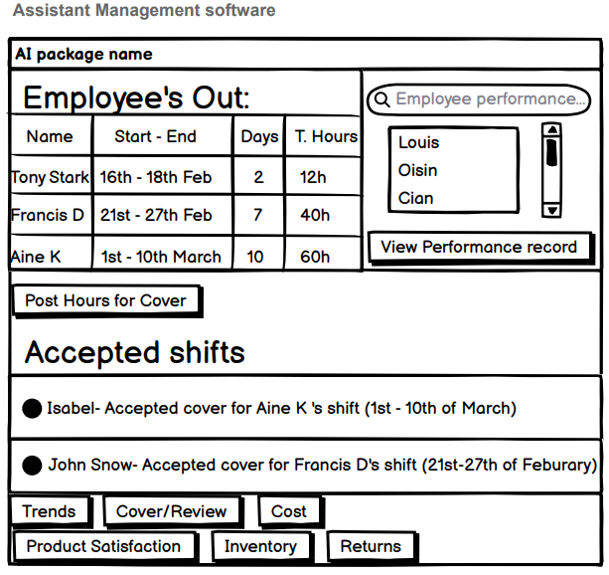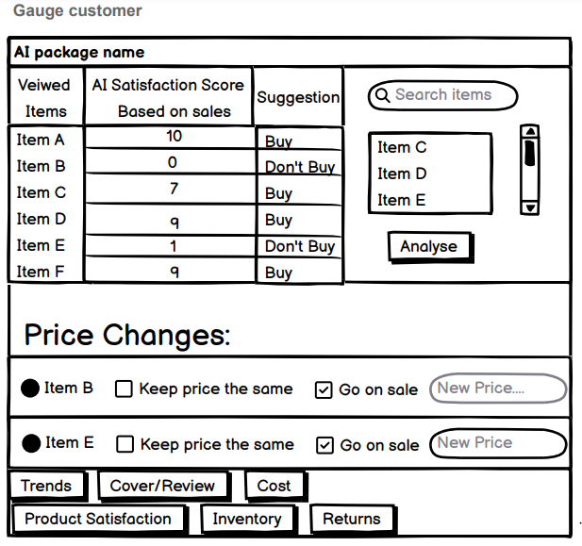

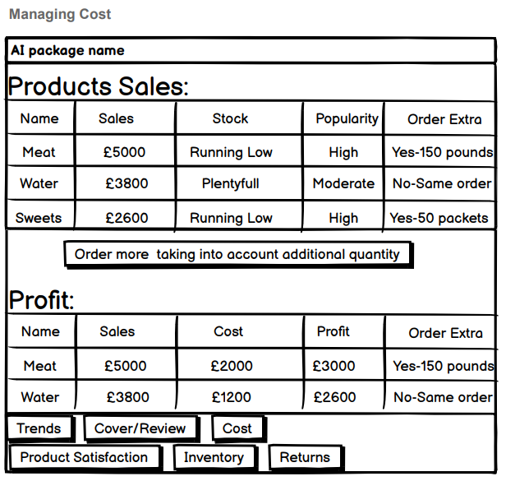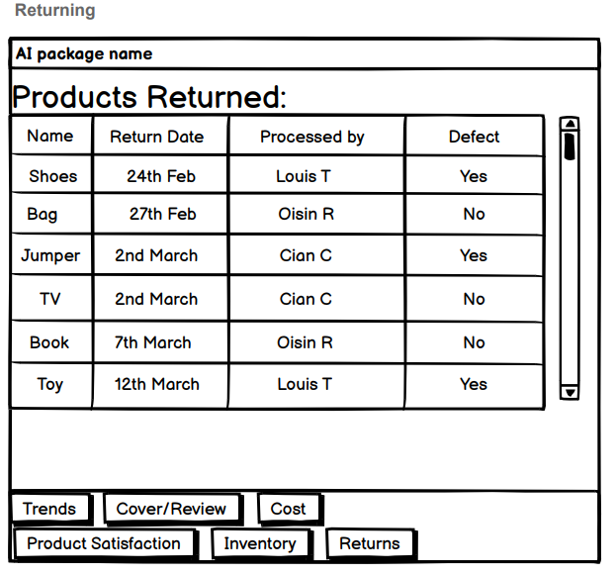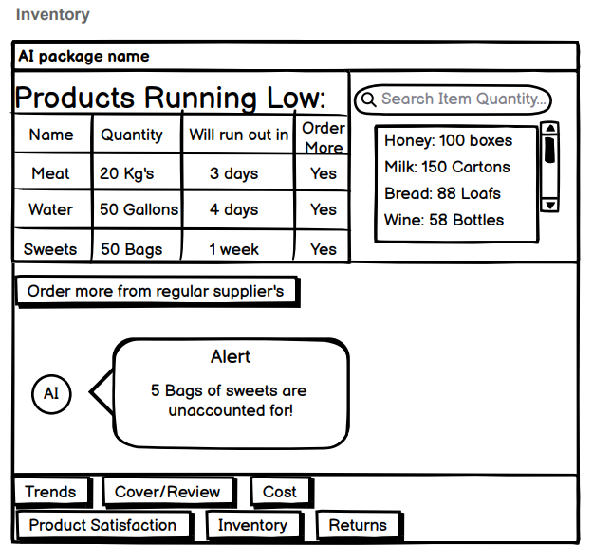

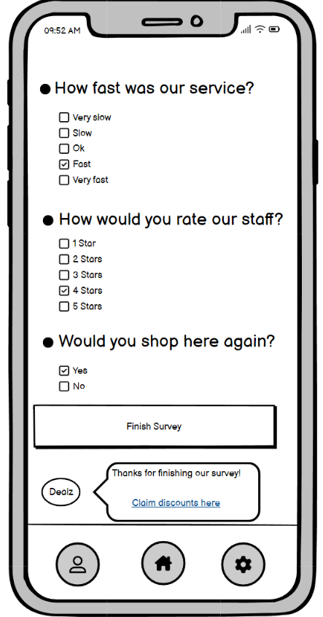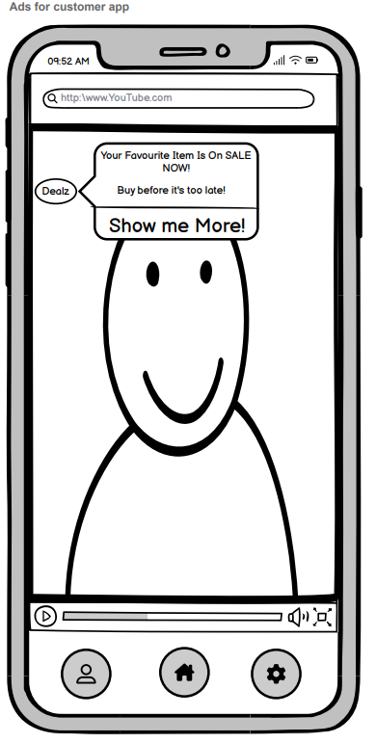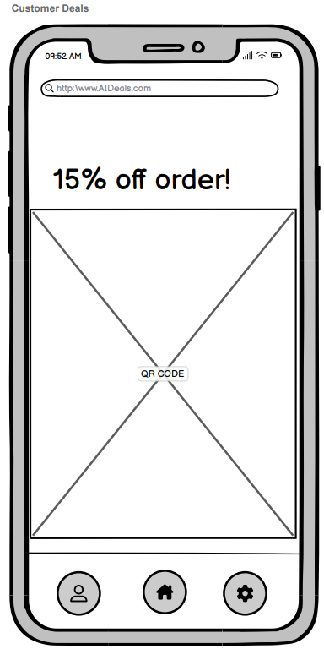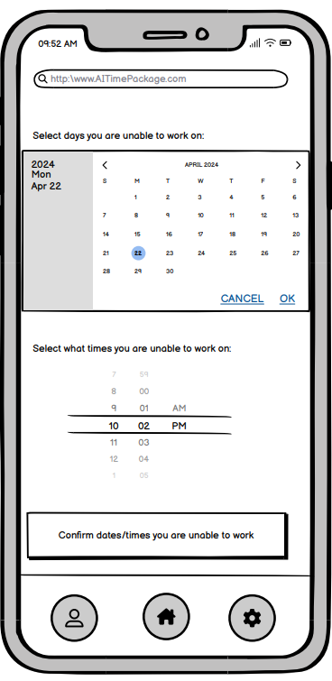

For the survey page, deals will link you to the customer deals wireframe