Họ và tên: Trần Tùng Lâm

MSSV: 21127337

Lớp: 21CLC08

**Test Case 1:**

**Test Case 2:**

**Test Case 3:**

**Test Case 4:**



Input = -2^32 + 1 is too big so the program crashed

**Test Case 5:**

Here input = -2^30 + 1 works just fine.

**Test Case 6:**

Here input = -2^31 + 1 works just fine.

**Test case 7:**

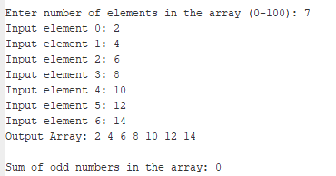

**Percentage of work: 100%**